
The Crossley Heath School
Savile Park, Halifax, West Yorkshire HX3 0HG

SCHEME OF FINANCIAL DELEGATION

Version Control

Version Number | Purpose/Change | Author | Date
1 | Original Policy created for review | Carol Spencer | September 2025
2 | Approved at BRC with amendments |  | November 2025
3 | Streamlined version with updated authority levels  Approved by Full Board | Nicola Beaumont | September 2026

Contents

1 | Introduction | Page 3
2 | Organisation | Page 3
3 | Accounting System | Page 7
4 | Financial Planning | Page 7
5 | Payroll | Page 8
6 | Purchasing | Page 9
7 | Income Control | Page 12
8 | Cash Management | Page 13
9 | Fixed Assets | Page 13
10 | Appendix A – School Delegatory Framework  Appendix B – Contingency Arrangements | Page 14

- Introduction

The purpose of this policy is to ensure that the Academy maintains and develops systems of financial control via the Department of Education (DfE) guidance. It is approved by the Board of Trustees and should be reviewed annually and immediately following a change in Trust management or organisational structure. All updates should be distributed and read (confirmed) by staff.

This policy should be used in conjunction with the Procurement policy to ensure that all purchasing activity is undertaken by the appropriate staff members.

- The Scheme of Financial Delegation (SOFD) ensures that individual roles have appropriate limits to their financial activities (net of VAT) and that everything aligns with DfE thresholds. It identifies the authority levels for individual roles and who should be undertaking what activities thereby ensuring financial control
- The Procurement policy details what must be done as preparation for an order, through to placing and approving an order and, finally, its subsequent management

The SOFD reflects a role-based approach and identifies those staff within the Academy and Trust that are responsible for financial functions. It is in line with the DfE Funding Agreement and includes a level of separation and accountability of duties that reflects best practice. For example, no single individual can set up and approve a bank payment.

- Organisation

The Academy has defined the responsibilities of each role involved in the administration of Academy finances to provide a framework of accountability, control and authority for Trustees and staff. This is tabulated in Appendix A. The functions involved in this administration are outlined below.

2.1 The Trust Board

The Trust Board has overall responsibility for the administration of the Academy’s finances. This includes:

  - ensuring that grant funding from the DfE is used only for the purposes intended
  - ensuring that funds from sponsors are received according to the Academy’s Funding Agreement and are used only for the purposes intended
  - approval of the annual budget
  - appointment of the Head Teacher (HT)/Accounting Officer (AO)
  - appointment of the Chief Finance Officer (CFO), in conjunction with the HT
  - approval of the annual Company Accounts
  - approval of spending over £100,000

The Business and Resources Committee

The Business and Resources Committee (BRC) is a sub-committee of the Trust Board and meets at least once a term. It is the equivalent of an Audit and Risk Committee. As part of the appointment process, the Chair of the BRC should demonstrate suitable finance and accounting qualifications/experience. An annual plan of financial training for Trustees should be proposed by the BRC and agreed at the start of the new school year. The main responsibilities of the BRC include:

  - monitoring and evaluating the implementation of the School Improvement Plan (SIP) in relation to Finance and Estates, ensuring that appropriate policies and decisions are recommended to match aims and objectives
  - agreeing and recommending the annual budget to the full Trust Board
  - advising the Trust Board on the school’s overall financial strategy and policy within the resources available
  - monitoring the school’s income and expenditure against the agreed budget figures and reporting to the full Trust Board at least once per term
  - seeking opportunities for income generation and maximising school assets
  - keeping the costs of the staffing of the school under general review and making recommendations to the full Trust Board
  - overseeing the school’s financial systems and operations to ensure compliance with DfE regulations and procedures
  - overseeing private and voluntary funds
  - approval of spending between £50,000 and £100,000
  - recommending the annual financial statements to the Trust Board for approval
  - reviewing the reports of the auditors and, as appropriate, advising the Trust Board of material control issues
  - ensuring compliance with national requirements in relation to policies and procedures associated with employment, pay, recruitment, selection, appointment, promotion, performance management, appraisal, grievance, discipline, remuneration, welfare, and professional development
  - reviewing the Pay policy annually with regards to the current STP and C document and providing appropriate guidance relating to support staff
  - advising the Trust Board on the adequacy and effectiveness of the Academy’s systems of internal controls and its arrangements for risk management, control and governance processes and securing economy, efficiency and effectiveness (value for money)
  - agreeing the programme of internal audit, including the checking of financial controls, systems, transactions and risks
  - proposing an annual plan for financial training to the Trust Board

The Accounting Officer (AO)

The HT of the school undertakes the responsibilities of the AO. The HT has overall executive responsibility for the Academy’s activities, including financial activities via the AO role. Much of the financial responsibilities have been delegated to the CFO, but the AO still retains responsibility for:

- liaison with Parliament, and the DfE's Accounting Officer, regarding the management of financial resources under the Trust's control
- assuring Parliament and the public of high standards in the management of public funds, particularly by:

  - following the '7 principles of public life'
  - having oversight of financial transactions
  - taking personal responsibility for assuring the Board that the Trust complies with the Academy Trust Handbook (ATH) and the Funding Agreement
  - completing and signing a statement on regularity, propriety and compliance each year and submitting this to the DfE with the audited accounts
  - demonstrating how the Trust has secured value for money via the governance statement in the audited accounts

  - approving new staff appointments within the authorised framework, except for any senior staff posts which the Trust Board have agreed should be approved by them
  - authorising orders and contracts up to £50,000; subject to the budget agreed at the beginning of the year
  - authorising payments in conjunction with the CFO and other authorised signatories
  - approving requests from the CFO for the treatment of school investments
  - approving draft budgets, forecasts, management accounts and financial reports/documents before distribution to the Trustees

2.4 The Chief Finance Officer

The CFO works in close collaboration with the AO and is a key member of the BRC, attending both BRC and full Board meetings. The CFO and all Finance Team staff must be appropriately qualified and/or experienced. The Trust must assess whether the CFO, and others holding key financial posts, should have qualifications in business (such as the CIPFA qualification developed in partnership with ISBL) or an accountancy qualification and hold membership of a relevant professional body, depending on the risk, scale and complexity of financial operations. The main responsibilities of the CFO are:

  - the day-to-day management of financial issues, including the establishment and operation of a suitable accounting system
  - the management of the Academy’s financial position at a strategic and operational level
  - the maintenance of effective systems of internal control
  - ensuring that the annual accounts are properly presented and adequately supported by the underlying books and records of the Academy
  - the review and approval of monthly management accounts
  - the preparation and review of annual budgets, forecasts and strategic plans
  - authorising orders up to a maximum of £30,000
  - signing cheques in conjunction with the AO and other authorised signatories
  - authorising BACS payments
  - managing Academy investments in conjunction with the AO
  - ensuring forms and returns are sent to the DfE in line with the timetable in the DfE guidance
  - complying with relevant legislation and reporting requirements (for example, HMRC and Pensions)

2.5 The Head of Finance

The Head Of Finance (HOF) reports to the CFO and has an authorisation limit of £5,000. They supervise the Finance team (Finance Assistants) and ensure that deliverables are timely, accurate and of good quality. Their key responsibilities include:

- the day-to-day management of the finances - processing invoices, managing payroll and maintaining financial records
- preparing financial reports - monthly management accounts, budget monitoring reports and year-end accounts
- implementing and maintaining financial controls – ensuring the proper segregation of duties, the maintenance of the fixed asset register and the management of procurement processes
- supporting strategic planning - preparing budgets and providing financial modelling and forecasting
- ensuring compliance - making sure financial procedures follow the ATH and Funding Agreement requirements

2.6 Other Staff

Other members of staff, primarily the Finance Assistants and budget holders, will have some financial responsibility and this is reflected in Appendix A. Appendix B shows the contingency arrangements for the Finance Team.

2.7 Internal Scrutiny

The Board of Trustees has chosen to appoint a non-employed Trustee to oversee the delivery of internal scrutiny.

This Trustee is the Chair of the BRC and is suitably experienced and qualified. The Trust Board and BRC Trustees approve the recommended programme of financial and non-financial internal scrutiny to be undertaken each year based on an assessment of the risks present within the Trust’s operations.

The non-employed Trustee reports three times a year to the BRC on the performance of the systems of control and prepares an annual summary report to the BRC outlining the areas reviewed, key findings, recommendations and conclusions to help the BRC consider actions and assess year on year progress. It is the BRC’s responsibility to update the full Board on progress and recommendations regularly and at year end.

The annual internal scrutiny programme includes the evaluation of controls and some testing of controls by a sample of transactions. Other key areas are also reviewed based on an annual risk analysis, such as governance, financial efficiency, strategic financial planning, IT systems, cyber security, health and safety, estates management, organisational culture, management information, anti-fraud, safeguarding, HR systems and succession planning. The internal scrutiny programme includes deployment of external organisations with identified areas of specialist expertise.

The Academy Trust’s system of internal financial control is based on a framework of regular management information and administrative procedures, including the segregation of duties and a system of delegation and accountability.

3. Accounting System

All the financial transactions of the Academy must be recorded in the Access Education Finance system. All Purchase Orders (POs) must be created in Access Education Purchasing for approval and processing. Annual budgets, forecasts and plans are prepared within the Access Budgeting system, which is linked to Access Education Finance. In addition to the accounting system, all payroll transactions must be recorded on the I-Trent system which is administered by Calderdale Council.

3.1 System Access

Entry to the Access system is password restricted and the CFO is responsible for implementing a system which ensures that passwords are changed at least every six months. The HOF is responsible for setting access levels for all members of staff using the system.

3.2 Back-up Procedures

The CFO, in conjunction with the Network Manager, is responsible for ensuring that there are effective back-up procedures for the system. Data is backed up on the cloud and internal servers. An electronic copy of the nominal ledger and audit trail should be created and saved each month.

3.3 Transaction Reports

The HOF will review system reports to ensure that only regular transactions are posted to the accounting system. The report obtained and reviewed will include:

  - masterfile amendment reports for the payroll, purchase ledger and sales ledger
  - management accounts summarising expenditure and income against budget at budget holder level

Any anomalies will be addressed with the CFO.

3.4 Reconciliations

The HOF and Finance Assistants are responsible for ensuring reconciliations are performed each month and that any reconciling or balancing amounts are cleared. Any unusual or long-standing reconciling items must be brought to the attention of the CFO. The CFO will review and sign all reconciliations as evidence of the review.

- Financial Planning

School Improvement Plan

The SIP is concerned with the future aims and objectives of the Academy and their achievement. The form and content of the plan should refer to any annual guidance issued by the DfE.

The AO will propose a planning cycle, timetable and agenda to the Trust Board for initial discussion at the annual strategic planning day. The agenda should cover:

  - a review of past activities, aims and objectives - “did we get it right?”
  - definition or redefinition of aims and objectives – “are the aims still relevant?”
  - development of the plan and associated budgets – “how do we go forward?”
  - implementation, monitoring and review of the plan – “who needs to do what by when to make the plan work and keep it on course” and
  - feedback into the next planning cycle – “what worked successfully and how can we improve?”

The completed plan will include detailed objectives for the coming academic year. The resource costs, both capital and revenue, associated with each objective have been identified within the annual budget. Requests for additional expenditure will be raised as separate agenda items. Success criteria against which achievement can be measured are also included.

Annual Budget

The CFO is responsible for preparing and obtaining approval for the annual budget. The budget must be approved by the AO, BRC and the full Trust Board. The CFO is responsible for establishing a timetable which allows adequate time for budget research, preparation and approval and ensures that the DfE submission date is met. There should be a clear link between the development plan objectives and the budgeted utilisation of resource. Development of the capital budget is a separate process which incorporates securing funding and ensuring that the proposed areas of spend link to the Asset Management Plan and SIP. The budget should be communicated to all department heads and budget holders so that everyone is aware of the overall budgetary constraints and the full year targets.

  - Forecasting

Quarterly forecasts will be undertaken because actual results will always vary from the budget as circumstances change throughout the year. Monthly reports will continue to reflect the variances against the original budget but, post Quarter 1, will also show any variances against the latest forecast; the latter should be smaller as the forecast projections are more recent. The forecasting process involves the HOF and CFO updating the budget and preparing a draft phased forecast for approval by the AO and BRC. The approved version will be used in the monthly reports until it is replaced by a later version and will drive remedial action to keep the school on financial track.

Payroll

Staff Appointments

The HT has the authority to appoint staff, except for members of the Senior Leadership Team and the CFO whose appointments must follow consultation with the Trustees. The HT and Chief Operating Officer maintain personnel files for all members of staff which include contracts of employment. All personnel changes must be notified in writing to the HOF immediately.

Payroll Administration Control

The Academy payroll is administered by Calderdale Council and the HR office sends in all starters, leavers and adjustments to pay/contracts. The I-Trent system is used to submit overtime, deductions, and sickness. The data is entered by the HOF or the Finance Assistant from time sheets submitted by the staff and approved by their line managers. These are sent to the AO for approval. The time sheets are submitted for the first of the month following the actual overtime worked; any amendments to contracts are submitted the week before the time sheets are submitted. These are signed by the HOF, scanned and submitted via email to the HR department at Calderdale Council.

All staff are paid monthly by BACS from Calderdale Council. A master file is created for each employee. New master files can only be created by the Calderdale HR Department with the express approval of the HT or CFO. All amendments and payments are approved by the CFO monthly and sent to HR and Payroll Officers at Calderdale. The original sheets are kept with the payroll file and checked each month by the HOF and the CFO.

Staff absence (including sickness) is recorded and monitored by the Chief Operating Officer. Any new appointments, termination or changes to contracts must be authorised by the HT and passed to the Finance Department for processing.

Payroll Payments Control

After the payroll has been processed, but before payments are dispatched, a print of salary payments by an individual and showing the amount payable in total should be obtained from the system. The print must be reviewed and authorised together with the authority to release payment by the HOF and the CFO/HT.

After the payroll has been processed, the nominal ledger will be updated by a journal transfer. Postings will be made both to the payroll control account and to individual cost centres. The HOF should review the payroll control account each month to ensure the correct amount has been posted from the payroll system, that individual cost centres have been correctly updated and to identify any amounts posted to the suspense account.

Purchasing

There is a separate school Procurement policy outlining the correct purchasing processes to follow. This includes the appropriate level of quotations to be obtained dependent upon the value and nature of the order and when and how to conduct tender exercises.

The value-based SOFD for individual roles to support the purchasing process is summarised below and detailed in Appendix A.

6.1 Routine Purchasing Authority Limits

Budget Holders | £2,000
Department Heads | £2,000
School Trip Organisers | £2,000
SLT (specific roles identified in Appendix A) | £5,000
HOF | £5,000
COO | £5,000
CFO | £30,000
HT | £50,000
BRC | £50,000 - £100,000
Board | Above £100,000

6.2 Exceptions

Per the Procurement policy, energy, capital projects and capital payments are for the approval of the Board of Trustees as a full order. Individual elements can then be processed as above. Other exceptions include payroll and payments for trips and school item sales.

Further delegated authority to sign POs exists for the roles below:

Biology Lab Technician £350
Physics Lab Technician £350
Chemistry Lab Technician £350
Reprographics Technician £450

Budget holders will be informed of the budget available to them at least one month before the start of the academic year. It is the responsibility of the budget holder to manage the budget and to ensure that the funds available are not overspent. A report detailing actual expenditure against budget will be supplied to each budget holder a week after the end of each month and budget holders are required to keep their own records of orders placed but not paid for.

6.3 Payments Control

The Finance Assistant will generate a payment run, as required, listing the approved invoices due for payment. This will be reviewed and approved by the HOF who will then create a BACS run in the main bank account.

The CFO (with the AO as contingency) will check each payment within the BACS set up in the main bank account against the associated POs and invoices in Access Education Purchasing (AEP). When satisfied, the CFO will make the payment. Dual authorisation exists as the HOF can create but not approve the bank payment, and the CFO/AO can only approve a pre-created payment.

6.4 Credit Card Payments Control

Company credit cards are available for purchases where:
- Best value principles can only be achieved by using a credit card
- There is no other way of purchasing the goods/service
- Internet purchasing is required

All company credit cards must be stored in the Finance safe whilst not in use and should not leave this office, unless the HOF has given explicit permission. The named cardholder is responsible for any purchases on the card and must maintain accurate records of all transactions. This is generally the HOF. All orders placed on the credit cards must be made by a member of the Finance Team or in their presence, including internet orders. Credit cards are not to leave the Finance office unless under special permission for trips/visits and other emergency purchases. The only exception is Catering because the purchasing of consumables is often done outside school hours.

In the same way as for all purchasing, Purchase Orders (POs) must be created on Access Education Purchasing and the approval workflow completed. Monthly statements will be sent to all cardholders and reconciled by the Finance Team. Cardholders must undertake these checks without undue delay.

6.5 Bank Account Control

The opening of a new bank account must be authorised by the Trust Board who should set out, in a formal memorandum, the arrangements covering the operation of accounts, including any transfers between accounts and cheque signing arrangements. The introduction of new systems, such as BACS and other means of electronic transfer of funds, must also be subject to the same level of control.

The HOF will ensure that bank account reconciliations are completed monthly and signed off by the CFO.

6.6 Deposit Control

Details of any deposit must be entered onto a copy paying-in slip (electronic), counterfoil or listed in a supporting book. The details should include the amount of the deposit, payer and the facility/service the payment covers, in addition to a reference, such as the number of the receipt or the name of the debtor.

6.7 Payments and Withdrawals Control

All cheques and other instruments authorising withdrawal from Academy bank accounts must bear the signatures of two of the authorised signatories as detailed on the bank mandate. This provision applies to all accounts, public or private, operated by or on behalf of the Trust Board of the Academy. Authorised signatories must not sign a cheque relating to goods or services for which they have also authorised the expenditure.

6.8 Petty Cash Accounts Control

The Academy maintains a maximum cash balance of £500. The cash is administered by the Finance Assistant and is kept in the Finance office safe.

Deposits - the only deposits to petty cash should be from cheques cashed specifically for the purpose. The receipt should be recorded in the petty cash system with the date, amount and a reference, normally the cheque number, relating to the payment. All other cash receipts, for whatever reason, should be paid directly into the bank.

Payments And Withdrawals - in the interests of security, petty cash payments will be limited to £100. Higher value payments should be made by alternative means. Payments will only be reimbursed by the HOF upon receipt of a completed, authorised, petty cash form with supporting receipts.

Administration - The Finance Assistant is responsible for entering all transactions into the petty cash records on a regular basis. In addition, unannounced cash counts should be undertaken by the HOF to ensure that the cash balance reconciles to supporting documentation.

Physical Security - petty cash should be held in a locking cash box which is put in the safe overnight.

- Income Control

  - Payments For Pupils

A lead teacher must be appointed for each trip/pupil payment. The lead teacher must prepare a record for each student intending to go on the trip or due to make a payment, showing the amount due. A copy of the record must be given to the HOF.

ParentPay payments are credited to the bank on a weekly basis. These receipts are reconciled by the Finance Assistant and the nominal ledger updated accordingly. ParentPay is the preferred method of payment. Any other payment method requires prior approval from the CFO.

The majority of catering income is also processed via ParentPay. Any cash received is processed by Finance staff and banked monthly. Other income, for example payments relating to ITT students, is receipted and banked on a weekly basis. An income return should be prepared for each banking deposit and authorised by the HOF prior to input to Access Education Finance.

7.2. Undocumented Income

Pre-numbered Academy receipts should be issued for all cash and cheques received where no other formal documentation exists. These must be kept in the Finance Office safe prior to banking. Banking should take place every week, or more frequently if the sums collected exceed the £8,000 insurance limit for the safe. The HOF is responsible for approving the reconciliations (prepared by the Finance Assistant) between the sums collected, the sums deposited at the bank and the sums posted to the accounting system.

- Cash Management Control

The CFO is responsible for preparing cash flow forecasts to ensure that the Academy has sufficient funds available to pay for day-to-day operations and ad-hoc spend. If significant balances can be foreseen, steps should be taken to invest the extra funds in the approved investment platform. Similarly, plans should be made to transfer funds from another bank account or to re-profile to cover potential cash shortages. There is a separate school Reserves and Investment Policy. All CFO requests for movement between accounts or in and out of the approved investment platform must first be approved in writing by the AO. Once in receipt of this, the HOF will create the transaction for the CFO to approve.

Fixed Assets Control

9.1 Disposals

Items which are to be disposed of by sale or destruction must be authorised by the CFO and, where significant, should be sold following a competitive tender. The Academy must seek the approval of the DfE, in writing, if it proposes to dispose of an asset for which a capital grant in excess of £20,000 was paid.

Disposal of equipment to staff is not encouraged as it may be more difficult to evidence that the Academy obtained value for money in any sale or scrapping of equipment. In addition, there are complications with the disposal of computer equipment, as the Academy would need to ensure licenses for software programmes have been legally transferred to a new owner.

The Academy is expected to reinvest the proceeds from all asset sales for which a capital grant was paid, in other Academy assets. If the sale proceeds are not reinvested, then the Academy must repay a proportion of the sale proceeds to the DfE. All disposals of land must be agreed in advance with the Secretary of State.

9.2 Loans

Items of Academy property must not be removed from Academy premises without the authority of the Head of Department. A record of the loan must be recorded in a loan book and booked back to the Academy when it is returned.

If assets are on loan for extended periods or to a single member of staff on a regular basis, the situation may give rise to a ‘benefit-in-kind’ for taxation purposes. Loans should therefore be kept under review and any potential benefits discussed with the Academy’s auditors.

Appendix A

This framework is also applicable to other policies, for example Pay and Procurement, in addition to the SOFD.

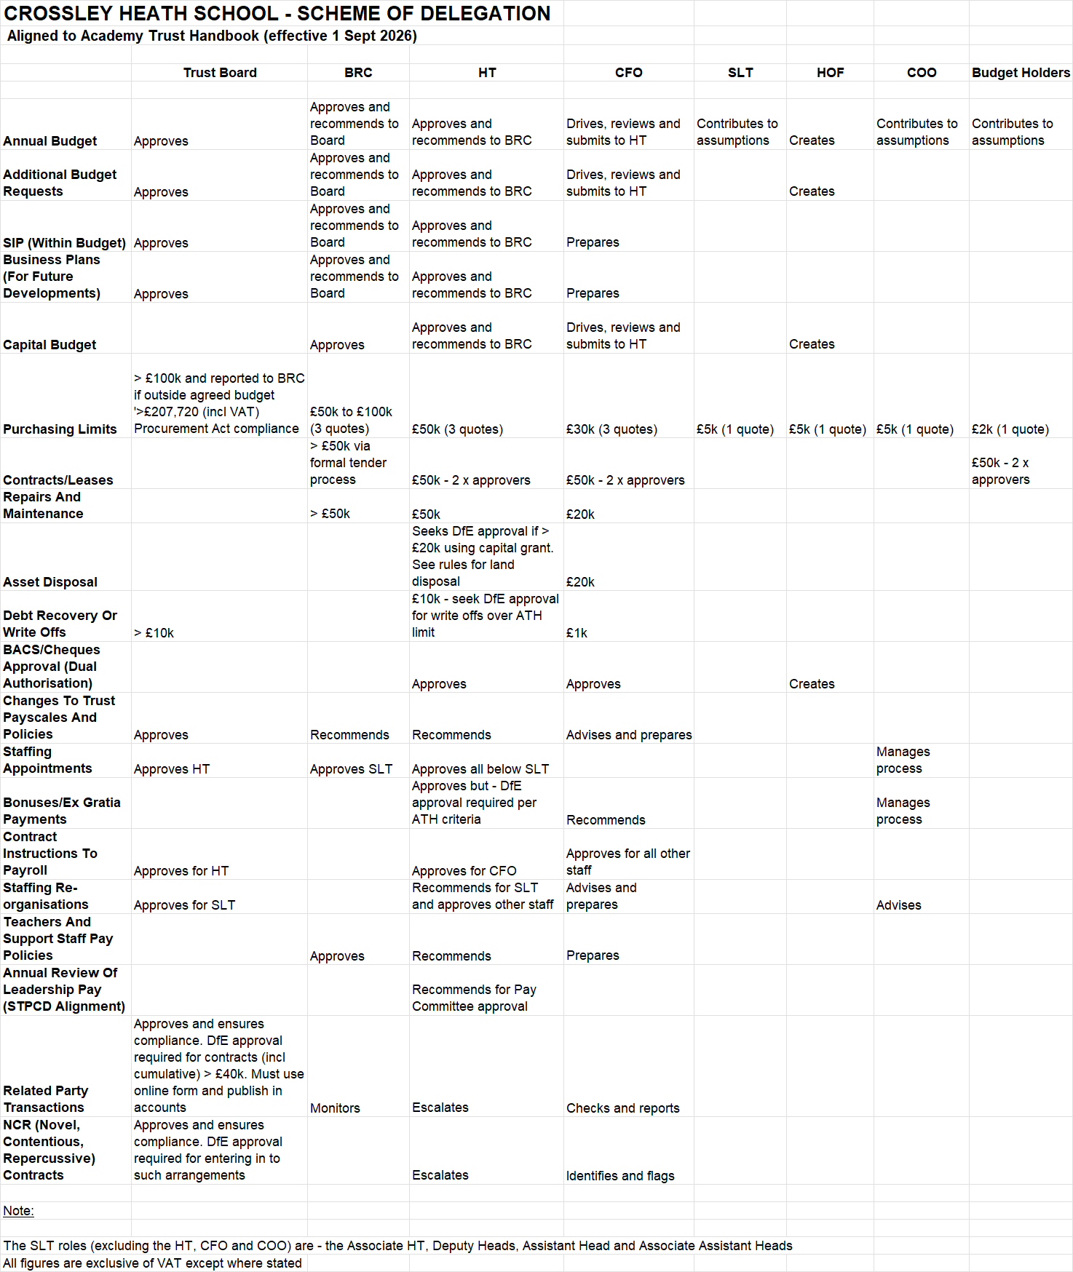

Appendix B

SOFD Contingency Arrangements

Head Teacher/Accounting Officer

Task | To Be Covered By:
Approving new staff appointments | Associate Head
Approving BACS payments | CFO
Bank account administration | Per bank mandate - CFO/certain SLT members
Approving investment platform transactions | CFO

Chief Finance Officer

Task | To Be Covered By:
Budget preparation | HOF
Approving POs | AO
Approving BACS payments | AO
Approving investment transactions | AO
Financial planning | AO/HOF
DfE returns | HOF/Appointed Auditor
Bank account administration | Per bank mandate – AO/certain SLT members
Preparation of annual accounts | HOF/Appointed Auditor
Reporting to Trustees | AO/Chair of BRC

Head Of Finance

There is one full-time HOF and two Finance Assistants (term-time only). The HOF will cover all activities during school holidays with a Finance Assistant providing remote support if the HOF is absent during this time.

Task | To Be Covered By:
Setting up BACS payments | Finance Assistant
Setting up Insignis investment transactions | Finance Assistant/COO
Monthly reporting | CFO
Petty cash | Finance Assistant
Budget holder reports | Finance Assistant
VAT returns | CFO
PO creations and approvals | Finance Assistant/CFO/COO
Creating BACS payments | Finance Assistant
Banking, ordering and payments | COO/CFO/AO
Journal approvals | CFO
Control account reconciliation approvals | CFO

