

SIXTH
FORM
CROSSLEY
HEATH
THE
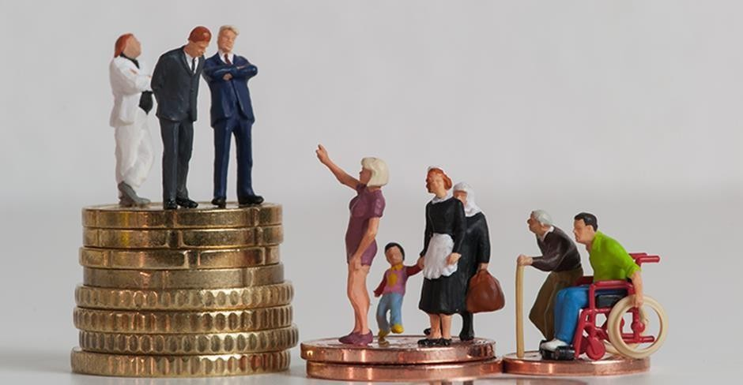

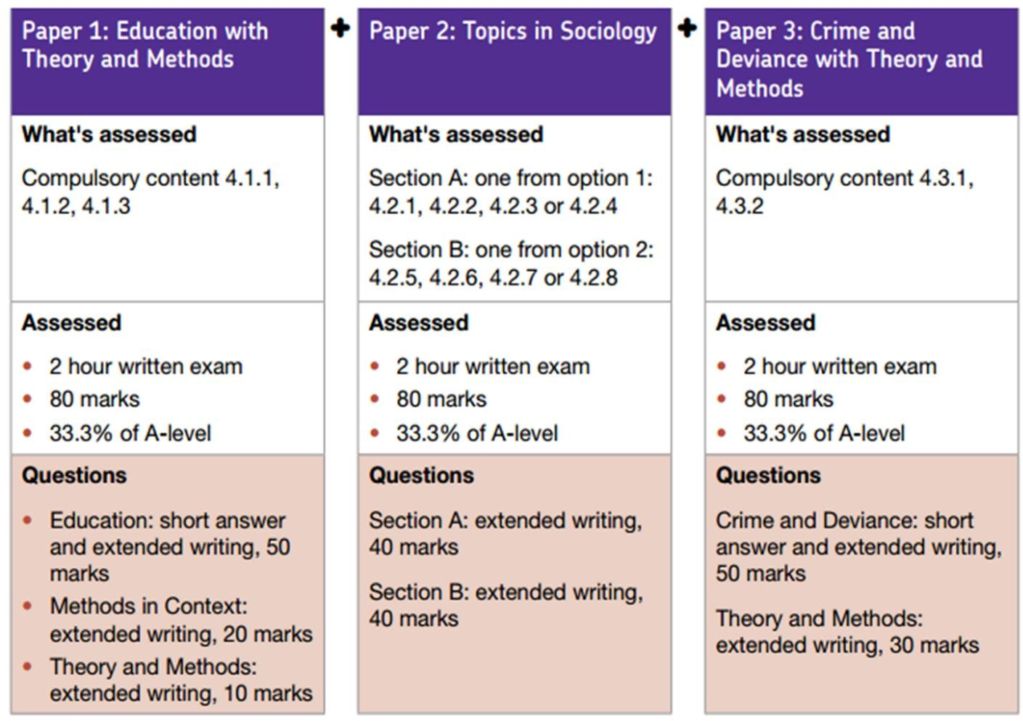
Welcome!
We’re thrilled to welcome you to The Crossley Heath School Sixth Form! We are absolutely delighted that you have chosen to study A-level Sociology with us, you’ve made a fascinating and empowering choice that will open your mind to new perspectives and a deeper understanding of the world around you.

Sociology is so much more than just studying society, it’s about questioning the everyday, uncovering hidden patterns, and exploring how individuals, groups, and institutions shape our lives. Whether you're interested in social justice, education, crime, culture, politics, inequality, or the forces that drive change, this subject offers you the tools to ask big questions, and to start finding meaningful answers.

You’re joining a welcoming and inquisitive learning community where your thoughts and perspectives truly matter. We’re here to challenge your thinking, encourage your curiosity, and support your growth into critical, informed, and compassionate thinkers.

We cannot wait to spark powerful discussions, broaden your horizons, and celebrate your progress every step of the way.

We’re so glad to have you with us, let’s explore society together and uncover what shapes our world.

Miss Z Azam
(Department Leader for Sociology)
Link to Specification: https://filestore.aqa.org.uk/resources/sociology/specifications/AQA-7191-7192-SP-2015.PDF
A-Level Sociology
Exam Board and Specification: AQA A-Level Sociology (7192)
We study the AQA specification, and study the following topics:
- Education
- Families
- Beliefs in society/ Media
- Crime and deviance
- Theory and Methods
These are divided into three papers, which are each 2-hour exams and make up 100% of your final grades.

SIXTH
FORM
CROSSLEY
HEATH
THE

SIXTH
FORM
CROSSLEY
HEATH
THE

SIXTH
FORM
CROSSLEY
HEATH
THE
Bridging
work
Task 1: Quick Check (1 hour)
Sociology
Sociologist
Social Institutions
Norms
Values

You may have studied Sociology for GCSE, or you may never have heard of it before.

Sociology refers to the study of society – the way people interact together in society, and how society shapes us and our decisions. Studying sociology will help you to understand different perspectives, to write analytic essays and crucially, to understand the same issue can be seen from multiple perspectives. One of the main issues we study in sociology is equality – how and why society is unequal, and why different people have different chances of succeeding in life. This will be the focus of this work pack.

Sociologists believe society can be broken down into different parts: social institutions. These include: education, the family, the mass media (TV and newspapers), the criminal justice system, health and religion. These different parts work together and play an important role in shaping our lives. They also believe that every society has a culture, which means a way of life, and a set of norms (expected behaviours) and values (what we hold to be important).

How do we become part of society? Sociologists argue that children go through a process called socialisation, which means learning society’s norms and values. At home, children go through primary socialisation, where they learn how to speak, share and other basic behaviours and norms. Secondary socialisation comes later, at school and beyond, where individuals learn from their peers and others.

Our behaviour is influenced by those around us – we are encouraged to conform to society’s expectations and norms (obey the rules and do what is expected) and discouraged from deviating from this. These expectations are enforced by sanctions from others – positive sanctions when we do the right thing, e.g. a smile, a laugh, or a reward, and negative sanctions when we do the wrong thing, a disapproving frown, a shake of the head, or a detention. The way society encourages us to confirm and discourages us from deviating is known as social control.
Find and write out the definitions of the following words in the text above or online

SIXTH
FORM
CROSSLEY
HEATH
THE
Sanctions
Primary socialisation
Secondary socialisation
Social control

Watch this video clip on YouTube: What is Sociology? Crash Course Sociology https://www.youtube.com/watch?v=YnCJU6PaCio and make notes on what you understand Sociology to be about.

What is Sociology
Sociology is the study of society.
It looks at why things are the way they are & how can we improve society.
To answer this, sociologists investigate and pose questions like:
Why is divorce more common today than 100 years ago?
Who does the best in education? Why?
Who has more power; media, religion, politicians, people or companies? Why?
Who do the police stop and search? Why? What affects does this have?

Task 2: Watch & Respond (40 mins)
Sociological Perspectives
In Sociology, there are three main different sociological perspectives, or ways of looking at society:

Functionalists: these sociologists believe society runs smoothly, and is made up of different parts which all work together to keep society stable. They believe people agree on what is important (there is a value consensus) and people generally conform to the norms of society. They tend to focus on the positive functions of different parts of society. Watch this video to find out more: https://www.youtube.com/watch?v=-83vVeSC2_g

Marxists: based on the ideas of Karl Marx, they focus on inequalities based on social class (how much or little money someone has). They believe this is the main inequality in society. They argue there are two main classes: the working class (proletariat) and ruling class (bourgeoisie) and believe the ruling class own and exploit the workers, treating them badly and giving them low pay so they can make more money for themselves. Watch this video and find out more: https://www.youtube.com/watch?v=fSQgCy_iIcc

Feminists: see gender inequality, inequality between men and women, as the main inequality in society. They argue women are treated badly and exploited by men, and that society is patriarchal (male-dominated). Watch this video to find out more: https://www.youtube.com/watch?v=D6Dl-9pSW-

SIXTH
FORM
CROSSLEY
HEATH
THE

Task 3: Complete the table (1 hour)
 | Summary | Image
Functionalism
Marxism
Feminism

Complete this quiz (highlighting your answers) to see which sociological perspective your views currently match the most.

What kind of Sociologist will you be?

- The defining characteristic of human behaviour is:
  - Their gender/ sex
  - Their social class
  - Their Race
  - Their integration into society
  - Their culture

- We have the freedom to choose our own behaviour
  - Yes
  - No
  - Depends
  - Doesn’t matter
  - What is freedom?

- What are your views on the family?
  - Family is oppressive to women and teaches us to conform to gender roles
  - Family is a tool of the ruling class teaching us to obey authority
  - Family is a vital part of socialisation that teaches us norms and values
  - Family is what you make it, everyone has a different view on it
  - Family – what is a family? You can’t define it

- When it comes to inequality…
  - Gender is the most serious issue!
  - Money and power the rich exploit the poor!
  - Inequality is normal part of society
  - Inequality is a label that has different meanings to people E)You make your own reality up

- When it comes to crime…
  - The justice system is more lenient on women
  - Criminal laws protect the rich and powerful
  - Crime is good for society as it reminds us of the rules
  - Crimes are actions labelled as wrong to influence our behaviour
  - Crime – what is a crime? Can we really define what a crime is?

- When it comes to religion
  - Religion oppresses and controls women – telling us to cover up and be obedient
  - Religion is a tool used by those with power to control us
  - Religion is a useful institution which unites people who share a common set of beliefs
  - Religion means different things to different people
  - Religion is just another meta-narrative (big story) people use to explain reality

SIXTH
FORM
CROSSLEY
HEATH
THE
Task 4: Take this Quick Quiz (10 minutes)
Write down your views on these topics:

1: Should we bring back the death penalty?
2: Should the police be armed?
3: Would you rather be alive for the start or the world or the end of the world?
4: Would you rather give £1 million to your worst enemy, or burn it?
5: Would you rather live without electricity or without education?
6: Should convicted paedophiles be allowed to live near children?

Task 5: Your opinion matters (30 minutes)

SIXTH
FORM
CROSSLEY
HEATH
THE


Your task is to research the History of Education in the UK. The focus of the research will be on the following questions:
Task 6: ‘The History of Education’ (1 hour)

SIXTH
FORM
CROSSLEY
HEATH
THE

    - How far back in History does education go?
    - What was early education like?
    - Who were the first teachers?
    - When did schools start?
    - Were there any differences in who used to receive schooling?
    - What are the oldest and newest subjects?
    - How have the methods of dealing with behaviour changed over time?
    - Your personal view on what is the role and purpose of education?

This needs to be completed in order for you to present it in your class at the start of the year

Watching & Application

SIXTH
FORM
CROSSLEY
HEATH
THE
Optional: Extension Summer Work
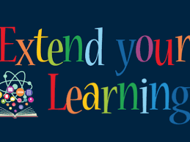
Documentaries  / TV | - Panorama, Louis Theroux, Stacey Dooley, Mind of a Murderer etc  - I, Daniel Blake (Amazon Prime)  - Years and Years (BBC i-player)  - The ‘Up’ series (eg. 56 Up, 63 Up - on Netflix or Youtube)  - The Secret Life of 5 year olds (Channel 4 series)  - McMafia (Netflix)  - Freedom Writer’s Diary (Amazon Prime)  - When They See Us (Netflix)  - The Society (Netflix)  - Love, Simon (Amazon Prime)  - Ted Talks/Sociology (online)  - Made in Dagenham (BBC iPlayer)  - Wonder (Netflix)  - The Wife (Netflix)  - Growing up Gifted (iPlayer)
Links to documentaries | Poor Kids: Life on the Breadline (Child Poverty Documentary) | Real Stories  www.ted.com/talks?topics%5B%5D=sociology BBC Panorama  www.bbc.co.uk/programmes/topics/Sociology_of_culture  Black Mirror www.channel4.com/programmes/dispatches
Books | - Brave New World – Aldous Huxley  - Animal Farm – George Orwell  - 1984 – George Orwell  - Educated – Tara Westover  - Invisible Women – Caroline Criado Perez  - Chavs: The Demonisation of the Working Class – Owen Jones  - The Establishment and How They Get Away With It – Owen Jones  - Natives - Akala  - The Handmaid’s Tale – Margaret Atwood (also a series)  - Vox – Christina Dalcher  - The God Delusion – Richard Dawkins  - Outsiders: Studies in Sociology of Deviance – Howard S Becker  - Folk Devils and Moral Panics – Stanley Cohen  - A Glasgow Gang Observed – Patrick James  - Gang Leader For A Day – Sudhir Venkatesh

Sociology is everywhere so you’ll be able to see aspects of it in all forms of media. Try searching for the following titles and make notes on any videos you watch, try to keep it relevant to the topics taught in Sociology (Education, Families, Beliefs, Crime and Deviance)

- What did you learn about society?
- How does the programme link to the topics you will be studying?
- Stacey Dooley documentaries (BBC iplayer/YouTube)
- Black Mirror (Netflix) – Nosedive episode
- School Swap documentary (4OD)
- Louis Theroux documentaries (Netflix)
- Dispatches documentaries (40D)
- Panorama documentaries (BBC iplayer)

Watching & Application
Optional: Extension Summer Work

SIXTH
FORM
CROSSLEY
HEATH
THE
Podcasts | http://podcasts.ox.ac.uk/series/department-sociology-podcasts https://www.spreaker.com/show/the-sociology-show  www.anchor.fm/allsociology www.measureradio.libsyn.com/podcast

Websites | - www.theguardian.com/education/sociology www.nytimes.com/topic/subject/sociology  - www.tutor2u.net/sociology/blog www.nortonbooks.typepad.com/everydaysociology/  - www.soc.washington.edu/news  - www.sociologysal.blogspot.com www.gendersociety.wordpress.com www.creativesociology.blogspot.com  - www.sociologylens.net www.blogs.lse.ac.uk/impactofsocialsciences/  - https://revisesociology.com/ https://www.senecalearning.com/ https://www.tutor2u.net/sociology  - https://www.aqa.org.uk/subjects/sociology/as-and-a- level/sociology-7191-7192  - https://thesociologyguy.com/a-level-sociology/  - https://www.youtube.com/channel/UC6VpoZj33Df_rNb8KymC czw  - https://napierpress.com/
Online courses | - Intro to Sociology (New York University): https://www.courses.com/new-york-university/intro-to- sociology  - Introductory sociology (Indian Institute of Technology, Kanpur): https://www.courses.com/indian-institute-of- technology-kanpur/introductory-sociology  - Foundations of modern social theory (Yale University): https://www.courses.com/yale-university/foundations- of-modern-social-theory  - Reading Marx’s Capital (City University, NY): https://www.courses.com/city-university-of-new- york/reading-marxs-capital  - What do we mean by ‘family’ (intermediate): https://www.open.edu/openlearn/society-politics- law/sociology/what-do-we-mean-family/content-section- 0?active-tab=description-tab  - ‘Problem’ populations, ‘problem’ places (intermediate): https://www.open.edu/openlearn/society-politics- law/sociology/problem-populations-problem- places/content-section-0?active-tab=description-tab  - https://www.open.edu/openlearn/people-politics-law/politics-policy-people/sociology/childrens-rights/content-section-0?active-tab=description-tab  - Social problems – who makes them (intermediate): https://www.open.edu/openlearn/people-politics- law/politics-policy-people/sociology/social-problems- who-makes-them/content-section-0?active- tab=description-tab  - Identity in question: https://www.open.edu/openlearn/people-politics- law/politics-policy-people/sociology/identity- question/content-section-0?active-tab=description-tab  - Social construction and social constructionism (intermediate): https://www.open.edu/openlearn/people-politics- law/politics-policy-people/sociology/social-construction- and-social-constructionism/content-section-0?active- tab=description-tab  - Understanding economic inequality: https://www.open.edu/openlearn/society-politics- law/understanding-economic-inequality/content-section- 0?active-tab=description-tab  - Beyond the ballot – Women’s rights and suffrage from 1866 to today: https://www.futurelearn.com/courses/womens-rights  - Understanding gender inequality: https://www.futurelearn.com/courses/understanding- gender-inequality  - Religion and conflict: https://www.futurelearn.com/courses/religion-and- conflict  - Why religion matters – religious literacy, culture and diversity: https://www.futurelearn.com/courses/why- religion-matters  - Gender representation in the media: https://www.futurelearn.com/courses/gender-and-the- media

SIXTH
FORM
CROSSLEY
HEATH
THE
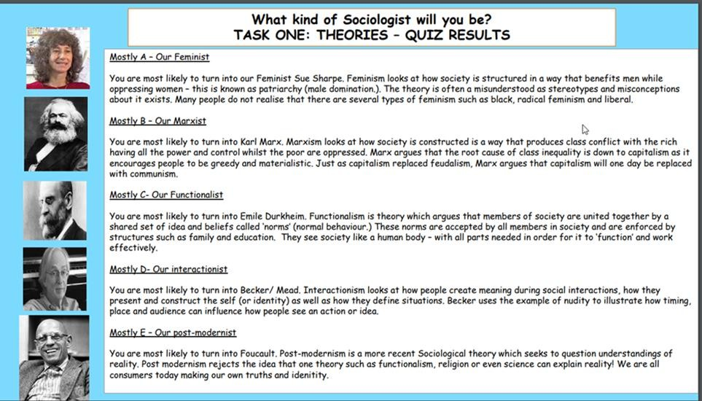
Answers to the sociological perspective quiz

