

SIXTH
FORM
CROSSLEY
HEATH
THE

Welcome!
Thank you for opting to study A-level Psychology at the Crossley Heath Sixth Form in September, we are excited to meet you. Prior to the start of the course, it is extremely important for you to conduct some work at home to prepare you for the extent of your A-level studies. The work that you will complete will not be specifically part of the specification, but will be background work to ensure you have some insight into the subject. As psychology is a new subject to most of you, conducting some research in the area is vital so that you can have a better idea about what you will be studying for the next two years. Psychology is an interesting and innovative subject, allowing you to look at a wide range of topics from a variety of perspectives, using studies and theories to develop a clear understanding of human behaviour. One feature of studying at A-level is that you are regularly required to work independently to support your studies.

It is important to remember that psychology is a science which involves observing behaviours and looking for explanations as to why these behaviours takes place. It is very important for you to keep up with the news and current affairs as advancements in the subject are occurring continuously and you must be able to apply this to your studies. There is also an application objective required in the exam and this is often reflected in the news and current issues.

This work is the first of two tasks that will be sent out to you over the course of the next couple of months. We trust you will aim to complete each of the tasks to the best of your ability and look forward to discussing them with you.

Mrs D Drucquer
(Department Leader for Psychology & Teacher of Sociology)

Mrs L Jones
(Teacher of Psychology & Sociology)

Miss Azam
(Teacher of Psychology & Department Leader for Sociology)
Link to Specification: https://cdn.sanity.io/files/p28bar15/green/5e92a1d5d836855e00d9347aad46698796c2bf04.pdf
Exam Board and Specification: AQA A-level Psychology (7182)
A-Level Psychology
Bridging
work

SIXTH
FORM
CROSSLEY
HEATH
THE
Subject Specific Terminology

There are a range of different approaches in psychology. We would like you to research and get down some information in the table provided. You should aim to spend about 20 minutes on each one.
 | Main assumptions | Study/Theory | Strengths | Limitations
Behaviourist
Approach
Social Learning
Approach

Task 2: Research (1 hour 40 minutes)
https://www.tutor2u.net/psychology/reference/research-methods-key-term-glossary

What is psychology?
Reliability
Internal Validity
External Validity
Ethical issues

Task 1: Find the definitions for the following (20 minutes)
 | Main assumptions | Study/Theory | Strengths | Limitations
Biological Approach
Cognitive Approach
Psychodynamic Approach
Humanistic Approach

https://psychologyalevel.com/aqa-psychology-revision-notes/approaches-in-psychology/

Task 3: Experimental Methods (1 hour)
Find out about the different experimental methods in psychology and document them in the table below:
https://www.savemyexams.com/a-level/psychology/aqa/17/revision-notes/7-research-methods/experiments-types-and-design/types-of-experiment/
https://www.simplypsychology.org/experimental-method.html
https://psychologysorted.blog/wp-content/uploads/2019/04/caspi-et-al._2003.pdf

SIXTH
FORM
CROSSLEY
HEATH
THE

 | Definition | Example | Strength/Limitation
Lab Experiment
Field Experiment
Natural Experiment
Quasi Experiment

There are certain terms that you should already be familiar with before staring the course.

Refresh your knowledge by completing the table below:
Task 4: Knowledge Recall (30 minutes)

SIXTH
FORM
CROSSLEY
HEATH
THE
https://www.tutor2u.net/psychology/reference/research-methods-key-term-glossary

Hypothesis:
Directional
Non-directional
Independent Variable
Dependent Variable
Mode
Median
Mean
Range
Standard Deviation
Correlations:
Positive/Negative
Scattergram
Bar chart
Histogram

Useful websites:
www.aqa.org.uk www.tutor2u.net www.psychboost.com

www.bps.org.uk www.simplypsychology.org https://www.ted.com/
I hope you found the first set of work interesting and it has given you a taste of what psychology is like. We are looking forward to seeing the work you have completed, your opinions and your conclusions.

On the following pages are the tasks we would like you to complete for the second part of this work. These focus on some of the most influential people from the world of Psychology, taking into account their ideas, as well as wider theories, debates and issues which you will be addressing throughout the next two years.

Bridging
work

SIXTH
FORM
CROSSLEY
HEATH
THE
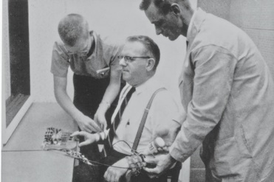
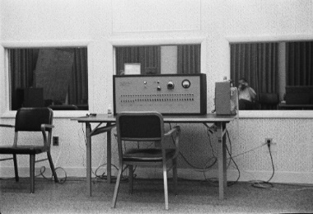
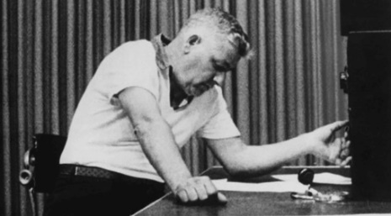
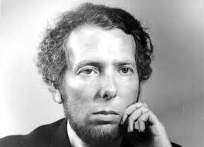
Use this link as a starting point for your research: https://www.youtube.com/watch?v=3YOox59J0Bk

What was the focus of this study?
Who was involved?
What were the participant asked to do?
What were the results?
What conclusions did Milgram draw?

Stanley Milgram
Task 1: Research the following person and complete the table below
Task 2: Protecting participants (15 minutes)

Although Milgram’s obedience study was judged to be ethical at the time of publication, it would be in violation of the strict ethics guidelines in place today.

In the UK the BPS (British Psychological Society) has produced a set of guidelines to ensure that participants are protected.

Using the link select two points from their guidance, explaining why you think it is included in the guidelines.

https://explore.bps.org.uk/content/report-guideline/bpsrep.2021.inf94

SIXTH
FORM
CROSSLEY
HEATH
THE
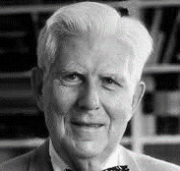
Use this link as a starting point for your research: https://senecalearning.com/en-GB/revision-notes/a-level/psychology/aqa/4-1-6-depression-cognitive-approach

What, according to Beck, is a negative self-schema?
What, according to Beck, is faulty information processing?
What did Beck mean by the negative triad? How does it explain depression?

Task 3: Aaron Beck and his explanation of depression (45 minutes)

Beck’s cognitive theory of depression suggests that depression is as a result of negative thoughts and views. Depression is triggered a “cognitive vulnerability” (negative and maladaptive thinking) and by stressful life events.

Beck's cognitive theory of depression is one of the most well-known.

Beck theorised that depression-prone people possess negative self-schemas. These lead to dysfunctional thoughts about the self, the world, and the future. It is likely that they develop early in childhood in response to stressful or negative life events.

Guideline | Why is it included?

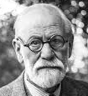
According to Freud there are three innate parts of the human personality: the id, ego, and superego.
- the id is the primal, instinctual part
- the ego is who you are and mediates between the id and superego
- the superego is governed by morals, pushing for perfection

Task 4: Sigmund Freud and his explanation of depression

SIXTH
FORM
CROSSLEY
HEATH
THE
Determinism

Free will

or

Is our behaviour inevitable or can we make our own choices? If it is inevitable, is this because of our nature or our nurture?

Complete the diagram below, explain what each one is in terms of psychological debate.

Task 5: Why do we behave this way? (30 minutes)
Use this link as a starting point for your research: https://psychcentral.com/depression/was-freud-right-about-depression-and-guilt#freuds-theory

Outline Freud’s explanation for depression. You should consider an individual’s innate personality, childhood and the role of their parents in your answer.

SIXTH
FORM
CROSSLEY
HEATH
THE
Follow the link for a useful starting point: https://studyrocket.co.uk/revision/a-level-psychology-aqa/psychology-in-context/issues-debates

Nature


Making reference to his explanation of depression, do you think Freud would say human behaviour is determined or down to free will? Justify your answer.

Task 6: Which side of the debate? (15 minutes)
or
Nurture

Task 6: Which side of the debate? (15 minutes)

SIXTH
FORM
CROSSLEY
HEATH
THE


Making reference to his explanation, do you think Freud would say depression is a result of nature (innate drives and genes) or nurture (our environment and experiences)? Justify your answer.

