So when do I start then?
A-Level Politics
SIXTH
FORM
CROSSLEY
HEATH
THE
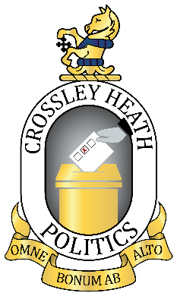
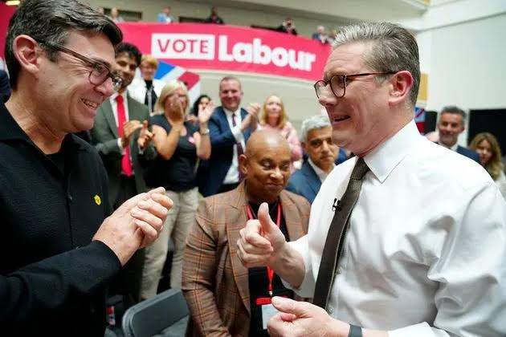

If you are curious and critical, care passionately about the state of the world whilst being able to see two sides of an argument, you will find Politics A Level exciting and rewarding.

The more active you are, the more you will get from the course. This bridging work guides you through some ways you can engage with politics and current affairs before September.

Maybe you love the detail of how government works; or perhaps the big visions of the political ideologies excite you; or maybe there’s a particular issue that fires you up, such as justice, peace or access to common fisheries. In this booklet, you have a chance to explore some of the ideas and topics that we will cover in depth next year.

Miss R Twort
(Department Leader for Politics)

Mr P Smith
(Teacher of Religious Studies & Politics, Head of Yr9)

What to expect
Although, essay writing is the main way in which you will be formally assessed in Politics, the lessons will be largely discussion-based and you will learn how to construct a supported argument.

Alongside the written skills, you will develop your research skills; you will learn how to find relevant evidence and to use this to produce a persuasive case.

You will develop your evaluation skills and learn how to weigh up the strength/s of different opinions.

Above all, you will learn how to think critically; how to question and debate; how to make judgments and how to weigh up evidence to reach a logical, supported and justifiable conclusion.

What you will study

Module 1 is UK Politics. This covers how people participate in politics: the role of elections and the effectiveness of different electoral systems; political parties; pressure groups and social movements, e.g. Extinction Rebellion; the role that referendums have increasingly made in decision-making and how democratic British politics is. You will also study the Core Ideologies: Liberalism, Conservatism and Socialism.

Module 2 is UK Government. This covers how the British government is organised and the features of the different branches of government (PM, cabinet, Parliament, judiciary – courts, devolved assemblies and parliaments, constitution and sovereignty). You will study an Optional Ideology – a choice between Anarchism, Feminism, or Nationalism.

Module 3 is Global Politics which you will study in Year 13. It covers global governance on many levels, including: rights, development, environment, conflict. You will also study theories of International Relations.

Exam Board and Specification: Edexcel A-Level Politics
Link to Specification: https://qualifications.pearson.com/content/dam/pdf/A%20Level/Politics/2017/Specification%20and%20sample%20assessments/A-level-Politics-Specification.pdf
Task 3: Follow, subscribe…
Task 2: Your MP
Task 1: Your interests and motivation

On whichever social media platforms you use, follow or subscribe to podcasts, newsletters, tweets etc of political parties, news sources etc. See the last page of this booklet for some ideas.

What issues interested you this summer? How were they presented and communicated in the media and on social media? Summarise here what happened, why it interested you, its significance and how it was communicated and presented:

Use this website to find out about your local MP: https://members.parliament.uk/FindYourMP

Have a look at their voting record on key issues. To what extent do you agree with their voting choices? For example, look at their voting record on VAT on Independent Schools, Winter Fuel Payments, or Terminally Ill Adults (End of Life) Bill.

Are there any particular issues or ideas that motivate you to act? For example, you may feel passionately about women’s reproductive rights, or about climate change, or about access to sports facilities.

SIXTH
FORM
CROSSLEY
HEATH
THE
Bridging
work

Look at the below photographs of British politicians. You must identify who they are, which party they belonged to and whether or not they were Prime Minister (PM) or Leader of Her Majesty’s Opposition (HMO). Get your family involved in this task – your parents will remember many of these faces, and some of them might be better suited even to your grandparents!

Task 4: People in Politics
Task 4: Finding out about the UK Parliament
Task 4: Finding out about the UK Parliament

Link to Specification:
SIXTH
FORM
CROSSLEY
HEATH
THE


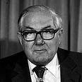
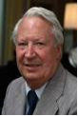
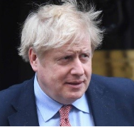
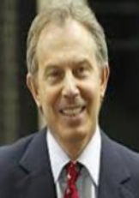

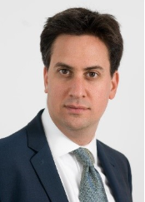
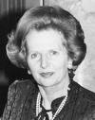
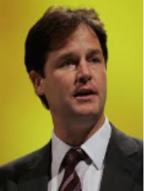



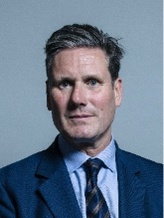
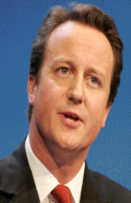
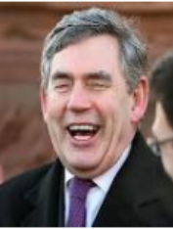

SIXTH
FORM
CROSSLEY
HEATH
THE

Watch this summary video (https://www.youtube.com/watch?v=JlQ5fGECmsA) on the political spectrum and add political parties to the spectrum. Are there any new Political parties not mentioned in the video that you can add? Now place yourself on the spectrum – where might you fit and why?
Task 5: Finding out about the political spectrum

Left wing
Right wing

Go to these links here for the UK’s three major parties:

https://www.bbc.co.uk/news/election-2019-50524262
https://www.bbc.co.uk/news/election-2019-50501411
https://www.bbc.co.uk/news/election-2019-50459123

These links summarise their key manifesto policies in the 2019 general election, which you may remember voting in at school. I would like you to choose a few policies of your choose and explain below why you support OR do not support that policy. You must choose at least 1 policy from each manifesto to discuss your agreement to or opposition to (therefore compulsory is to do 3) – if you want to extend yourself and go further, you can do more than 3 by copying and pasting the spaces I have provided.
Task 6: Finding out about politics

SIXTH
FORM
CROSSLEY
HEATH
THE

Party: __________________________

Manifesto policy:

Agree/disagree & why:

Party: __________________________

Manifesto policy:

Agree/disagree & why:

Party: __________________________

Manifesto policy:

Agree/disagree & why:

Task 7: Research these terms

SIXTH
FORM
CROSSLEY
HEATH
THE
Term | Explanation
Power
Authority
Legitimacy
Government
Politics
Civil society
Executive branch
Prime minister
Cabinet
Legislative branch
Parliament
House of Commons
House of Lords
Judicial branch
Rule of Law
Westminster Model
Elective dictatorship
Direct democracy
Representative democracy
Constitutional monarchy
Fusion of powers
Separation of powers
Devolution

Here is an example of a Politics A Level exam question:
Evaluate the view that the major parties still remain the dominant force in UK politics.
The major parties are Labour and the Conservatives. The question asks you whether Labour and the Conservatives have got less dominant. Think about how minor parties like Reform and the Greens have had an influence over politics in the UK.
- Write an answer to this question, using examples and evidence from recent politics.
- You should write at least one paragraph.
- You should give an argument and counterargument. Start with the weaker argument before offering your stronger argument.

Task 8: Exam Style Question

SIXTH
FORM
CROSSLEY
HEATH
THE
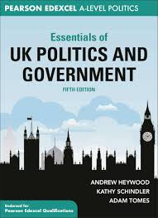
SIXTH
FORM
CROSSLEY
HEATH
THE
Recommended Podcasts:
The Rest is Politics on YouTube – analysis and comment

Oh God what now – UK politics

A Level Politics Show on Spotify

Recommended Publications and Websites:

On Substack – This week in A level Politics
Recommended Reading:

How Westminster Works and Why it Doesn’t by Ian Dunt

Code of Conduct by Chris Bryant

Politics on the Edge by Rory Stewart

The Life of an MP by Jess Phillips
Recommended Films and TV:
Some amazing movies to learn more about political figures, theories and events.
The Iron Lady (2011) – An aged Margaret Thatcher gets nostalgic as she empties her late husband Denis’s wardrobe. She struggles to come to terms with her husband’s passing while also recollecting her political journey.
The Deal (2003) -The relationship between Gordon Brown and Tony Blair upon the death of the leader of the Labour Party.
The Queen (2006) – Queen Elizabeth II tries to deal with a series of events following the death of Princess Diana.
The Special Relationship (2010) – The story of Tony Blair and his relationship with Bill Clinton.
In the Loop (2009) – satirical film about the invasion of Iraq.
Brexit: The Uncivil War (2018) – a drama about the biggest foreign policy decision in recent years.
State of Chaos – a documentary about the 5 Conservative Prime Ministers 2016-2023
Question Time (BBC) – a weekly Q&A show where members of the audience give questions to ministers, politicians, journalists and more. Great for keeping up to date with political developments as they happen.
Politics Live (BBC) – a daily talk show with politicians and journalists, again good for keeping up to date with political events.
Yes Minister (BBC) – a favourite of Margaret Thatcher, this satirical programme looks at the work of the (fictional) Minister of Administrative Affairs.
The Thick of It (BBC) – satirical show about the ins and outs of a government department.
Blair & Brown: The New Labour Revolution (BBC) – a look into the governments of Tony Blair and Gordon Brown.
Four Hours at the Capitol (BBC) – the inside story of the January 2021 Storming of the Capitol.
Politics is fast-changing and complex. Staying abreast of events and developing a critical approach is a key part of Politics A Level and is one of its best features! Subscribe to podcasts, download apps and join the conversations we will have in class.
We will be using the ‘Essentials of …’ series of textbooks as a basis of independent study.
Copies will be available to borrow during Year 12, but you may prefer to have your own copy. The ‘Essentials of Political Ideas’ will be useful after Easter. The ISBN for this is 9781350382398. You can buy it here: https://www.bloomsbury.com/uk/essentials-of-political-ideas-9781350382398/

A-Level Politics
Recommended Reading & Media



