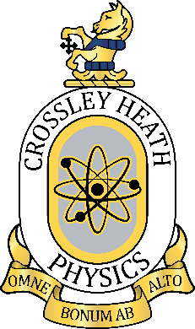

5

SIXTH
FORM
CROSSLEY
HEATH
THE

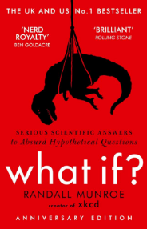
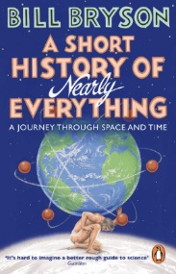
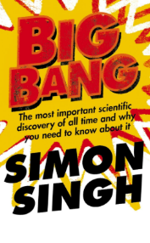
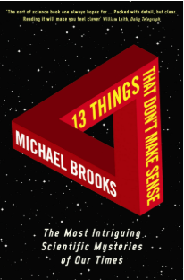
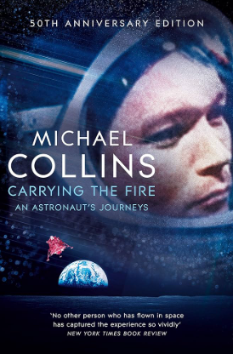
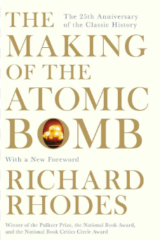
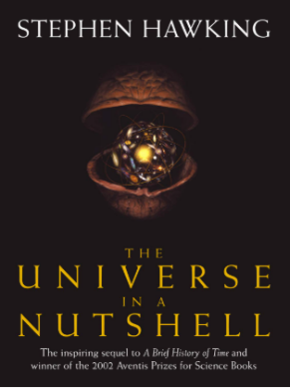
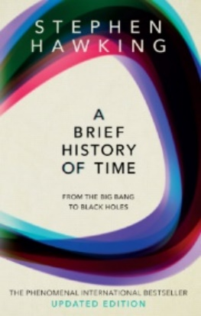
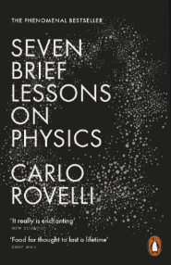
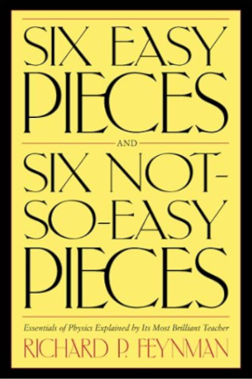
Welcome!
Welcome to A-Level Physics at Crossley Heath School! Get ready for an exciting journey into the world of physics, where you'll explore the fundamental principles that govern our universe. From understanding the behaviour of subatomic particles to the dynamics of celestial bodies, A-Level Physics will challenge your curiosity and expand your understanding of the natural world. Our high performing physics department is here to support you every step of the way as you embark on this amazing course. Get ready to dive into experiments, equations, and the wonders of physics!

This is a highly regarded qualification and Universities and prospective employers view Physics students with great positivity. As a result, Physicists are found working in a huge variety of sectors, ranging from the electronics industry and many branches of engineering through to medical industries and banking and finance.

On the next few pages are four sections that outline some things you can do and some others that you must do in preparation for your A-Level Physics course. Sections 1-3 point you towards some resources to read, watch and try out – every extra bit you invest in your studies now will be a benefit! Section 4 contains instructions for your written tasks which you must complete (4.1 and 4.2) and bring with you in September to hand in. Section 4.3 contains extension tasks that it would be great for you to try.

Mr J Stead
(Associate Assistant Head Teacher/Faculty Leader for Science & Department Leader for Physics)

Mr M Carradus
(Department Leader for Astronomy & Teacher of Physics)

Mr A Mistry
(Teacher of Physics)
Exam Board and Specification: Pearson Edexcel A-Level Physics (9PH0)
Link to Specification: https://qualifications.pearson.com/content/dam/pdf/A%20Level/Physics/2015/Specification%20and%20sample%20assessments/pearsonedexcel-alevel-physics-spec.pdf
A-Level Physics

SIXTH
FORM
CROSSLEY
HEATH
THE
Bridging
work
Once studying for you’re a-Levels you will notice how you are able to link many physics concepts together to explain and model a wider range of natural phenomena. To prepare for this it will help to stand back and see physics in its wider context, and to look in more detail at some areas of physics that you may currently know little about. I consider reading the three books in bold below to be the easiest way for you to do this, and they’re something that would be easy to obtain and simple for you to take away with you on holiday. The books are written at a level that assumes little about your prior subject knowledge but reading them will stretch you into areas that go beyond university level. The other books are also highly recommended.
- A Short History of Nearly Everything by Bill Bryson
- Big Bang: The Most Important Scientific Discovery of All Time and Why You Need to Know About It by Simon Singh
- What if? Serious Scientific Answers to Absurd Hypothetical Questions by Randall Munroe
- Seven Brief Lessons on Physics by Carlo Rovelli
- A Brief History of Time by Stephen Hawkins
- The Universe in a Nutshell by Stephen Hawkins
- The Making of the Atomic Bomb by Richard Rhodes
- Carrying the Fire: An Astronaut’s Journey by Michael Collins (the Apollo 11 astronaut)
- 13 Things That Don’t Make Sense: The Most Intriguing Scientific Mysteries of Our Time by Michael Brooks
- Six Easy Pieces: Fundamentals of Physics Explained by Richard R Feynman (or any other books by this same author)
If you don’t want to pay the full price for the books then they can often be found in charity shops or online auctions, or even visit a library!
1. Do some reading...
Check out these resources for further reading and revision!
2. Do some revision...

SIXTH
FORM
CROSSLEY
HEATH
THE
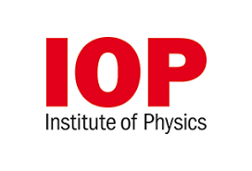
Click this icon for Earth and Space videos


Click this icon to deepen your knowledge


Click this icon for revision activities

3. Explore some physics

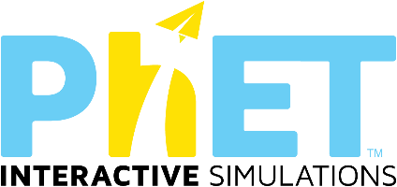
Physics simulations… just because they are fun!

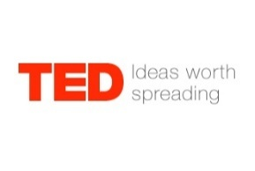
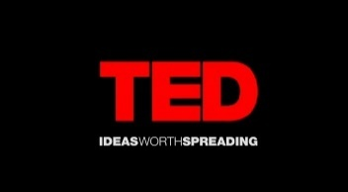



General Physics interest…
Physics videos…
Secondary Physics Crash Course Physics Astronomy Universe
Bridging
work

SIXTH
FORM
CROSSLEY
HEATH
THE
SIXTH
FORM
CROSSLEY
HEATH
THE
4. Written tasks
Complete the tasks outlined in the next 2 parts of the document “Section 1: Mathematics” and then “Section 2: Mechanics”. This is your bridging work – these tasks need doing and bringing to hand in as soon as possible with you to your Physics lessons in September. These tasks will be checked and marked by your new teacher. It will be very important practice for you in preparing to resume your studies!
Section 4.1: Mathematics
Instructions:
Work through the student tasks on each page in this section on Mathematics. Write your answers on lined paper – you will need to hand them in to your Physics teacher in the first or second lesson in September.

Section 4.3: Unstructured Question Practice
Instructions:
These are optional extension questions. You could try them all! You could choose some of each section / theme. These are like the long answer questions and calculations from your physics studies at GCSE. If you tackle them, write your answers on new sheets of lined paper and bring them along to give to your Physics teacher in the first or second lesson in September.

Instructions:
Work through each page in this section on Mechanics. On some pages you are asked to only attempt some of the questions. Write your answers on a new sheet of lined paper – you will need to hand them in to your Physics teacher in the first or second lesson in September. You must complete the page with the title “Questions on Motion” to hand in to your teacher in September.

Section 4.2: Mechanics
Click these links to the documents!

