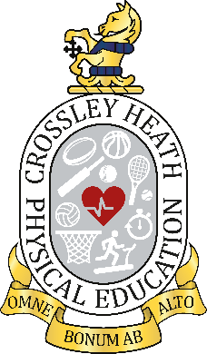

SIXTH
FORM
CROSSLEY
HEATH
THE
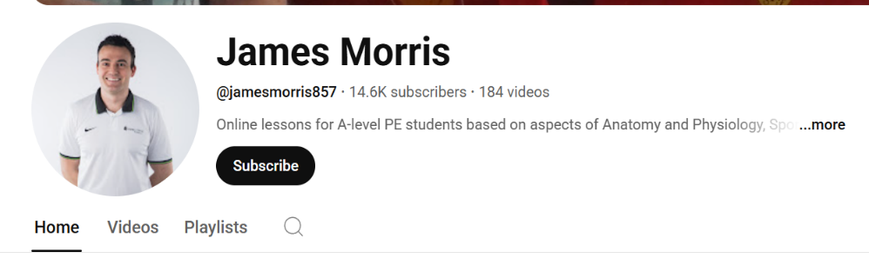

Meet the Team:

Mrs S Hillam
- Head of Department and lead teacher for the Anatomy and Physiology section of the course
Miss B Denton
- Head of Year 12 and lead teacher for the Sport and Society section of the course
Mr C Davis
- School SENCO and lead teacher for the Skill Acquisition section of the course

Read the AQA A-Level Specification (see link below) to understand the course requirements and how you are assessed.

Subscribe to James Morris A-Level PE on YouTube
@jamesmorris857

Things to do before you start the course:
A-Level PE
Link to Specification: https://cdn.sanity.io/files/p28bar15/green/3ce755833757d8a9a172d6050e7c8cf54e6a6467.pdf

Exam Board and Specification: AQA A-Level Physical Education
To complete the work on the next few pages, either print a copy and handwrite it on, or include text boxes over the image files
Weaknesses

Strengths

Write down 2 areas you think will be your strengths and 2 areas you think are your weaknesses

Task 1:
SPORT & SOCIETY
- Pre-industrial > post-industrial > post WWII
- Impact of sport on society > impact of society on sport
SKILL ACQUISITION
- Skill continuums and skill transfer
- Practice
- Theories of learning
- Guidance and feedback
- Memory models
ANATOMY & PHYSIOLOGY
- Cardiovascular system
- Respiratory system
- Neuromuscular system
- Musculoskeletal system and movement analysis
Yr12 Curriculum Content

SIXTH
FORM
CROSSLEY
HEATH
THE
Bridging
work
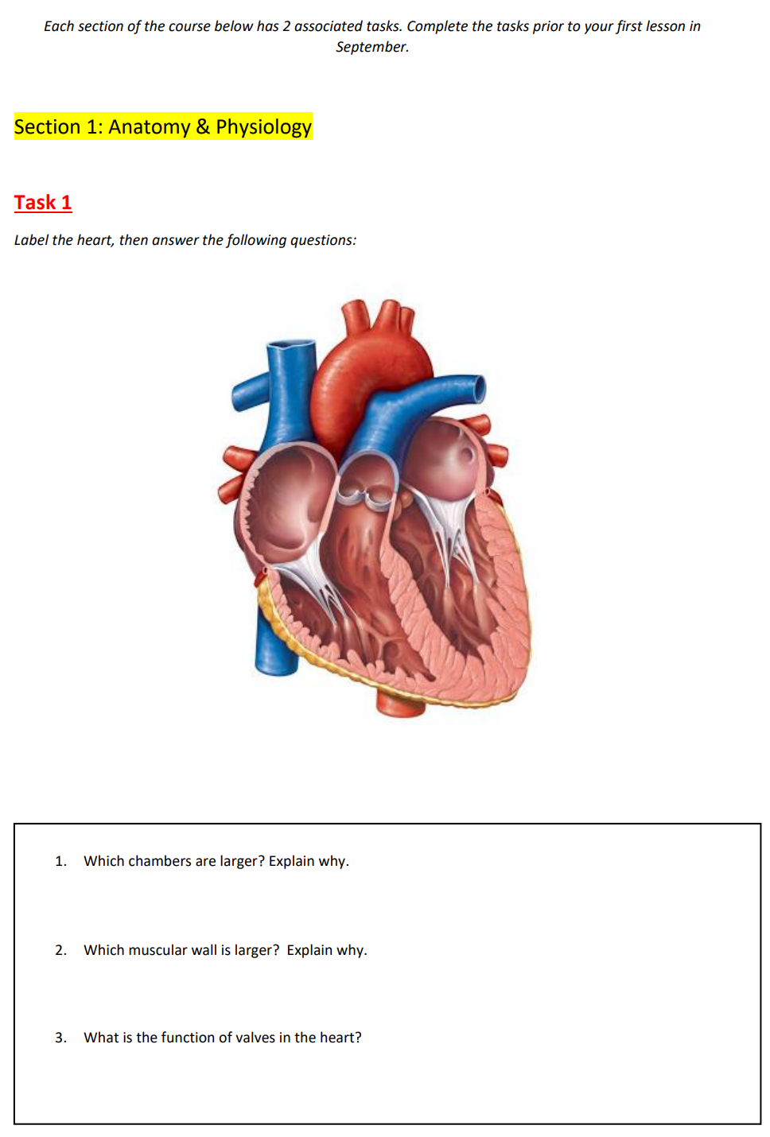

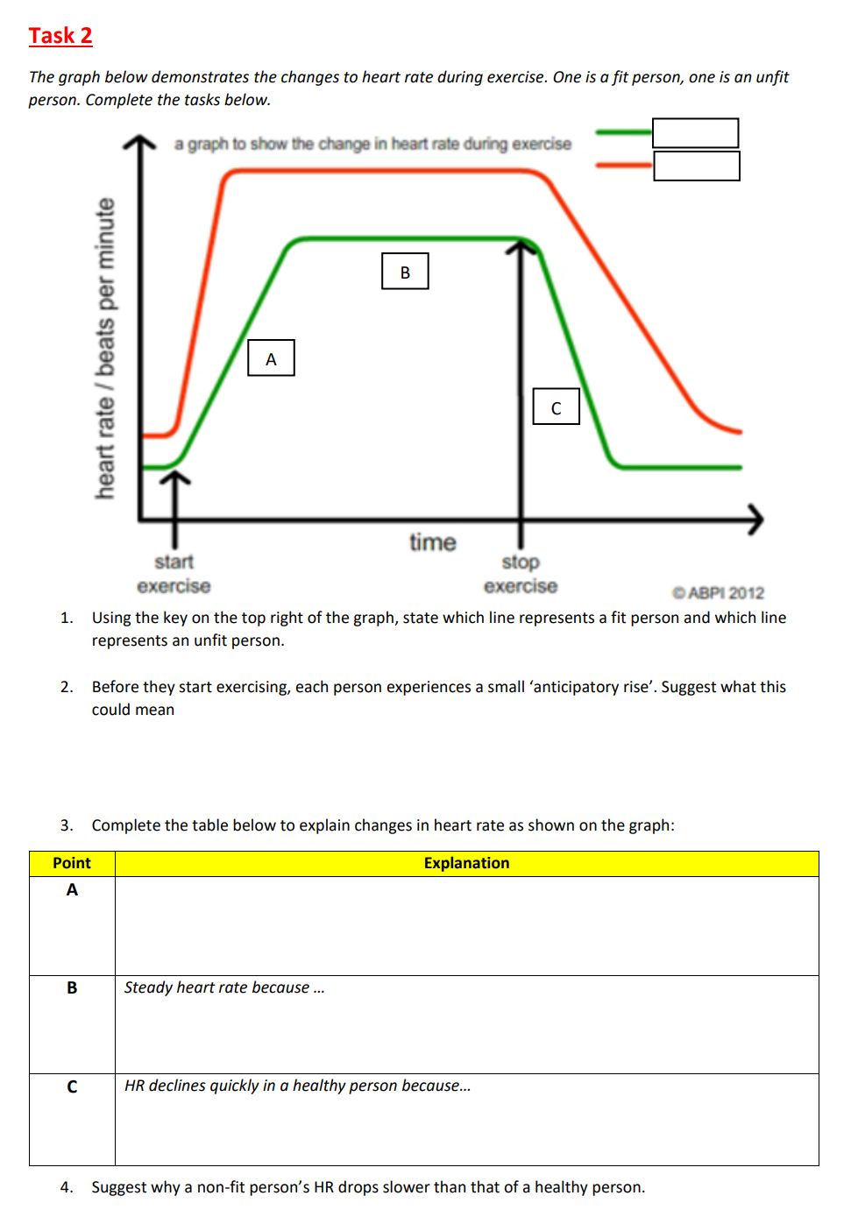

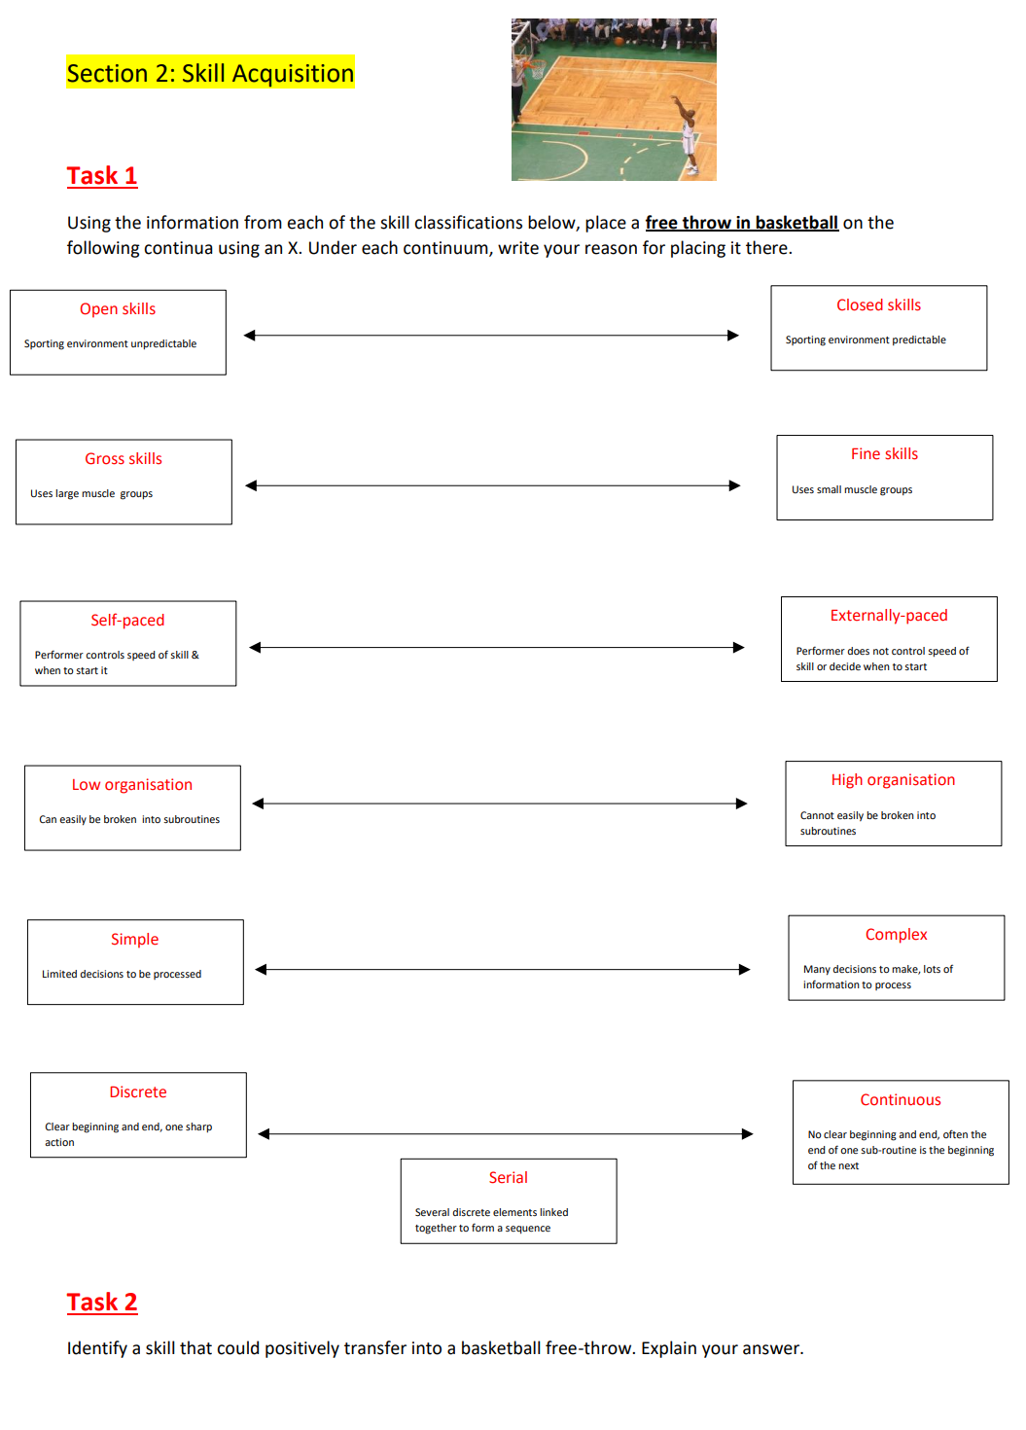

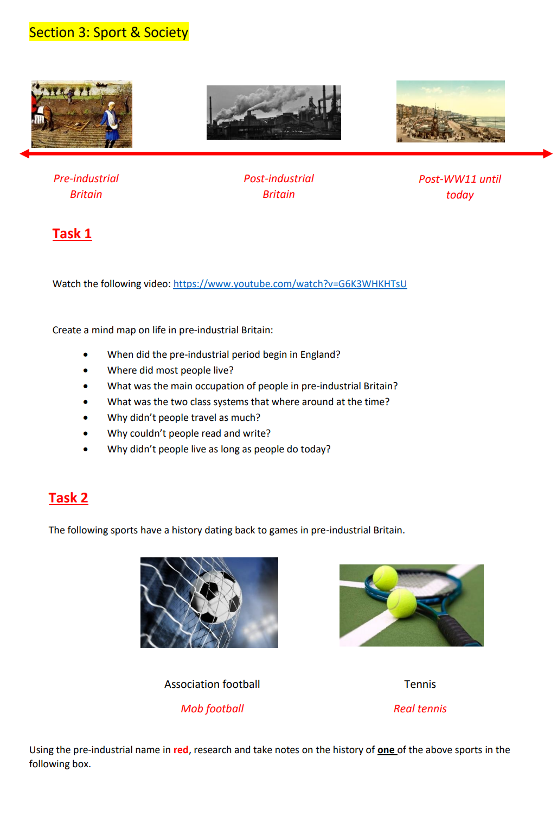

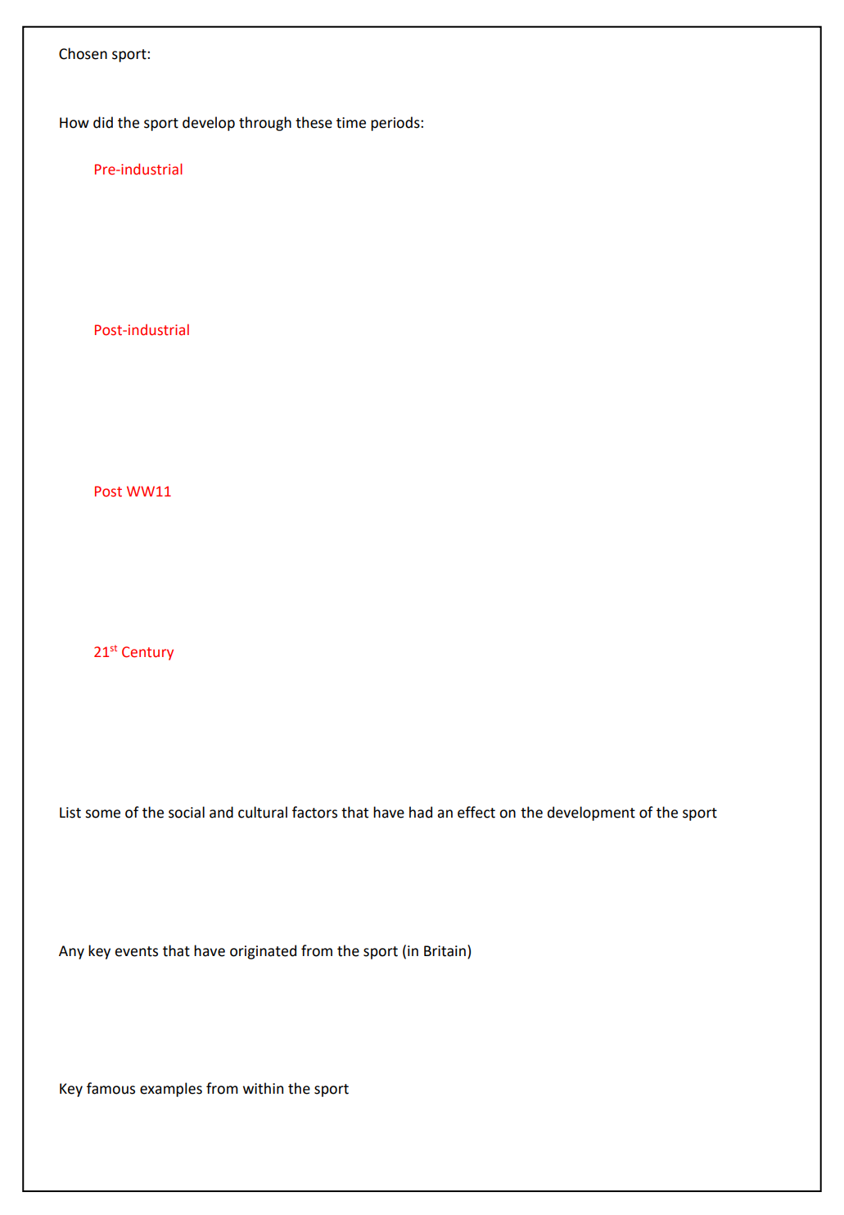

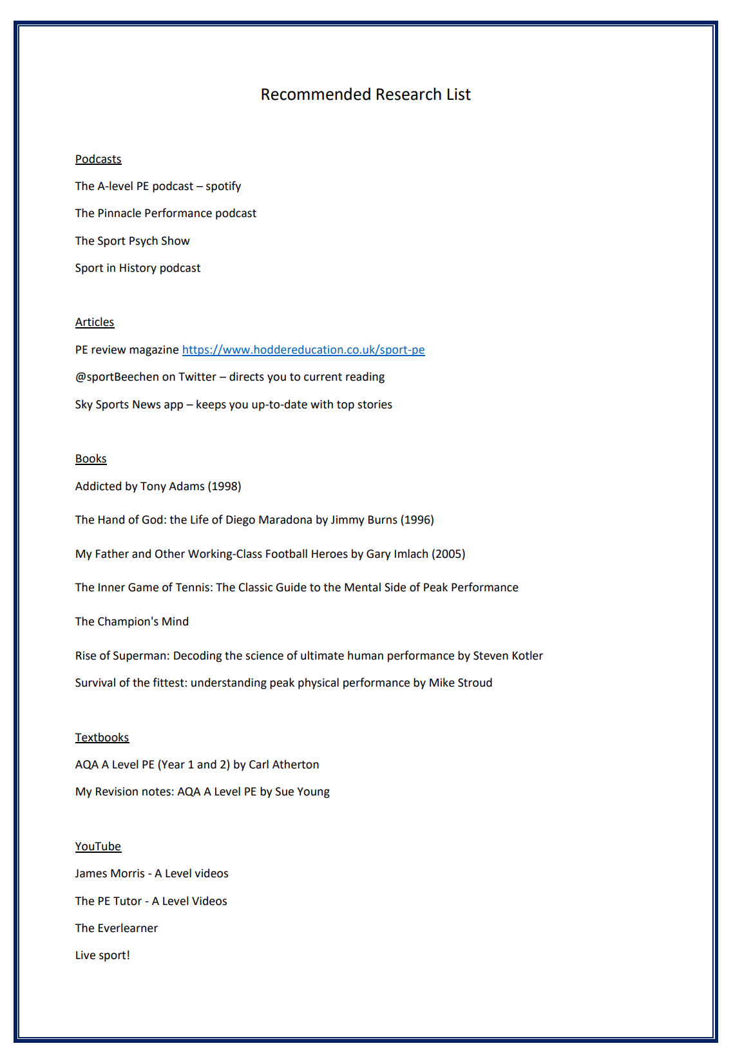

SIXTH
FORM
CROSSLEY
HEATH
THE
PE Education on TV



The English Game
(Sport & Society)
Stop at Nothing
(Drugs & Doping)
The Psychology of Winning (audiobook)
(Sport Psychology)
Is Professionalism killing sport
(Sport & Society)
Coach Carter
(Sport Psychology)
Fitness in Dubai
(Health & Fitness)
The Game Changers
(Diet & Nutrition)
Breaking4
(Fitness)
All or Nothing
(Manchester city and All Blacks documentaries)
The program – Lance Armstrong
(Drugs in sport)

Andy Murray – Resurfacing
(Injury Rehabilitation)
You can write directly into this table
Review Grid
Name of podcast/video/article:
REWORD IT: Use this space to look up any words you don’t know on an online dictionary/thesaurus: | CRUNCH IT: Identify 6 keywords in this podcast/ article/source. Say WHY you have picked these word  1.  2.  3.  4.  5.  6.
SUMMARISE 3 KEY POINTS/LEARNINGS FROM THE SOURCE: | REVIEW IT:  Would you recommend this resource to another person?  Why/Why not?  Key takeaway from the source?  What questions do you still have?

You can write directly into this table
Review Grid
Name of podcast/video/article:
REWORD IT: Use this space to look up any words you don’t know on an online dictionary/thesaurus: | CRUNCH IT: Identify 6 keywords in this podcast/ article/source. Say WHY you have picked these word  1.  2.  3.  4.  5.  6.
SUMMARISE 3 KEY POINTS/LEARNINGS FROM THE SOURCE: | REVIEW IT:  Would you recommend this resource to another person?  Why/Why not?  Key takeaway from the source?  What questions do you still have?

Review Grid
Name of podcast/video/article:
REWORD IT: Use this space to look up any words you don’t know on an online dictionary/thesaurus: | CRUNCH IT: Identify 6 keywords in this podcast/ article/source. Say WHY you have picked these word  1.  2.  3.  4.  5.  6.
SUMMARISE 3 KEY POINTS/LEARNINGS FROM THE SOURCE: | REVIEW IT:  Would you recommend this resource to another person?  Why/Why not?  Key takeaway from the source?  What questions do you still have?

You can write directly into this table

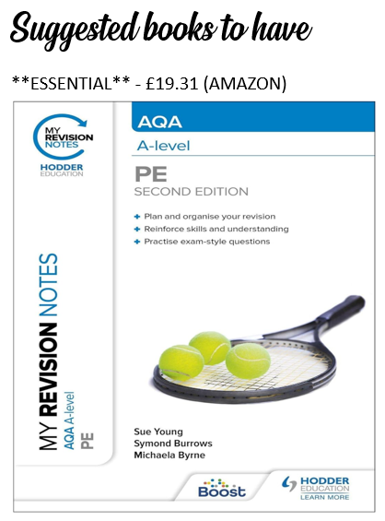

SIXTH
FORM
CROSSLEY
HEATH
THE


