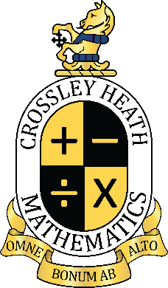

SIXTH
FORM
CROSSLEY
HEATH
THE

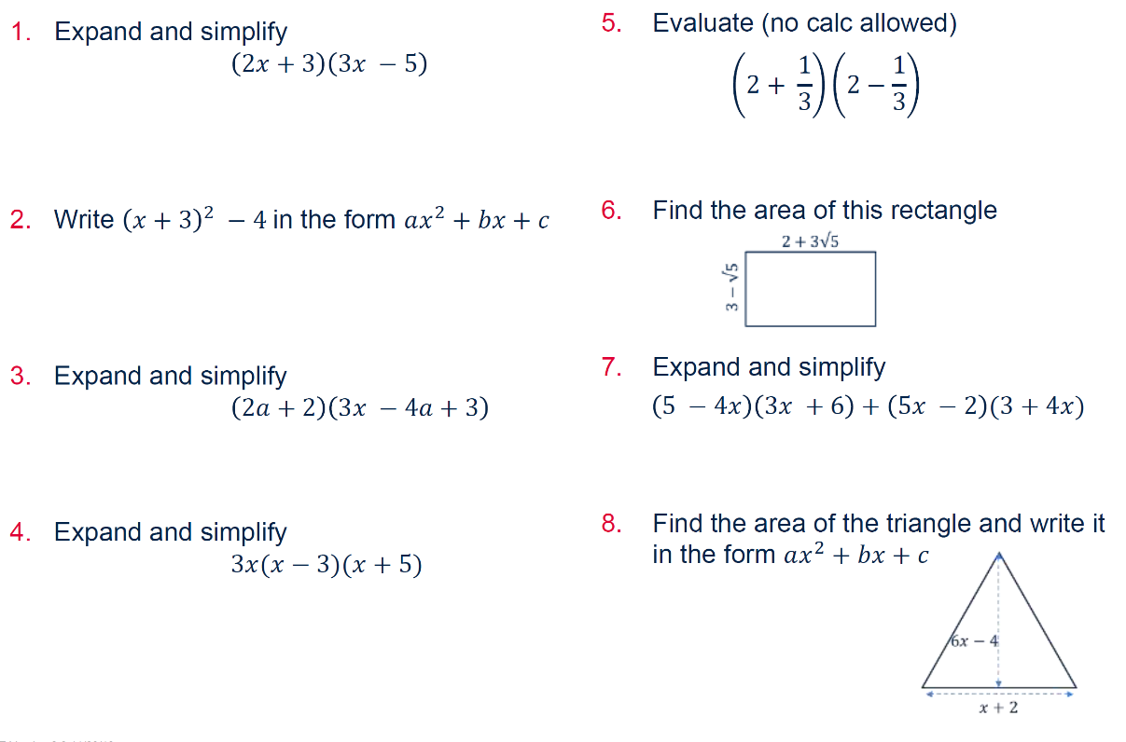
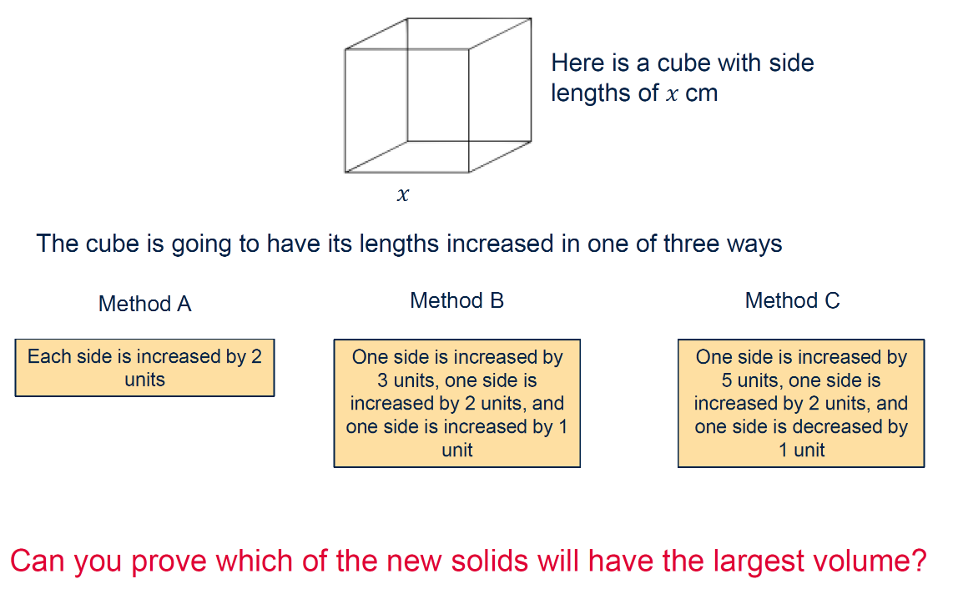
Welcome!
A very warm welcome to The Crossley Heath School Sixth Form, and congratulations on choosing to study A-level Further Mathematics — a truly exciting, challenging, and rewarding subject!

You’ve made a fantastic decision that opens up a world of possibilities. Further Mathematics is not just about solving complex equations; it’s about developing deep logical thinking, creative problem-solving, and analytical skills that are highly valued in many fields. Whether you’re considering a future in engineering, computer science, physics, economics, finance, architecture, or even fields like medicine, law, and data science, Further Maths will give you a powerful edge.

Studying this subject will not only stretch your mathematical ability but also demonstrate to universities and future employers that you’re ambitious, resilient, and capable of tackling advanced concepts — qualities that are essential for success in any career path.

We are genuinely excited to be part of your journey. At Crossley Heath, you’ll be supported every step of the way by a passionate and experienced team who are here to help you grow in confidence, curiosity, and capability. We can’t wait to explore the elegance and depth of mathematics with you and to see all that you’ll achieve over the next two years.

Welcome aboard — the adventure starts here!

The Mathematics Department
Exam Board and Specification: Pearson Edexcel A-Level Further Mathematics (9FM0)
Link to Specification: https://qualifications.pearson.com/content/dam/pdf/A%20Level/Mathematics/2017/specification-and-sample-assesment/a-level-l3-further-mathematics-specification.pdf
Maths
A-Level Further
Section A: Vital Skills
In Further Mathematics, your algebraic skillset is as vital if not even more so than it would be for standard A level mathematicians.

Below is a selection of exercises and puzzles for you to attempt.

Task 1: Expanding brackets (30 minutes)
workspace

SIXTH
FORM
CROSSLEY
HEATH
THE
Bridging
work
You can solve the following problem relatively easily by completing the square on each of the numerators and cancelling down. Work out this without a calculator!
Task 2: Completing the square (15 minutes)

SIXTH
FORM
CROSSLEY
HEATH
THE
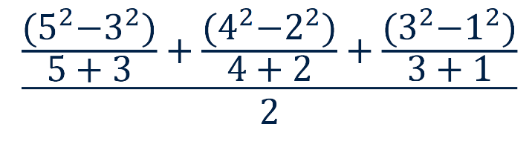
workspace

Task 3: Rearranging formulae (45 minutes)

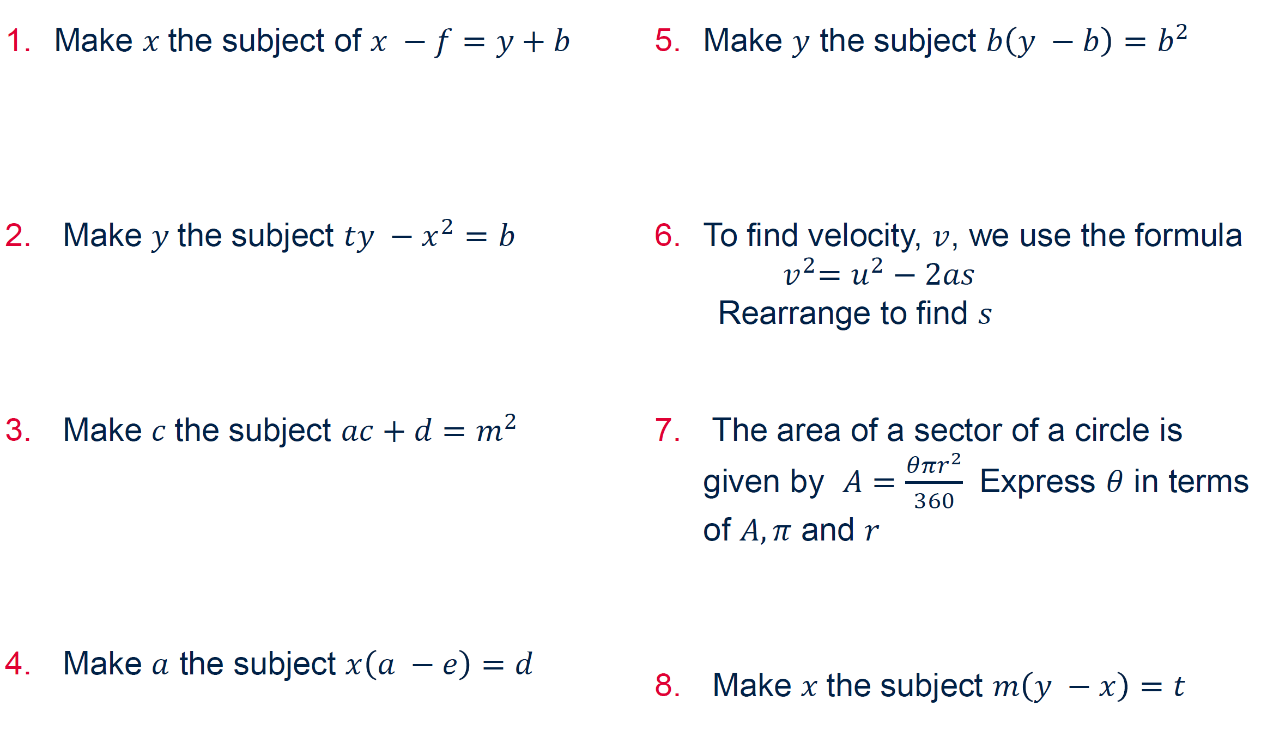

workspace
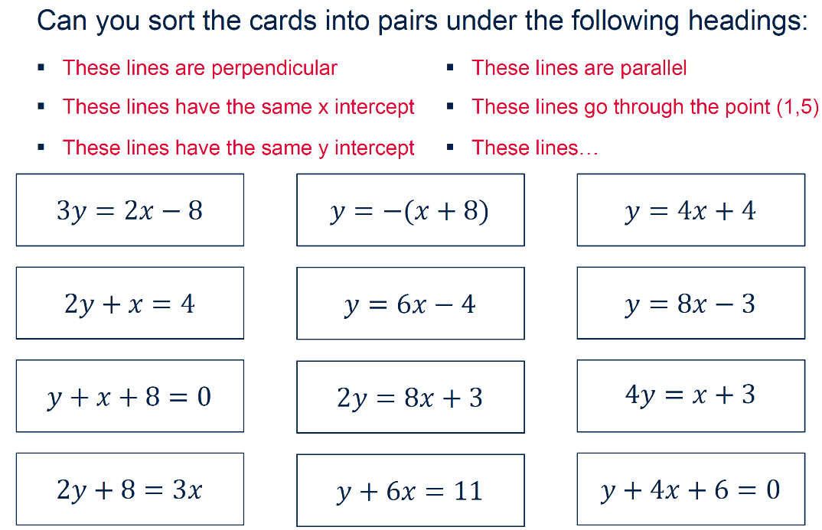
Task 4: Straight line graphs (30 minutes)

SIXTH
FORM
CROSSLEY
HEATH
THE

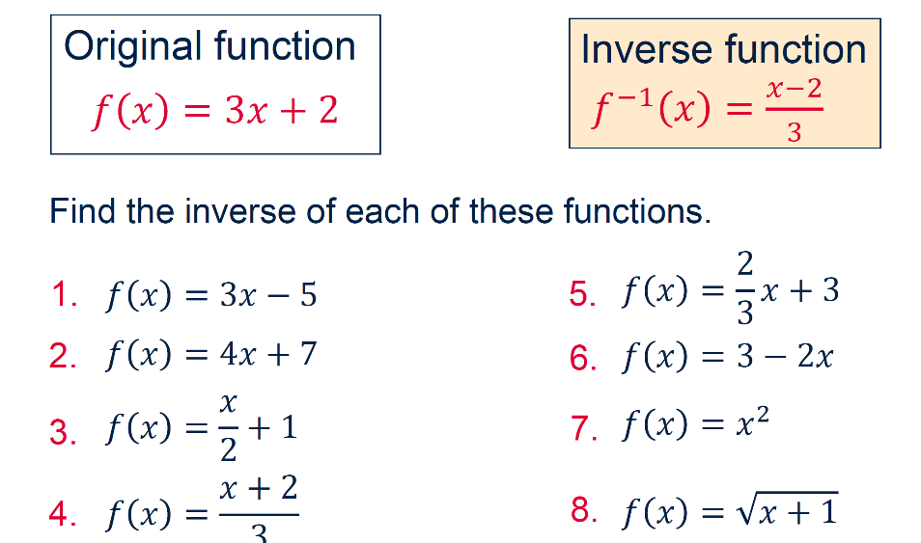
workspace
Task 5: Inverse functions (30 minutes)
workspace
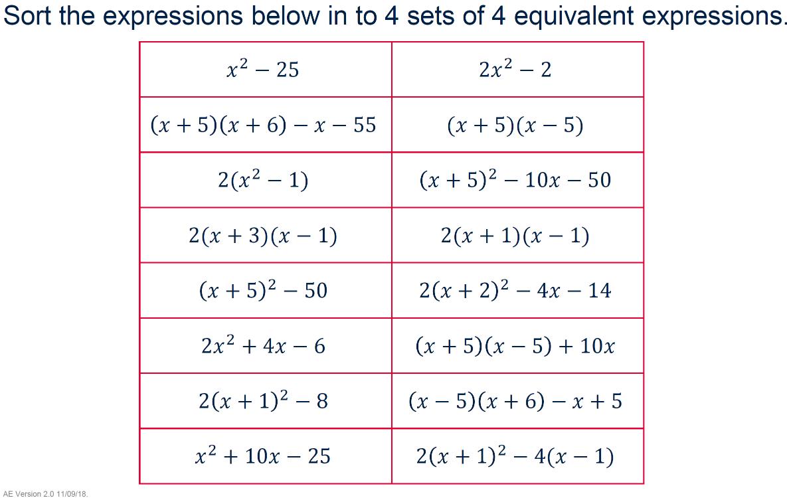

SIXTH
FORM
CROSSLEY
HEATH
THE
Task 6: Equivalent quadratics (30 minutes)
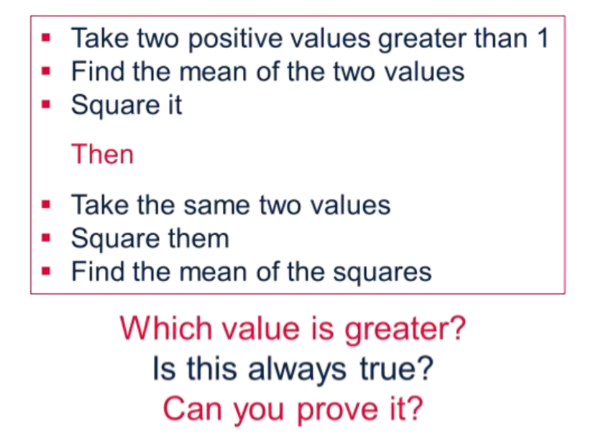
workspace
Task 7: Mean squares (30 minutes)
workspace
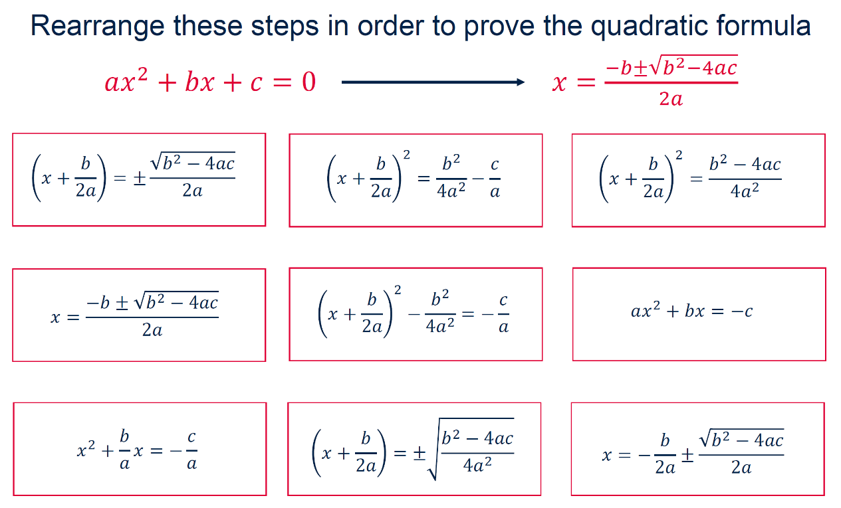
Task 8: Forming the formulae (15 minutes)

SIXTH
FORM
CROSSLEY
HEATH
THE
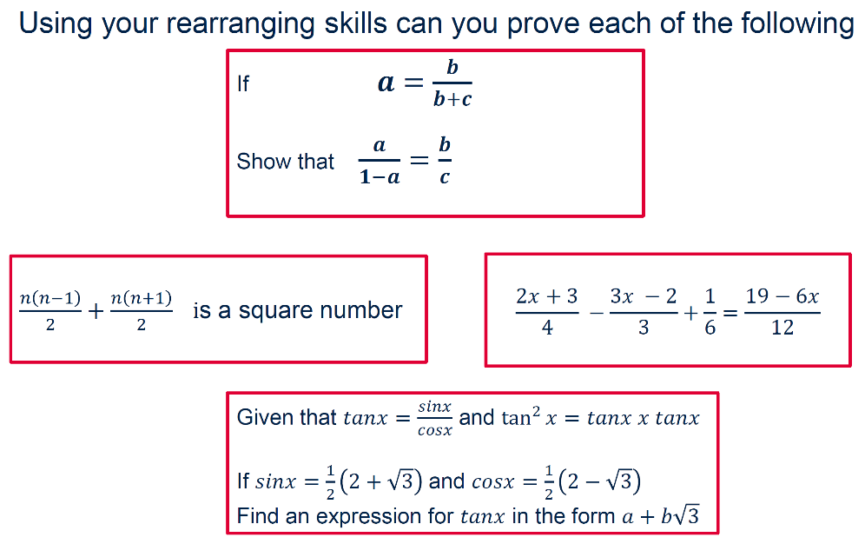
workspace
Task 9: Prove it! (45 minutes)
workspace
Bridging
work

SIXTH
FORM
CROSSLEY
HEATH
THE

Speaking of YouTube, if you want to start learning about more abstract interesting mathematics, start watching videos by Numberphile. This channel has been going for years and trying to follow their videos with massively develop your skills. They are accessible but definitely challenging!
Channel Link - https://www.youtube.com/user/numberphile
Suggested videos
Golden Ratio - https://www.youtube.com/watch?time_continue=480&v=sj8Sg8qnjOg
The scientific way to cut a cake - https://www.youtube.com/watch?v=wBU9N35ZHIw
The sum of 1,2,3,4,… - https://www.youtube.com/watch?v=w-I6XTVZXww

Some rules that you have heard about at GCSE are not quite 100% of the picture.
One example is that you cannot square root a negative number. This is true in the number system you are currently aware about, but it is possible if you broaden the range of numbers you are allowed to work with. These numbers are called complex numbers and you can start to learn about these at the following links.
https://nrich.maths.org/13167
https://nrich.maths.org/13129
https://nrich.maths.org/13131
This is a good starting point but if you want to learn more, then explore the rest of the website and do some research in other places such as YouTube!

Section B: Research Task (4 hours)

