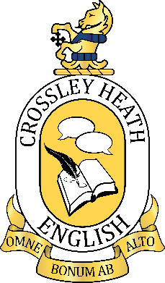


SIXTH
FORM
CROSSLEY
HEATH
THE
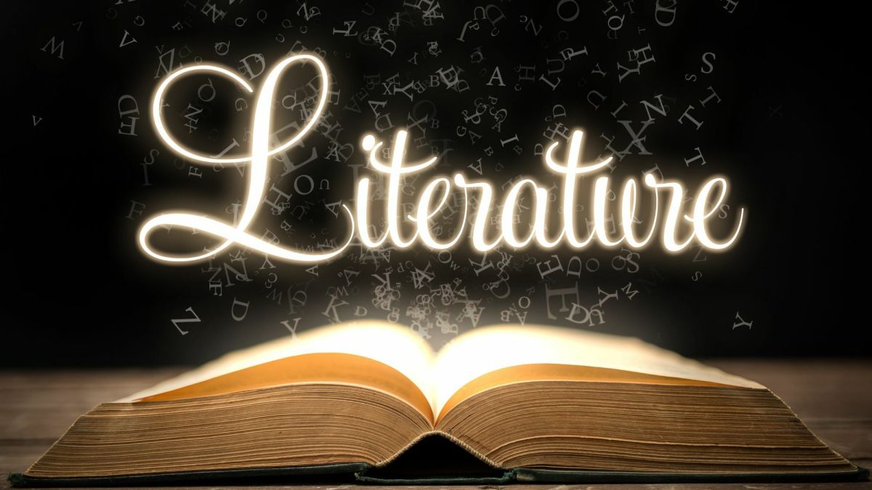
Welcome!
We are so delighted that you are here and reading this. It means that you are joining us soon to study A-level English Literature at Crossley Heath. We have been teaching this course for a while now and totally love it. There’s a great mix of old and new, poetry, drama and prose - something for everyone, we think.
So in the meantime (there’s a Carol Ann Duffy poetry joke in there), here are a range of tasks for you, they are pretty random but fun, in fact quite a Lark(in) – second bad pun.
Enjoy.

Mrs V Johnson
(Department Leader for English)

Mrs Paxman
(Teacher of English)
Link to Specification: https://www.eduqas.co.uk/qualifications/english-literature-asa-level/#tab_keydocuments
Exam Board and Specification: Eduqas A-Level English Literature
A-Level English
Literature
Bridging
work

SIXTH
FORM
CROSSLEY
HEATH
THE

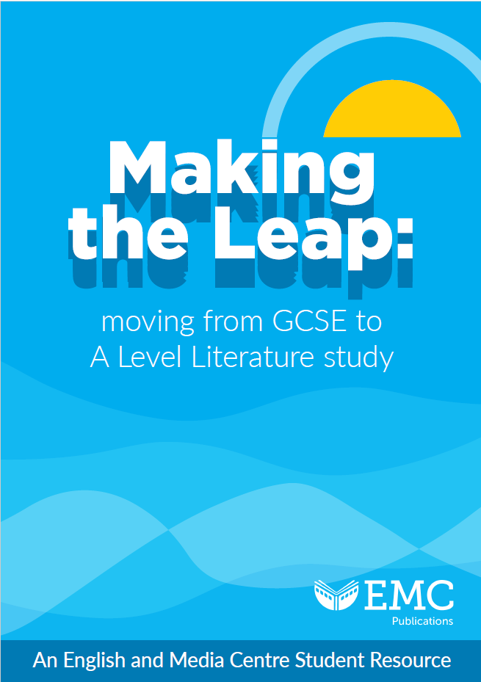
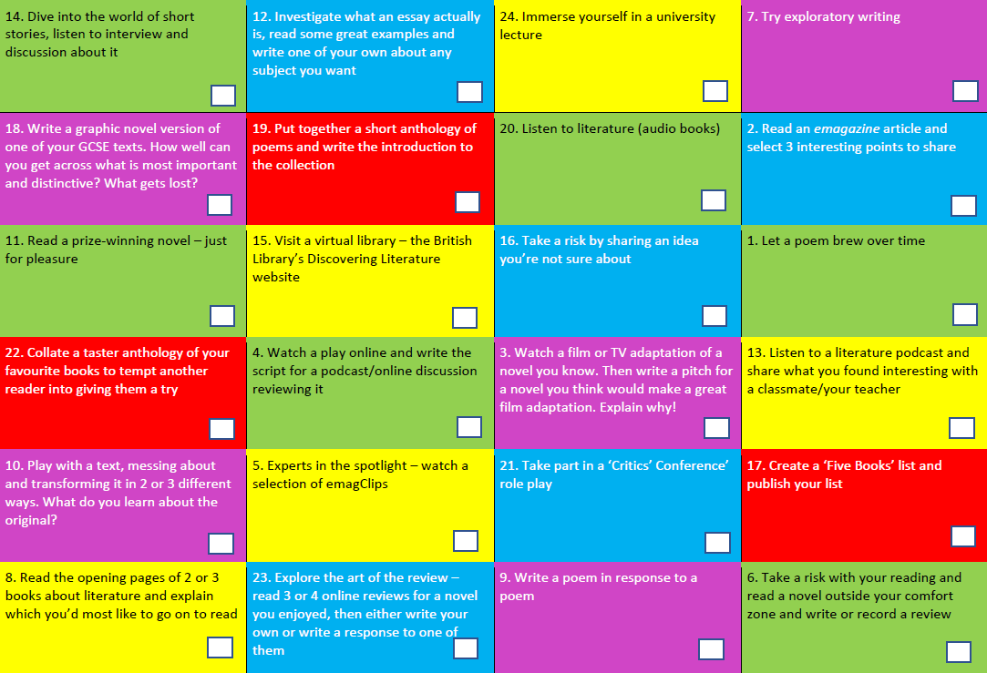
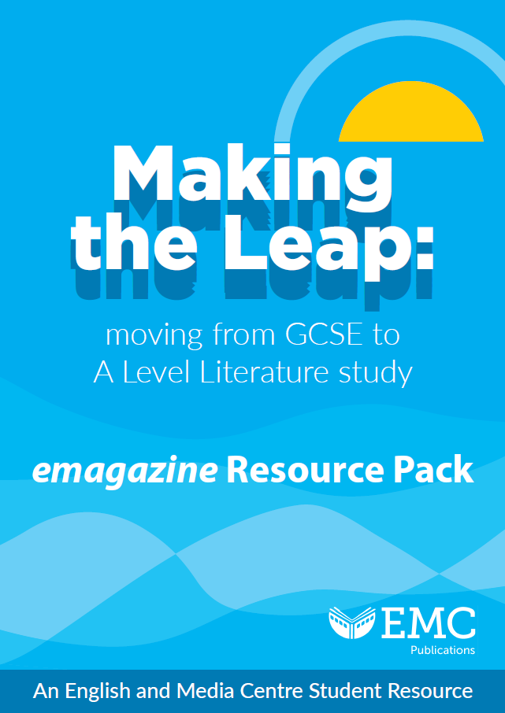
Click here
Making the leap GCSE to A-Level
Click on the linked PDF documents below.
Please pick three and have a go – we will start our first lesson back with a catch up on who tried what and how it went.

