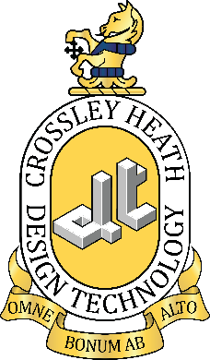

SIXTH
FORM
CROSSLEY
HEATH
THE


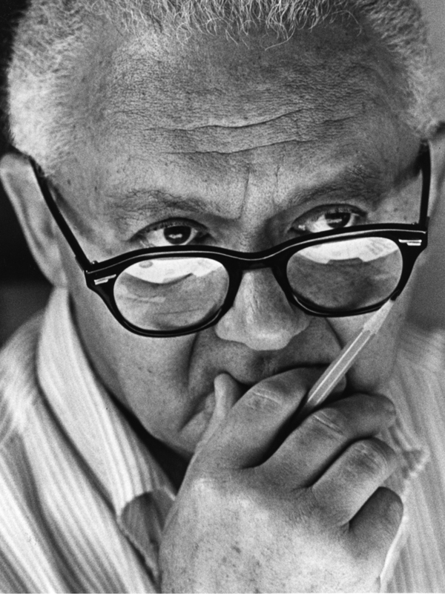
Introduction
Every day we come into contact with a multitude of products from mobile phones to cars, from toothbrushes to the furniture we sit on, every one of these products has been designed to fulfil a specific set of needs, (some that do it better than others!).

Your role as a designer or engineer is to ensure these products improve and enhance our lives by creating safe and sustainable solutions to real world problems.

Through Design Technology you will study design theory, you will build upon and develop the necessary skills to design and make innovative products that respond responsibly to social and environmental issues.

Expectations
Crossley Heath ‘A Level’ DT students benefit from having priority access to our resources and facilities to complete independent study outside of scheduled lesson times.

We expect students to spend at least one study period and one free lesson, each week, to be physically in the department practising and developing the required skills, or to be working on their practical assignments.

We encourage all students to fully immerse themselves within the subject outside of the classroom. To be curious and questioning of their environment, to look at the products around them and ask themselves; - What is it made from? How was it made? How has it been designed to be ergonomic/sustainable/environmentally friendly? How could I improve it?

A good starting point when preparing for the course is to look back through your GCSE coursework and theory folders to highlight your strengths and areas of development to discuss with your new DT teacher.
We also encourage students to practice sketching and presentation techniques in preparation for A Level study

Mrs J McGill (Faculty Leader for Art, Design & Technology)

Mr D Pritchard (Department Leader for Technology)

Mr N Barber (Teacher of Technology)
(Title)
Exam Board and Specification: AQA Design and Technology: Product Design (7552)
Technology
A-Level Design
Link to Specification: https://cdn.sanity.io/files/p28bar15/green/04bdff216c2025e10cdce371578ac885ad55fff7.pdf

“To design is much more than simply to assemble, to order, or even to edit: it is to add value and meaning, to illuminate, to simplify, to clarify, to modify, to dignify, to dramatize, to persuade, and perhaps even to amuse. To design is to transform prose into poetry.” – Paul Rand
SIXTH
FORM
CROSSLEY
HEATH
THE

ESSENTIALS TO BRING TO YOUR FIRST LESSON
Please bring a pen, a HB pencil and lots of enthusiasm for creativity!
Over the next two years, we have a lot to cover, so buckle up and let’s start as we mean to go on.
We would also like you to bring with you in the first week, the below Transition Tasks.
We assume you have chosen DT because you have a keen interest in design, an awareness of your environment, you enjoy making and are outstanding at problem solving, but have you got the desire to exceed expectations and strive for perfection?
SUPPORT
In Design and Technology, we work closely with our students to help them reach their full potential. As a member of our ‘A Level’ course, you are welcome to use our equipment and facilities whenever a member of staff is present.
If you feel that you need additional support in your tasks, or you have a gap in your knowledge, make sure you talk to us about it and we are here to support you in your journey.
AQA ‘A Level’ Design Technology - Product Design, is split into two related areas:
1. Technical principles
2. Designing and making principles

This course builds upon the learning gained through the Design Technology GCSE.
Your final assessments include:
- Two written papers
Paper 1 - Technical principles
A mixture of short answer and extended response questions.
2 hours and 30 minutes, 120 marks, 30% of A-level

Paper 2 - Designing and making principles
A mixture of short answer and extended response questions, Section A: Product Analysis: 30 marks, Section B: Commercial manufacture: 50 marks
1 hour and 30 minutes, 80 marks, 20% of A-level

A non-exam assessment (NEA)
A substantial design and make project, with a digital design portfolio, looking at the practical application of technical principles, designing and making principles. 100 marks, 50% of A-level

Through our practical based learning, we offer students the opportunity to develop knowledge, skills and experience, to be able to produce thoughtful and viable solutions to exciting design problems.
The Course...
Bridging
work

SIXTH
FORM
CROSSLEY
HEATH
THE

Transition Project

Prominent designers and movements have been influential in the design work of others ever since the industrial revolution.
The Exam board states that…
“Students should be aware of, and be able to discuss,
  - key design styles and movements and their principles of design,
  - the work of influential designers and how their work represents the principles of different design movements,”

You should recognise the list to the right.
We would like you to produce a study on any of the listed movements (or designers), that you have an interest in or admiration of.
This should be in detail, including the content mentioned above, as well as examples of the work that inspires you, explaining why. Information about what the social and economic influences were at the time and who their influences were and who has been influenced by them. Trying to link all this together to highlight what they stood for and what was different.
You will be presenting your work to the class in the second week in September.
The study can be in whatever format you think most suitable, however we would like a digital handout that you can give to your class peers, when you present your work.
With detailed research and production time you should aim to complete this in 5-6 hours

Listed examples given:
Arts and Craft movement
Art Nouveau
Art Deco
Modernism, eg Bauhaus
Streamlining​
Scandinavian Design
Minimalism​
Post modernism, eg Memphis.
Phillipe Starck
James Dyson
Margaret Calvert
Dieter Rams
Charles and Ray Eames
Marianne Brandt.

planning space

SIXTH
FORM
CROSSLEY
HEATH
THE

