SIXTH
CROSSLEY
HEATH
THE
Introduction
Biology is an interesting subject to study at advanced level as it provides an understanding of life at all levels from molecules and cells to ecosystems and the biosphere. A good grade in the subject rewards students with the respect of future employers and a wealth of career opportunities. The most challenging part of A level biology is bridging the gap between GCSE and A level work.

The transition between GCSE and A level is large, both for pupils who have completed a single GCSE in biology and for students who have completed GCSE science trilogy. The objective of this booklet is to help you to make this transition more easily.
A-Level Biology

SIXTH
FORM
CROSSLEY
HEATH
THE


Exam Board and Specification: AQA AS and A-Level Biology
Expectations
As you embark upon your study of A level biology, you will begin to explore cells and important biological molecules. As well as developing skills, knowledge and understanding in biology and the necessary literacy skills to communicate your ideas, you will also need to demonstrate competence in applying practical and mathematical skills. In addition, to reach the highest grades in A-level biology, you should engage in wider reading around the subject to develop your understanding beyond the specification.
To give yourself the best possible start to the course:
Task 1. Complete this task in the last week of the summer holidays so you arrive with the knowledge still fresh in your mind ready to start lessons. It should take about 4 hours (1 hour per topic). Try to complete it in a few small sittings.
Task 2. Choose at least one TED talk to watch and write a short review.
Task 3. Have a browse through the A level biology specification and let us know what you are most looking forward to learning!
Tasks 1 – 3 will be due in by the end of 11th September.
Tasks 4-6 (optional). Try to carry out some of the optional reading / watching / listening tasks as they will help you fit everything you learn in lessons into context more easily, which, in turn, makes learning it all a lot more enjoyable!
Be aware that there will be a baseline test at the start of the course; this booklet will help you prepare.

Dr S Chipperfield (Department Leader for Biology)
Dr R Jackson (Teacher of Biology) Mrs A Cameron (Teacher of Biology)
Ms C Dollive (Teacher of Biology) Mrs S Slack (Teacher of Biology)

Name
(Title)
Link to Specification: https://cdn.sanity.io/files/p28bar15/green/98cdb01fb651d63df2ab345a2547774092b43bbc.pdf
Task 1: Read or watch

Read or watch (it’s your preference) the key information from GCSE Biology to refresh your memory. Those shown in bold refer to topics from the single science specification. If you did the combined science (trilogy) course, spend a little more time on these as they will be new to you.
Topic | Read | Watch
Cells | - https://www.bbc.co.uk/bitesize/guides/z84jtv4/revision/1 | - https://www.youtube.com/watch?v=HBZcpzr5B2g&list=PL9IouNCPbCxVU74eQtCcqbaQdYmwzAnlC&index=1  - https://www.youtube.com/watch?v=EAoeI2gXBRg&list=PL9IouNCPbCxVU74eQtCcqbaQdYmwzAnlC&index=5  - https://www.youtube.com/watch?v=GuY0n7-zfds&list=PL9IouNCPbCxVU74eQtCcqbaQdYmwzAnlC&index=4
Transport in cells | - https://www.bbc.co.uk/bitesize/guides/zc7k2nb/revision/1 | - https://www.youtube.com/watch?v=C5pMigXBAgk&list=PL9IouNCPbCxVU74eQtCcqbaQdYmwzAnlC&index=14  - https://www.youtube.com/watch?v=qqe2NhQt8bY&list=PL9IouNCPbCxVU74eQtCcqbaQdYmwzAnlC&index=16  - https://www.youtube.com/watch?v=BXTi5tbnOr0&list=PL9IouNCPbCxVU74eQtCcqbaQdYmwzAnlC&index=18  - https://www.youtube.com/watch?v=DHGWH3NdAjc&list=PL9IouNCPbCxVU74eQtCcqbaQdYmwzAnlC&index=15
Enzymes | - https://www.bbc.co.uk/bitesize/guides/zcttv9q/revision/1 | - https://www.youtube.com/watch?v=VLK2wANjQm0&list=PL9IouNCPbCxXGDt3ATU1xM_X_F8JghPCB&index=2  - https://www.youtube.com/watch?v=Rfvh4LIsEEM&list=PL9IouNCPbCxXGDt3ATU1xM_X_F8JghPCB&index=3
DNA | - https://www.bbc.co.uk/bitesize/guides/z9pkmsg/revision/1 | - https://www.youtube.com/watch?v=TQ_iCf8mzMA&list=PL9IouNCPbCxWt28Bifo2jK9xn-ym956sf&index=4  - https://www.youtube.com/watch?v=o4LHU79fB3s&list=PL9IouNCPbCxWt28Bifo2jK9xn-ym956sf&index=5  - https://www.youtube.com/watch?v=1GgNNYZ47rk&list=PL9IouNCPbCxWt28Bifo2jK9xn-ym956sf&index=6

For each of the four topics, complete the summary page in this booklet (you will need to insert textboxes onto the pages or print and handwrite it on).

Bring your four summaries to your first lesson of Biology in September.
Review GCSE Biology Key Ideas

SIXTH
FORM
CROSSLEY
HEATH
THE
Bridging
work
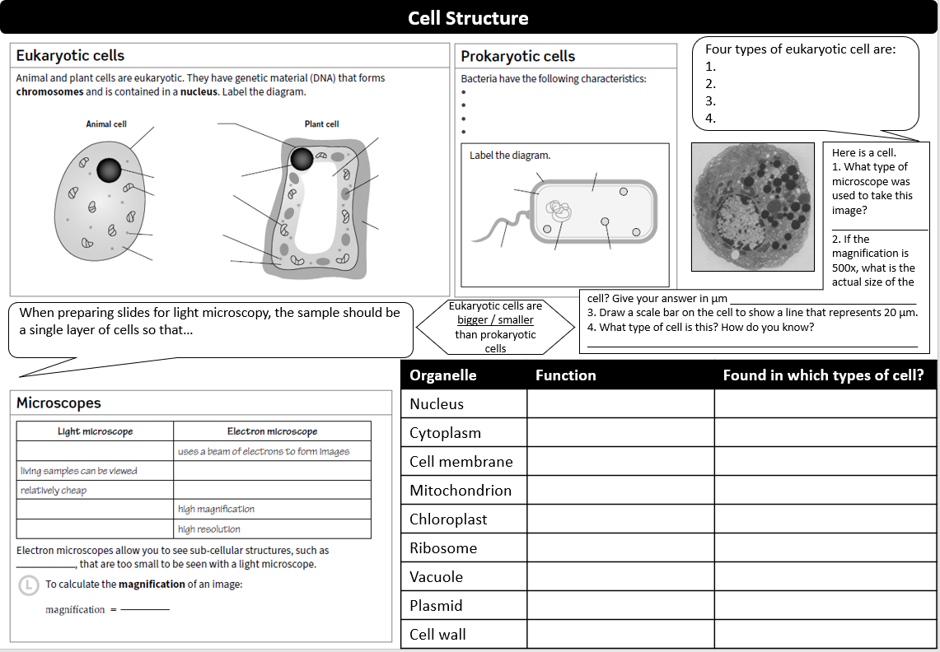

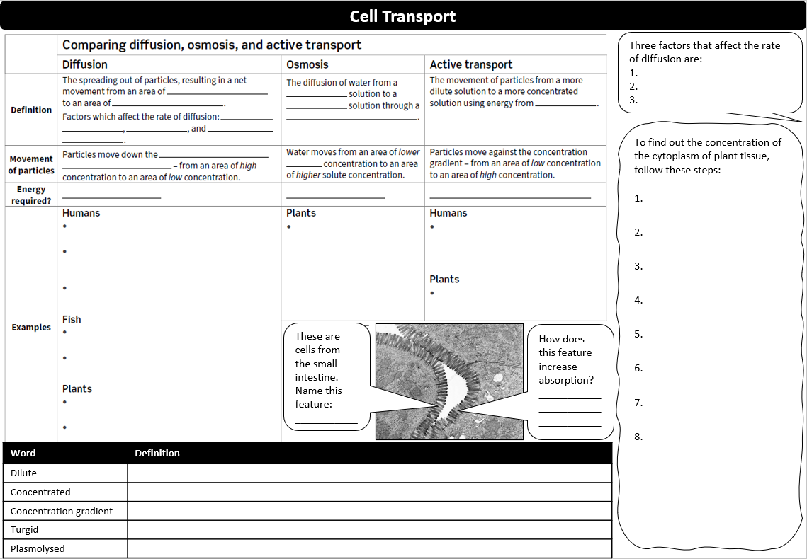

v
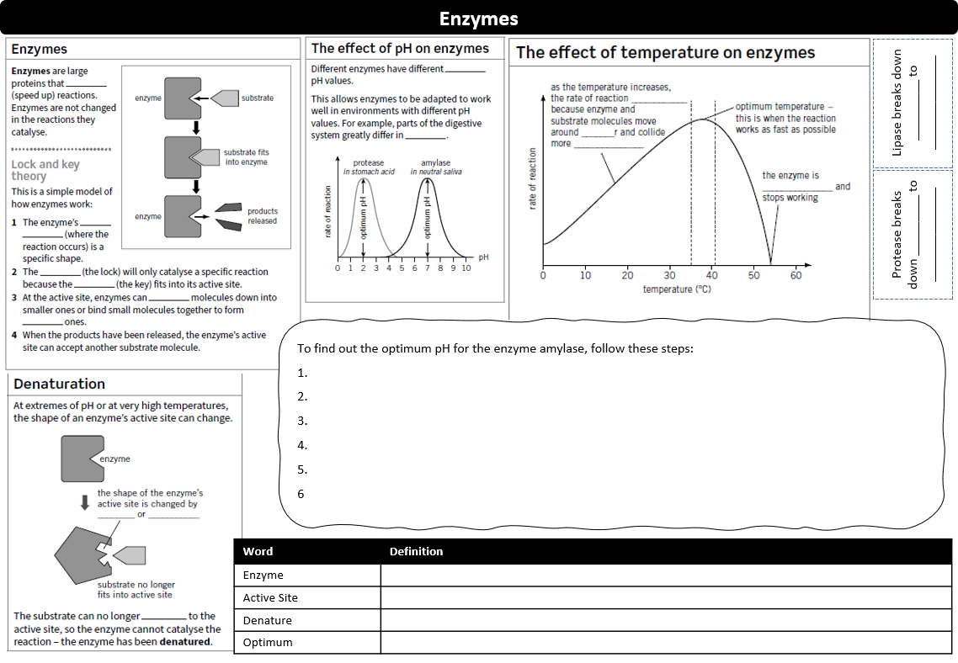

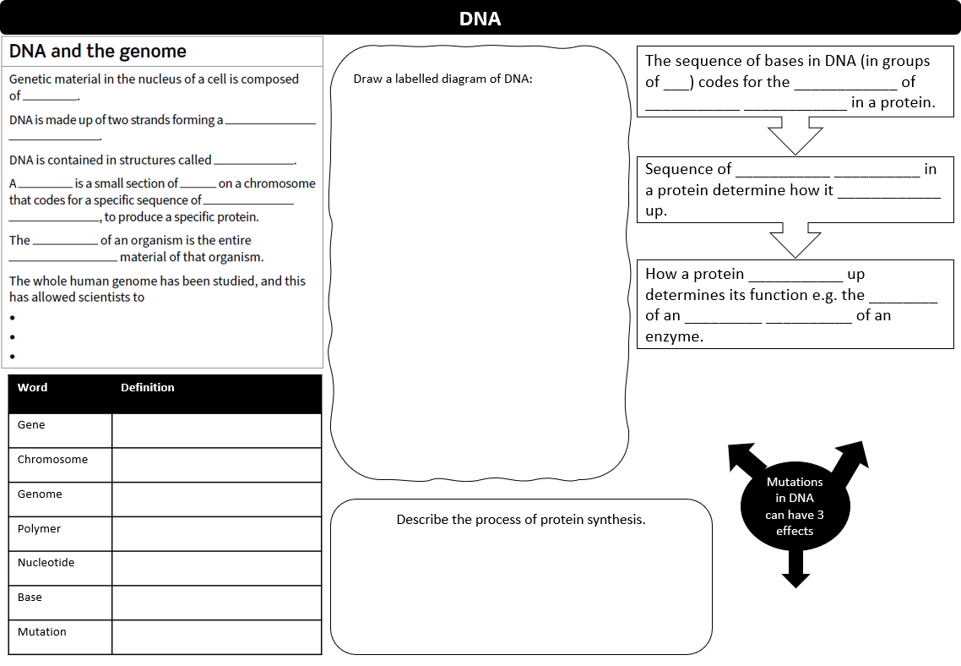

Bridging
work

SIXTH
FORM
CROSSLEY
HEATH
THE
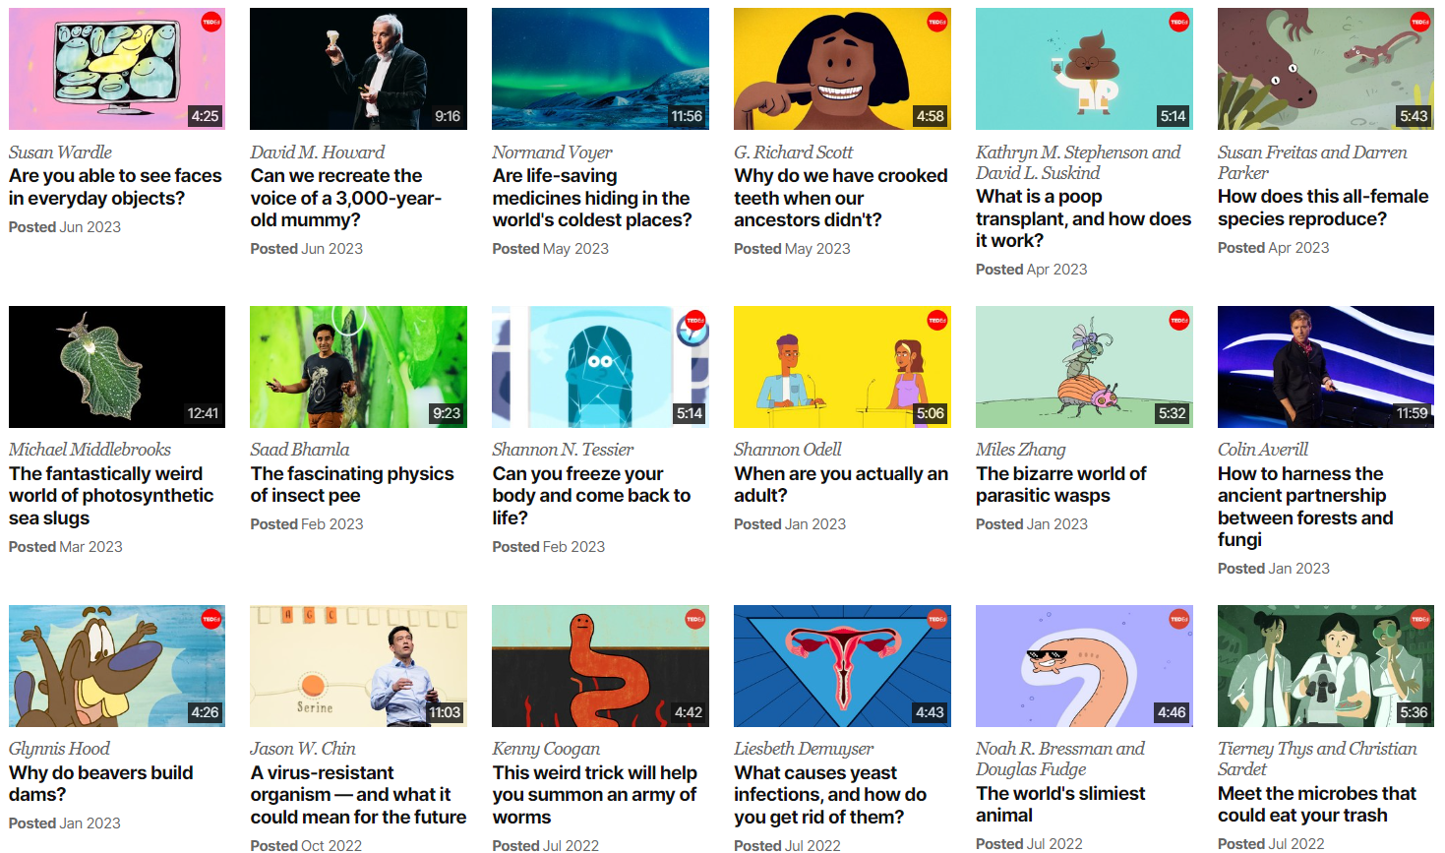
Choose at least one biology related TED talk, watch, and write a short review here:
Title: _____________________________________________________________________________
Presenter: ______________________
Date: _________________________

Review:

TED talks include some great presentations from world leading scientists and researchers on a variety of topics. They provide some interesting answers and ask some thought-provoking questions. There are loads more to choose from on the website: https://www.ted.com/biology
Task 2: Watch some TED talks
Broaden your knowledge
Bridging
work

SIXTH
FORM
CROSSLEY
HEATH
THE
Task 3: Let us know what you think by answering these questions:

- What are you most looking forward to learning about? Why?

- What do you think you will find most challenging? Why?

- Which topic(s) will be completely new to you (you didn’t study them at GCSE)?

Have a browse through the A Level Biology specification by following this link: https://www.aqa.org.uk/subjects/biology/a-level/biology-7402/specification/specification-at-a-glance
Browse the A-Level Specification
Bridging
work

SIXTH
FORM
CROSSLEY
HEATH
THE
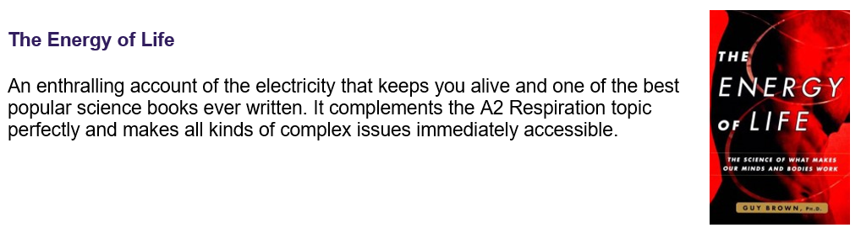
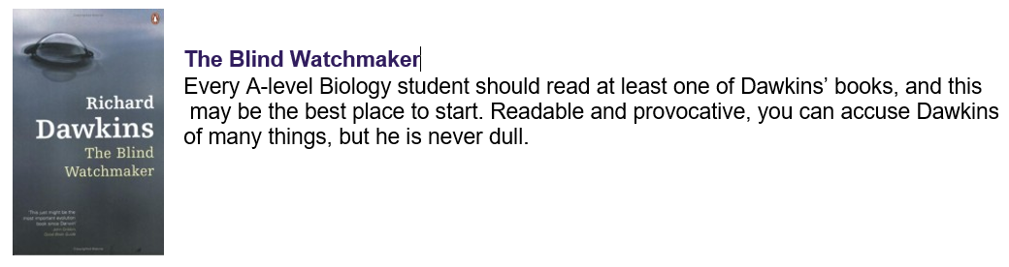
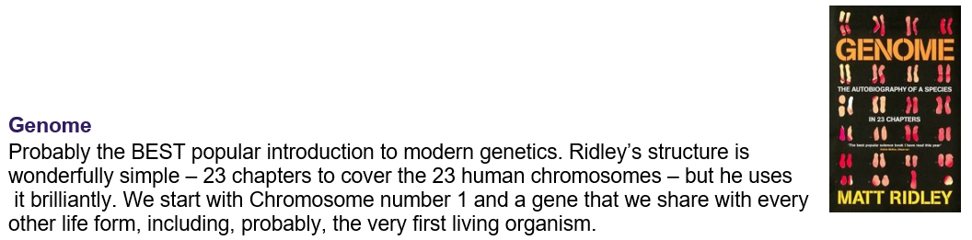
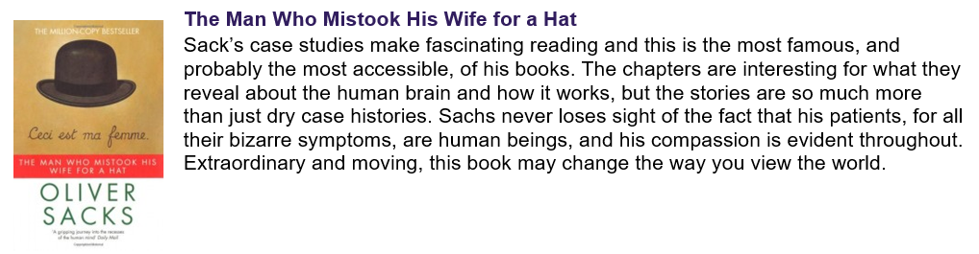
Wider Reading (Optional)
Looking for something to do? Pick one of these for a great summer read!
Task 4: Going on holiday?
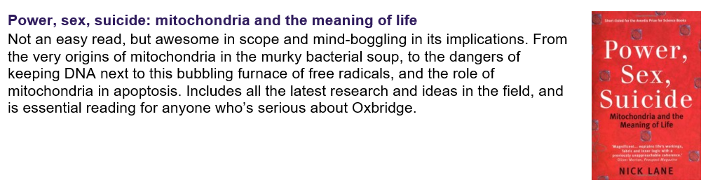

SIXTH
FORM
CROSSLEY
HEATH
THE
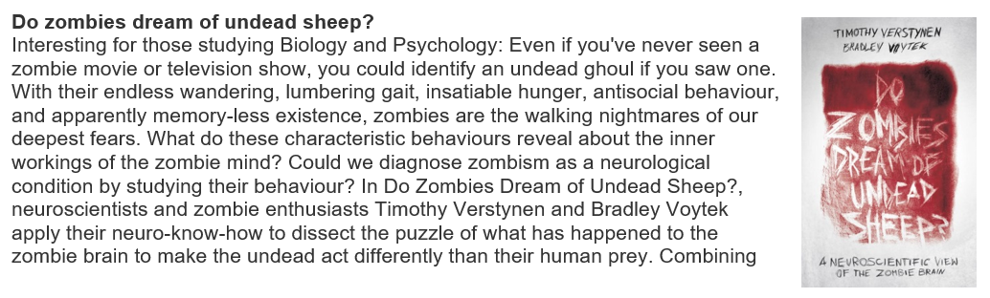
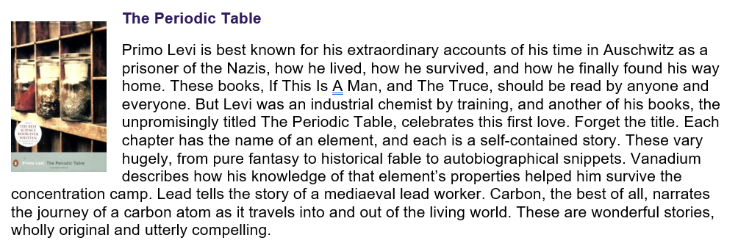
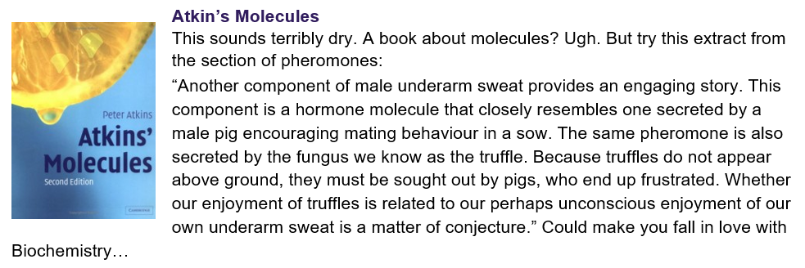
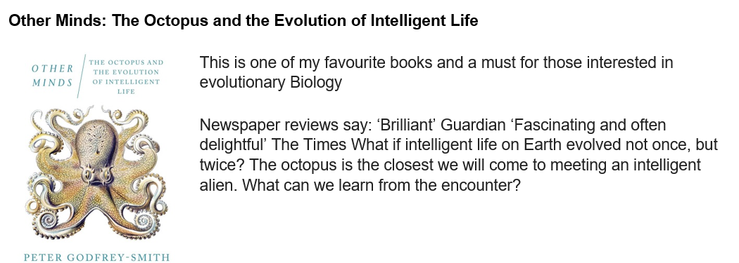
*optional
Task 5: Follow some great biology accounts on Instagram

SIXTH
FORM
CROSSLEY
HEATH
THE



The Life Scientific (BBC Sounds) – Jim Al-Khalili interviews a famous scientist each week about their work and their life
Anything by Sir David Attenborough! (BBC iplayer)
Any episodes of Horizon or Panorama you find interesting (BBC iplayer)
More or Less (BBC Sounds) – a surprisingly entertaining look at the use and misuse of statistics in the news
The Infinite Monkey Cage (BBC Sounds) – a comedy science quiz hosted by Brian Cox
Curious Cases (BBC Sounds) – a comedy show where two scientists investigate questions sent in by the public
Task 6: Watch / listen to some biology documentaries on BBC iPlayer / BBC Sounds
*optional
Science magazine: @sciencemagazine
IFLScience: @iflscience
The Deep: @thedeephull
Chester Zoo: @chesterzoo
New Scientist: @newscientist

