

SIXTH
FORM
CROSSLEY
HEATH
THE

A-Level Business
Welcome!
Thank you for opting to study A-level Business at the Crossley Heath Sixth Form in September.
It is extremely important for you to conduct preparatory research work at home during the summer in order to give yourself a strong foundation and the best possible start to your studies next term.
One feature of studying at A-level is that you are regularly required to work independently to support your studies. This checklist outlines a range of tasks you are required to complete.
It is important to remember that business leaders have to make key decisions on a daily basis as they react to the market conditions they face. Households and businesses are currently facing extremely challenging conditions in the economy as the country emerged from the Covid Pandemic and more recently coped with the impact of what is known as ‘the cost-of-living crisis.’ Given the unprecedented circumstances we are currently facing in society, it is essential for you to regularly keep up to date with developments in the news and monitor the impact on all forms of businesses, big and small, and the markets they operate in.
We trust you will endeavour to complete each of the tasks to the best of your ability and we look forward to meeting you all in September.
Yours Sincerely
Mrs M Jervis
(Department Leader for Business & Economics)

Mr A Ahmed
(Teacher of Business & Economics)

Name
(Title)
Link to Specification:
https://qualifications.pearson.com/en/qualifications/edexcel-a-levels/business-2015.html

Exam Board and Specification: Edexcel A-Level Business (9BS0)

SIXTH
FORM
CROSSLEY
HEATH
THE
Bridging
work

1.

2.

3.

4.
- What is the role of an entrepreneur? What objectives do they have? What character traits do they need to succeed? Is there are particular entrepreneur you admire? Why?
- What is meant by opportunity cost and trade off? Give examples to support your answers.
- What is meant by value added? – define the term and outline ways in which firms can add value to their product/service.
- What is meant by the term marketing? Try to create a comprehensive list of key terms and definitions of terms related to the concept of marketing – such as the components of the marketing mix, market mapping, market segmentation

Task 1: Develop your own detailed definition of the following key terms and give an example to demonstrate your understanding
Essential Definitions
Task 2:
Knowledge of different types of business ownership is a key element in developing an appreciation of the decisions and choices made by business leaders in different markets.

Please answer the following questions to develop a detailed understanding of the types of business ownership that exist, including the advantages and disadvantages of each form of ownership.

The following link will provide access to a useful online resource that will assist you in completing the task - https://www.tutor2u.net/business/reference/different-forms-of-business-introduction

Business Ownership

SIXTH
FORM
CROSSLEY
HEATH
THE

- Clearly define what is meant by the terms incorporated and unincorporated.

- Explain the difference between limited and unlimited liability.

- Using the table below, outline the characteristics of each type of business ownership shown –

Type of Business | Characteristics
- Sole trader;  - Partnership;  - Limited Company (Ltd);  - Unlimited Company (Plc); | - How many owners?  - Incorporated or unincorporated?  - Liability – limited or unlimited?  - Who keeps the profits?  - Who makes the decisions on a day-to-day basis?  - Advantages and disadvantages of this form of business?  - Examples?

An important aspect of studying Business at A-level involves recognising how industries change over time and how businesses have to adapt in order to remain popular and relevant. This task requires you to consider developments in the television streaming industry and how powerful new entrants to the market are making it more competitive.

Read the article on ‘Streaming Wars’ that has been provided and answer the following questions:
Industry Spotlight: Streaming
Task 3:

SIXTH
FORM
CROSSLEY
HEATH
THE

1.

2.

3.

4.

5.

6.

7.

8.
- Which firms currently dominate the global television streaming market?
- What is meant by over-the-top television?
- Identify the new players that are currently breaking into the market and assess their chances of success?
- Which businesses are involved in BritTV and BritBox and why do you think they have joined forces?
- Research the term creative destruction in relation to businesses and explain how it can be related to the traditional television broadcasters in the UK.
- Assess what all these developments mean for consumers/customers.
- Evaluate whether or not you believe Netflix will continue to dominate the market over the next decade given the amount of increased competition they now face.
- To what extent do you think the cinema industry is also under threat from online streaming and what steps can the big cinema chains take as they strive to attract customers in such a competitive market?
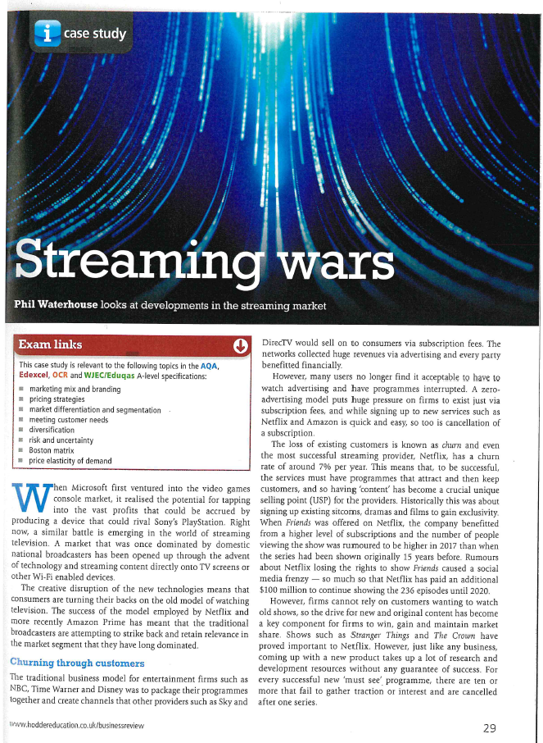

SIXTH
FORM
CROSSLEY
HEATH
THE
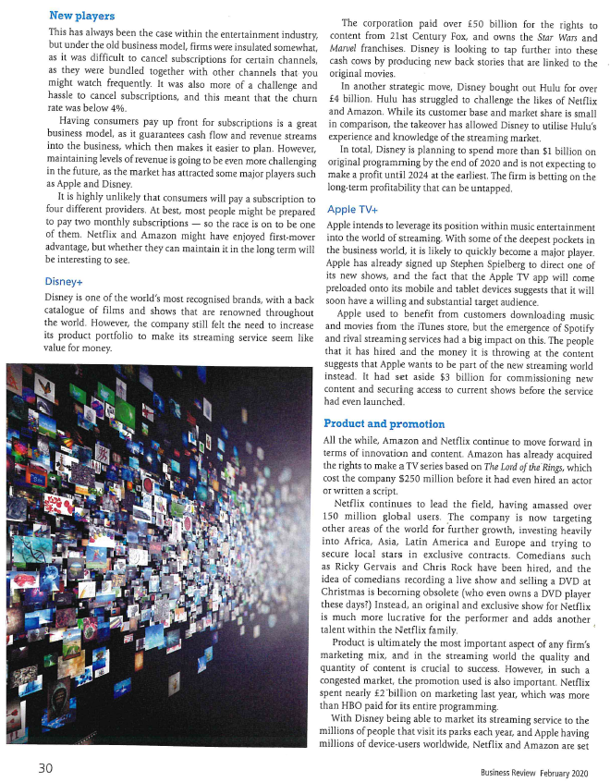

SIXTH
FORM
CROSSLEY
HEATH
THE
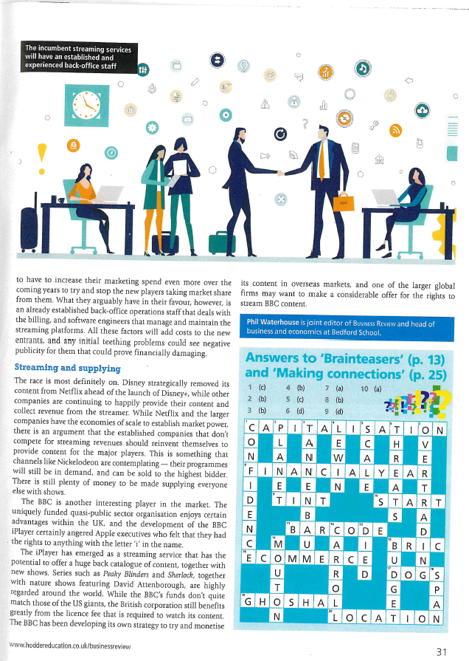

SIXTH
FORM
CROSSLEY
HEATH
THE

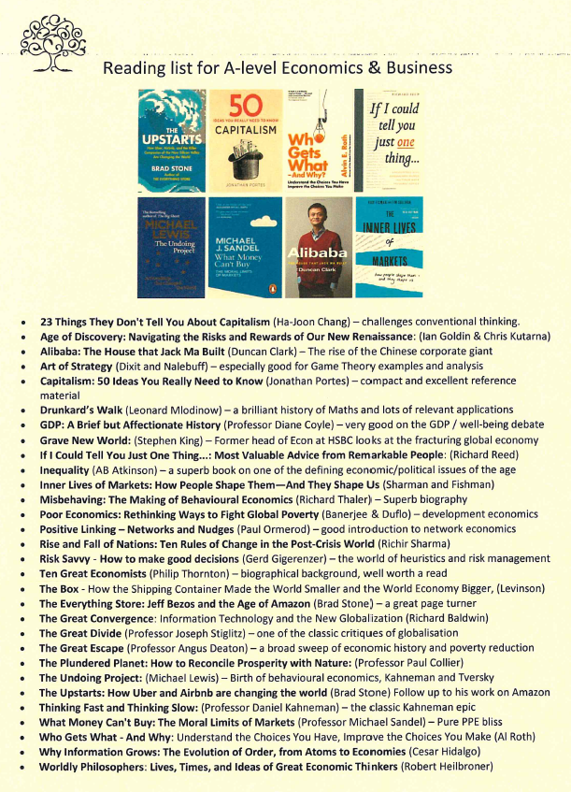

SIXTH
FORM
CROSSLEY
HEATH
THE



Believe today and you will achieve tomorrow!!

Task 5: Introduction to Edexcel Business
Tutor2U is a valuable resources to support your studies and they have created a brief course (1-2 hours) to provide an overview of the course. Please use the link below to access the course. Please note – it will require you to register with Tutor2U.

Introduction to course - https://ondemand.tutor2u.net/students/introduction-to-edexcel-a-level-business-getting-started
Task 4: Monitoring the news media
Business-related matters constantly appear in news bulletins online and on television. You are advised to monitor good quality news outlets and come to class with three articles related to business that feature in the news and caught your attention.

The following links will help you to get started –
https://www.bbc.co.uk/news/business
https://www.theguardian.com/business

SIXTH
FORM
CROSSLEY
HEATH
THE

