

SIXTH
FORM
CROSSLEY
HEATH
THE

Welcome!
Thank you for opting to study A-level Economics at the Crossley Heath Sixth Form in September.
It is extremely important for you to conduct preparatory research work at home during the summer in order to give yourself a strong foundation and the best possible start to your studies next term.
One feature of studying at A-level is that you are regularly required to work independently to support your studies. This checklist outlines a range of tasks you are required to complete.
It is important to remember that Economics is a behavioural science that involves you observing how individuals, businesses and the Government make choices in order to satisfy their individual objectives. Given the unprecedented circumstances we are currently facing in society, it is very important for you to regularly keep up to date with developments in the news and monitor the impact on all of these stakeholders.
We trust you will endeavour to complete each of the tasks to the best of your ability and we look forward to meeting you all in September.
Yours Sincerely
Mrs M Jervis
(Department Leader for Business & Economics)

Mr A Ahmed
(Teacher of Business & Economics)

A-Level Economics
Link to Specification:
https://qualifications.pearson.com/en/qualifications/edexcel-a-levels/economics-b-2015.html

Exam Board and Specification: Edexcel A-Level Economics B (9EB0)

SIXTH
FORM
CROSSLEY
HEATH
THE
Bridging
work

1.

2.

3.

4.

5.

6.
- The basic economic problem;
- Opportunity Cost;
- Trade-off;
- The factors of production – List the factors and how the owners of these factors are rewarded;
- Stakeholder – List a range of stakeholders in society and consider their objectives (what they want to achieve) and how this might come into conflict with other stakeholders and their objectives.
- The role of an entrepreneur including an example of a business person you admire with reasons why you consider them to be a good entrepreneur (e.g. Elon Musk, Jensen Huang, Tim Cook …).

Task 1: Develop your own detailed definition of the following key terms and give an example to demonstrate your understanding
Essential Definitions
Business Ownership
Task 2:
Businesses are one of three key economic agents we constantly use at A-level to analyse developments and the impact of change in society; the other two agents are consumers and the government.

Please answer the following questions to develop a detailed understanding of the types of business ownership that exist, including the advantages and disadvantages of each form of ownership.

The following link will provide access to a useful online resource that will assist you in completing the task - https://www.tutor2u.net/business/reference/different-forms-of-business-introduction

SIXTH
FORM
CROSSLEY
HEATH
THE

- Clearly define what is meant by the terms incorporated and unincorporated.

- Explain the difference between limited and unlimited liability.

- Using the table below, outline the characteristics of each type of business ownership shown –

Type of Business | Characteristics
- Sole trader;  - Partnership;  - Limited Company (Ltd);  - Unlimited Company (Plc); | - How many owners?  - Incorporated or unincorporated?  - Liability – limited or unlimited?  - Who keeps the profits?  - Who makes the decisions on a day-to-day basis?  - Advantages and disadvantages of this form of business?  - Examples?

An important aspect of studying Business at A-level involves recognising how industries change over time and how businesses have to adapt in order to remain popular and relevant. This task requires you to consider developments in the television streaming industry and how powerful new entrants to the market are making it more competitive.

Read the article on ‘Streaming Wars’ that has been provided and answer the following questions:
Industry Spotlight: Streaming
Task 3:

SIXTH
FORM
CROSSLEY
HEATH
THE

1.

2.

3.

4.

5.

6.

7.

8.
- Which firms currently dominate the global television streaming market?
- What is meant by over-the-top television?
- Identify the new players that are currently breaking into the market and assess their chances of success?
- Which businesses are involved in BritTV and BritBox and why do you think they have joined forces?
- Research the term creative destruction in relation to businesses and explain how it can be related to the traditional television broadcasters in the UK.
- Assess what all these developments mean for consumers/customers.
- Evaluate whether or not you believe Netflix will continue to dominate the market over the next decade given the amount of increased competition they now face.
- To what extent do you think the cinema industry is also under threat from online streaming and what steps can the big cinema chains take as they strive to attract customers in such a competitive market?
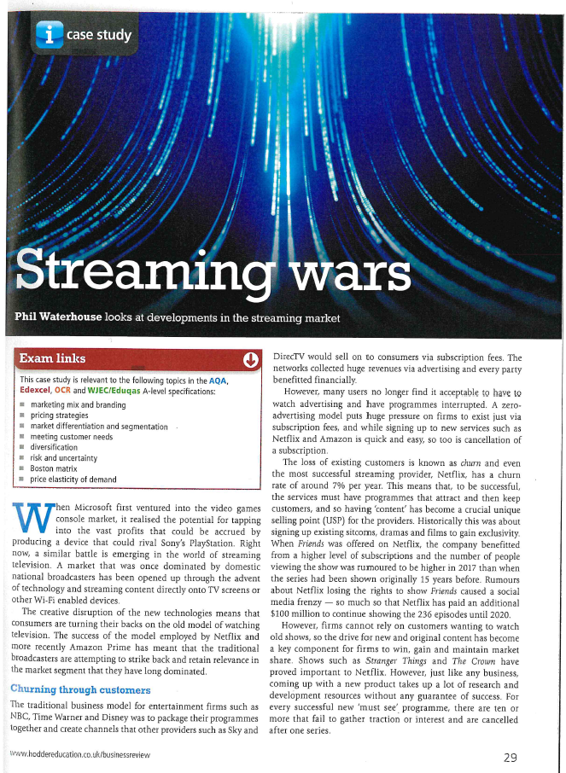

SIXTH
FORM
CROSSLEY
HEATH
THE
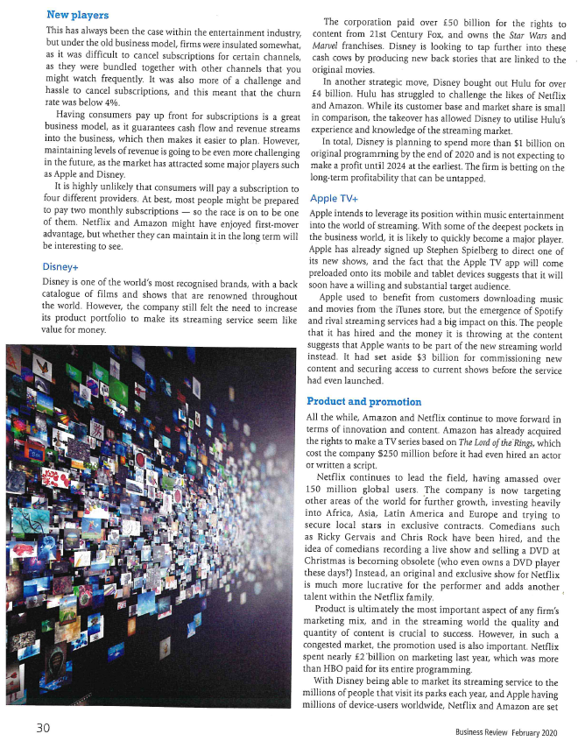

SIXTH
FORM
CROSSLEY
HEATH
THE
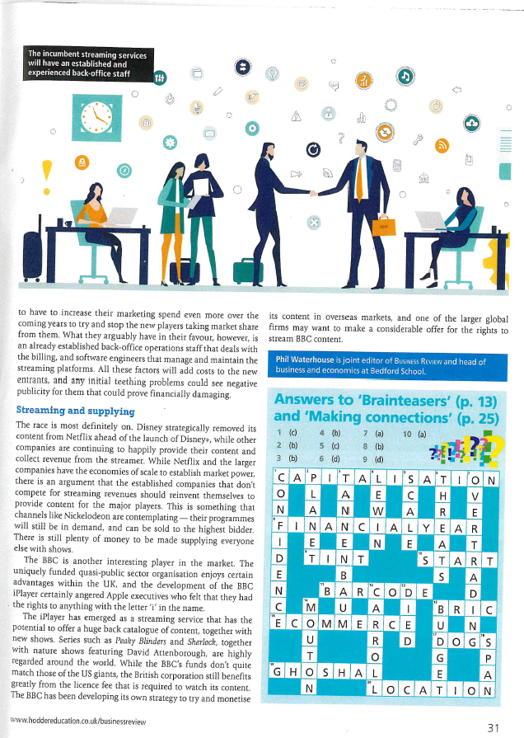

SIXTH
FORM
CROSSLEY
HEATH
THE

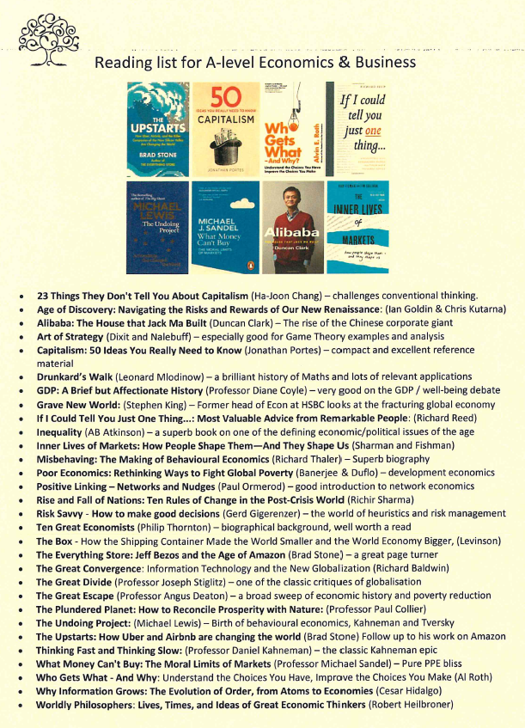

SIXTH
FORM
CROSSLEY
HEATH
THE



SIXTH
FORM
CROSSLEY
HEATH
THE
- What is inflation and how is it measured?
- What is the impact of rising inflation on individuals/households, businesses and the Government?
- What methods are used to control inflation?
- What is the current level of inflation in the UK? How does this compare to recent history?

1.

2.

3.

4.

Task 5: Monitoring the news media
The subject of economics constantly appears in news bulletins online and on television. You are advised to monitor good quality news outlets and come to class with three articles related to the economy or business that have recently featured in the news caught your attention.

The following links will help you to get started –
https://www.bbc.co.uk/news/business/economy
https://www.theguardian.com/business/economics

Task 4: The Economy - Inflation
The study of the wider economy forms a significant element of the course and you will monitor developments in the economy yourself alongside side your studies in class.

The UK has recently experienced a ‘cost of living crisis’ caused by rising inflation. This will be covered in detail in class; however, you can start the process by developing a basic understanding of the concept prior to joining the course.

Believe today and you will achieve tomorrow!!

