

SIXTH
FORM
CROSSLEY
HEATH
THE

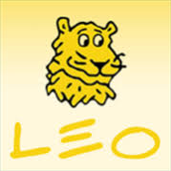
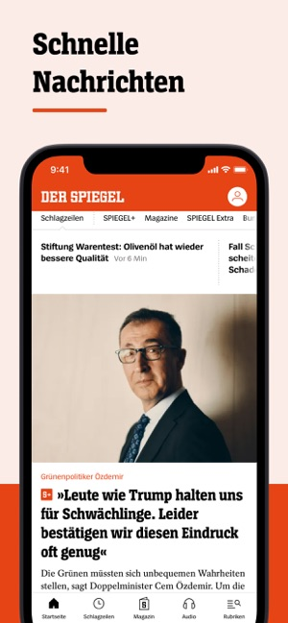
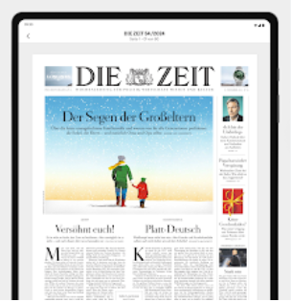
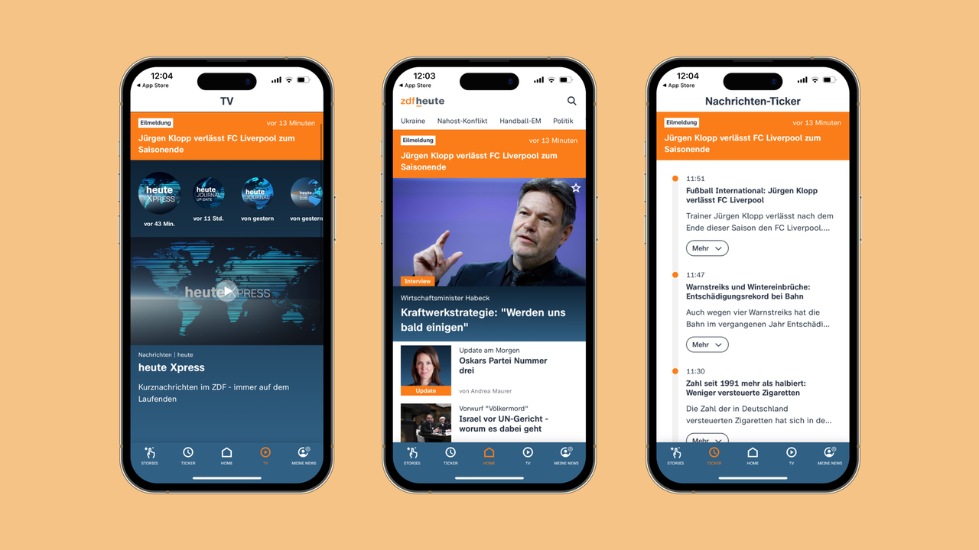
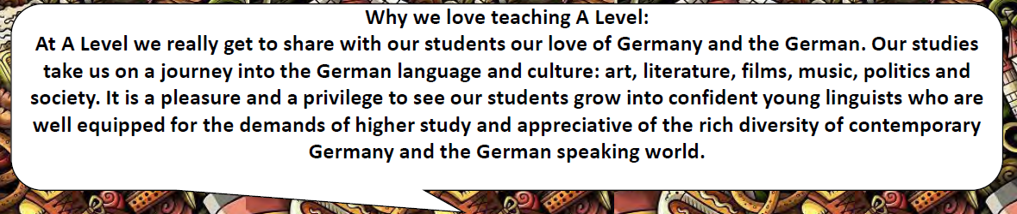
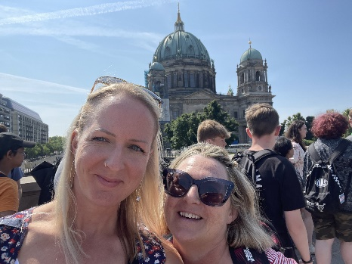

- A comprehensive Collins German dictionary will be provided for you in all your lessons. Even though dictionary apps are quick and easy, a dictionary is still the most comprehensive reference guide at this stage and you develop another skill in learning to navigate around one.

- Download a German dictionary app such as Word Reference or Leo

- Download a German news app such as der Spiegel, Zeit online or ZDFheute to your phone and enable alerts in German

Helpful things to do before you start:
Read the AQA A-Level Specification to understand the course requirements, content (p.10) and methods of assessment (p.19)

Understand the course (30 minutes)
Guten Tag!
Wir sind Frau Grossova and Frau Hazelton und wir unterrichten das Abitur für Deutsch.
A-Level German
Exam Board and Specification: AQA A-Level German (7662)
Link to Specification: https://filestore.aqa.org.uk/resources/german/specifications/AQA-7662-SP-2016.PDF
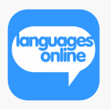
Task 1: (2 hours)
It is important that you have a good grounding in the basic principles of German grammar (nouns and genders, cases, verbs and tenses, word order, connectives).

Click here for languagesonline.org.uk to practise the following aspects of German grammar

- Mixed Tenses Revision
- GCSE Revision
- Prepositions in Accusative and Dative

It is also vital that you have learnt as much of the GCSE vocabulary as possible. This will give you a solid foundation upon which to build and will also help you to infer the meaning of new vocabulary by making connections in the language.

Quizlet is an excellent resource for learning vocabulary. Click here to test yourself on the GCSE vocabulary:
https://quizlet.com/294430243/test?funnelUUID=6ff1ea93-3f97-42a1-8b90-57de96ccd796

Spend at least one hour each on both grammar and vocab.

Ensure you write down your scores for both vocab and grammar and submit to the teacher

SIXTH
FORM
CROSSLEY
HEATH
THE


2 German-speaking singers

2 German-speaking bands

A German-speaking philosopher

2 German-speaking novelists

2 German-speaking actors

2 German-speaking
sports personalities
2 German language films

2 German language newspapers

A German film director

2 German language magazines for young people
2 German TV channels

2 German-speaking artists

2 German-speaking architects

2 German-speaking fashion designers
2 German radio stations

2 German chancellors
(past or present)
2 German political parties

2 German specialities

2 German inventions

Delve into German-speaking culture and complete the grid opposite.

Write the name of the person or item requested and add an image if you are able to find one. If you would like to be creative and present this in the form of a poster – even better!

Spend one hour on this and bring this to the first lesson in September to discuss in class.

Task 2: (1 hour)
Bridging
work
- Complete the task ‘E-Zigaretten sind nicht gesund’ below
- There is a vocabulary list to assist you.
- Try to use all your reading strategies to tackle this more challenging text.

Task 3: Practise your reading comprehension skills (1 hour)
(30 minutes)

SIXTH
FORM
CROSSLEY
HEATH
THE
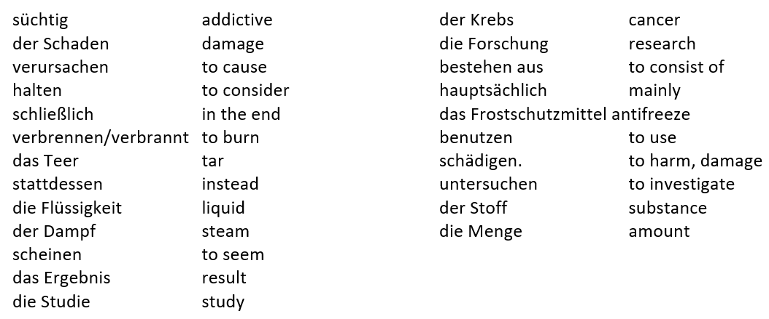

Vokabeln

Elektronische Zigaretten - die sogenannten E-Zigaretten - sind nicht ungefährlich. Sie machen süchtig und können gesundheitliche Schäden verursachen.

Mehr als eine Million Deutsche rauchen E-Zigaretten. Sie halten sie für gesünder als normale Zigaretten. Schließlich wird kein Tabak verbrannt und kein Teer inhaliert. Stattdessen wird aus einer Flüssigkeit ein Dampf produziert, der dann geraucht wird.

Doch dieser Dampf scheint gefährlich zu sein. Das ist das Ergebnis einer Studie vom Deutschen Krebsforschungszentrum. Der Dampf besteht hauptsächlich aus Propylenglykol, einer Substanz, die auch als Frostschutzmittel benutzt wird. Propylenglykol kann innere Organe schädigen.

Andere Substanzen der E-Zigaretten sind bisher wenig oder gar nicht untersucht. So wissen die meisten E-Raucher also nicht, welche Stoffe sie in welcher Menge inhalieren. Deshalb - so die Experten - kann man nicht von "gesundem Rauchen" sprechen. Ob E-Zigaretten helfen, das Rauchen aufzugeben, ist unklar.
- Why are electronic cigarettes considered to be dangerous? (2 reasons)
- How many Germans smoke them and why?
- Give 2 reasons why people think they are safe.
- What do people actually inhale?
- What potentially dangerous substance does this contain?
- What other use does it have?
- In what way can this substance be dangerous for humans?
- According to experts, do electronic cigarettes help people give up smoking?

- Translate the ‘restaurant prose’.
- You will have to think about all aspects of grammar as well as vocabulary to complete this.
- For those who need a bit more support, at the side (Hilfe!) there is some of the more challenging vocabulary and structures.

Task 4: Practise your writing, grammar and translation
(30 minutes)
skills

SIXTH
FORM
CROSSLEY
HEATH
THE

Hilfe!

über about
in der Nähe von near
bestellen to order
zäh though
zumindest at least
der Wackelpudding jelly
rundlich plump
im Großen und Ganzen all in all
Walisisch Welsh
hoffen to hope
Dear Auntie Jean,

Thank you for the birthday money which I received two weeks ago. You asked me about my birthday party at ‘Jumbo’s’. Well we went to the restaurant last week. It is near the station in Huddersfield. We arrived at 7:00 and my dad ordered drinks. Uncle Derec drank a coke but I drank a glass of wine because it was my birthday. To start I ordered Salmon because it is my favourite fish. Then for the main course I took the pork with garlic sauce. Unfortunately the meat was tough but at least the sauce was tasty. For dessert I ate fruit in order to stay slim. Uncle Derec had the Jelly and ice cream, although he is already plump! All in all it was a great meal. There was only one problem – I didn’t have a knife!

Next week I will go to Wales in order to see the beautiful countryside. However, I must change the Euros into Pounds. I am already looking forward to my journey to Dwygyfylchi. I want to hear some Welsh!

I hope that you are well – when will you visit me?

Write soon,

Antje


- Complete the true/false tasks (below) about ‘Zoos’ listening to this audio file: sgzoo.mp3
- Download the Radio Germany online app to your phone to listen to lots of different radio stations and types of music.

- For further and less formal listening practice throughout the year, go onto Netflix and search for German films or series. Watch with German audio and English subtitles (if you need to!).
Task 5: Practise your listening skills

SIXTH
FORM
CROSSLEY
HEATH
THE
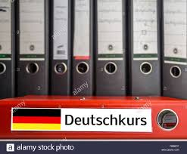

Get a folder organised with dividers and ready for September.
Include sections for:
- Frau Hazeltons Themen
- Frau Grossovas Themen
- Film (Good bye, Lenin!)
- Buch (Der Vorleser)
- Grammatik

Include any of your Bridging Work in the file, your old vocabulary books and a supply of A4 lined paper.

Read through the A-Level reading list (20 mins) on the next few pages and explore some of the many and varied resources available to you over the summer so you know what's there ready for September.
And finally...

Übung 1

Sind die folgenden Sätze richtig oder falsch? Schreib ‘R’ oder ‘F’.

- Im neunzehnten Jahrhundert sind viele Leute um die Welt gereist.
- Nur wenige Leute hatten einen Fernseher.
- Sie konnten Wildtiere wie Löwen oder Tiger nur im Zoo sehen.
- Wissenschaftler untersuchten und beobachteten die Tiere, die im Zoo lebten.
- Seltene Tiere findet man nicht sehr oft in Zoos.
- In Deutschland gibt es berühmte Tierparks.
- Hagenbecks Tierpark in Hamburg wurde im zwanzigsten Jahrhundert gegründet.
- In diesem Zoo wurden die Tiere in Käfigen gehalten.
- Im Zoologischen Garten Berlin leben sehr viele Tierarten.
- Die meisten Tierparks sind sehr groß.
- Zoos sind normalerweise sehr familienfreundlich.
- Kritiker sagen, dass viele Tiere in Zoos in einer falschen Umwelt leben.
- Knut war ein kleiner Eisbär, den man in Nordfinnland gefangen hat.
- Man kann Knut heute im Zoo sehen.
Online dictionaries
www.leo.org
www.wordreference.com
www.kurraki.com

Reading List

SIXTH
FORM
CROSSLEY
HEATH
THE
Generic Listening materials

www.wdr.de/tv/neuneinhalb/aktuell/index.php5
(short news clips of around 9 ½ minutes aimed at children. Click on ‘letzte’ and you can look at all the topics available/ very user friendly)

www.tivi.de/fernsehen/logo/start/index.html (you can watch the latest logo! programmes. logo! is the German version of ‘Newsround’)

www.slowgerman.com podcasts

www.goethe.de/lrn/prj/gad/eue/deindex.htm (podcasts linked to many of the A Level topics)

www.audio-lingua.eu (recordings by native speakers on a range of topics with exercises to do)

http://www.fluentu.com/ - German videos with subtitles (great website)

http://www.easy-languages.org/category/german/ Easy German– another good website with videos and subtitles to practise listening skills

www.surrey.ac.uk (a series of web information pages for advanced learners which gives practice in listening. Specially designed for AS students)
Generic Reading materials
www.goethe.de (year 12/13 materials. Click on ‘topics’ to read articles on all the topics)

Planet Schule contains an array of articles, videos and fact-files, all aimed at learners of German
http://www.planet-schule.de/
Newspapers

www.spiegel.de (online version of popular German magazine. Great for language and culture)

www.news-und-trends.de (all the latest news on fashion, tourism, food, sport, art and much more)

www.dw-world.de (live radio and news)

www.tageschau.de (news and videos)

http://www.dw.de/langsam-gesprochene-nachrichten-learning-german/a-2925601 - Slowly spoken German news
A Level Topics: Year 12

Familie
- Aus dem Leben eines Teenagers by Anna Lise Gordon
- Der kleiner Bruder by Sven Regener
- Schöne Augen: Carsten Tsara ist verliebt by Franz Specht
- www.news-und-trends.de (click on Family in the options)
- www.youtube.com jung und naiv (interesting interviews)
- Der Besuch by Jenny Erpenbech

die digitale Welt
- www.news-und-trends.de (lots of different areas of technology)
- Auf der Spur der Hacker by Timo Steffans
- We are the machine by Paul A Young (a look at the literary and cultural reception of IT in Germany, Austria and Switzerland)

Mode
- Young Germany - http://www.young-germany.de/
- Frühlings Erwachen by Franz Wedekind
- www.news-und-trends.de (click on music or fashion)
- Fashion Germany by Martina Rind

Musik
- www.lyricstraining.com(an easy and fun way to learn and improve your German skills through music videos and the lyrics of your favorite songs. You will need to set up an account)
- www.goethe.de(discover the amazing world of German music and find out why German music rocks!Listen to podcasts about the German music scene, watch the ‘video clip of the month’, watch music videos and download lyrics and worksheets, look at the German charts)
- www.mamalisa.com (German children’s songs and rhymes)
- www.spex.de (a leading website for music criticism and arts coverage)
- Kraftwerk/ future music from Germany by Uwe Schütte

Fernsehen
- www.news-und-trends.de
- www.zdf.de (die heute Show)
- www.ard.de
- www.youtube.com jung und naiv (interesting interviews)
- www.disney.de (trailers for films)
- http://www.dw.de/deutsch-lernen/telenovela/s-13121
- http://www.kika.de/sesamstrasse/sendereihe230.htm German online soap operas
- News & video website - http://www1.wdr.de/mediathek/video
- RTL Aktuelle – German news website http://www.rtl.de/cms/news/rtl-aktuell.html

Feste und Traditionen

- German festivals and Traditions by Nicolette Hannam
- Germany (festivals of the world) by Richard Lord
- The best festivals in Germany on www.tripsavvy.com
- Germany festivals on www.roughguides.com
- Germany festivals and holidays www.germanfoods.org

SIXTH
FORM
CROSSLEY
HEATH
THE


Kunst und Arkitektur
- www.spex.de (a leading website for music criticism and arts coverage)
- www.news-und-trends.de (click on Art)
- Der Arkitekt by Stefan Heym
- History of German Art: Painting, Sculpture and Architecture by Gottfried Lindemann
- Street Art Berlin by Wolfgang Steinmetz

Berlin
- Berlin Alexanderplatz by Alfred Döblin
- Emil und die Detektive (set in Berlin)
- Café in Berlin (10 short stories bi-lingual version)
- www.planet-wissen.de/geschichte/ddr/geteiltestadtberlin
- Berliner Pokalfieber by Felix and Theo
- Der Himmel über Berlin by Wim Wenders (film and book)

A Level Topics: Year 13

Einwanderung/Intergration/Rassismus
- Das Fundbüro by Siegfried Lenz (covers topic of Ausländerfeindlichkeit)
- No country for migrants; critical perspective on immigration and integration in Germany by Wilfried Zoungrana
- Turkish Germans by Sarah Tomsen Vierra
- Germany in transit Nation and Immigration 1955-2005 by Deniz Gokturl
- Inside Nazi Germany by Detler J.K Penkert and Richard Deveson
- Auschwitz and after by Charlotte DELBO

Politik
- Fluter.de is an online magazine aimed at 16-22 year olds, containing informative features on current German cultural and political issues.
- http://www.fluter.de/
- www.theeuropean.de (political debate magazine)
- www.news-und-trends.de (click on politics)
- Der Schwarm by Frank Schätzing (Ecological thriller)

die Wiedervereinigung
- das Leben der anderen (film and book) by Florian Henchel von Donnersmarsch
- Leben in der DDR by Franziska Kleiner
- Was bleibt by Christa Wolf
- Deutschland nach der Wende by Renate Luscher
- Russian Disco by Wladimir Kaminer (life in Berlin after the fall of the wall)
- Der Giraffenhals by Judith Schalansky (reunification of Germany)

SIXTH
FORM
CROSSLEY
HEATH
THE

SIXTH
FORM
CROSSLEY
HEATH
THE
Extras
Die Kultur
- The friendly German-English dictionary: A guide to German Language, culture and society by Peter Watson
- www.neon.de (for easier news and culture- linked to Stern)

Literatur und Gedichte
- Deutsche Lyrik Suhrkamp (a collection of German poetry)
- Gedichte- Buch der Lieder by Heinrich Heine
- Selected poems by Goethe
- Zonenkinder by Jana Hensel (looks at Ostalgie)

Fun sites
- www.sowieso.de(an online newspaper aimed at children. Click on ‘Welt’ or ‘Deutschland’ for articles from all over the world or Germany, ‘boahey!’ for ‘strange but true stories’ or ‘Halbzeit’ for sports stories)
- www.dw.de/themen/s-9077 (website of the German broadcaster Deutsche Welle. Click on ‘Deutsch lernen’, then ‘Deutsch Aktuell’ for ‘langsamgesprocheneNachrichten’, ‘Top-ThemamitVokabeln’ or ‘Video-Thema’)
- German games - http://www.wiegehtsgerman.com/games
- German blogs - http://blogs.transparent.com/german/

Generic grammar materials: Grammar
- Essential German Grammar by Martin Durrell/Katrin Kohl
- Hammer German Grammar (5th edition) by Martin Durell
- Using German by Martin Durrell
- 501 German verbs by Henry Strutz
- http://coerll.utexas.edu/gg/gr/about.html (online grammar reference and exercises linked to the imaginary world of Grimm Grammar)
- www.languagesonline.org.uk
- http://www.vistawide.com/german/grammar/german_grammar.htm (a comprehensive list of all grammar aspects)
- http://www.german-grammar.de/grammar/content/english_german_table_of_content.htm
- http://www.travlang.com/languages/german/ihgg/ (internet handbook of German grammar)

Vocabulary
- Wort für Wort by P Stocker ( a number of these are kept in the MFL office)
- On the Study Stack website, you can test yourself on existing sets of virtual flashcards and even build your own set – particularly useful for testing yourself on words you’ve recently learnt.
- http://www.studystack.com/German
- Anki is open-source (i.e. free) software for vocabulary learning that comes highly recommended by Oxford undergraduates.
- The Goethe-Institut offers a vocabulary trainer app.
- Quizlet – already has uploaded vocabulary lists. You just have to search by subject/topic
- https://quizlet.com/subject/german
- Learn German online - http://www.learn-german-online.net/
- Vocabulary builder - http://www.vocabulix.com/online/Learn/German
- Word of the week - http://www.dw.de/deutsch-lernen/wort-der-woche/s-9031
- The German Professor - http://www.thegermanprofessor.com/

SIXTH
FORM
CROSSLEY
HEATH
THE

Interesting German novels (some are kept in the LRC and some kept with the individual teachers)
- Ich fühle mich so fifty-fifty by Karin König
- Die Entdeckung der Currywurst by Uwe Timm
- Die unendliche Geschichte (a fairytale) by Michael Ende
- Momo by Michael Ende
- Homo Faber by Max Frisch
- Harry Potter series (German version)
- Brothers Grimm (fairytales)
- Das Parfüm by Patrick Süskind
- Fantastische Mr Fox (German version) by Roald Dahl
- Sophiechen und der Riese by Roald Dahl
- Katz und Maus by Günther Grass

