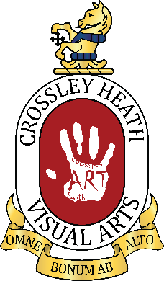

SIXTH
FORM
CROSSLEY
HEATH
THE
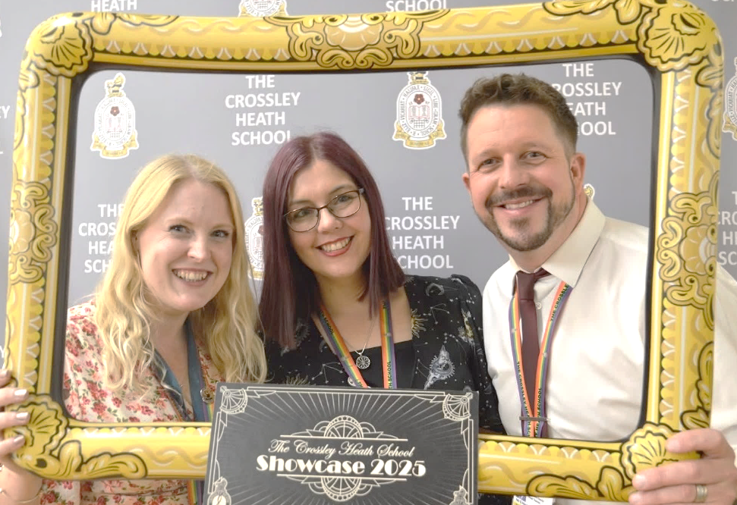

Link to Specification: https://cdn.sanity.io/files/p28bar15/green/80577b7e4e6f566866e5ac421ce9cf8f9b444dff.pdf
A very warm welcome to The Crossley Heath School Sixth Form! We are absolutely delighted that you have chosen to study A-level Visual Arts with us — you have made an inspiring choice that will open doors to a world of creative possibilities.

Studying Visual Arts is about so much more than developing your practical skills — it’s about learning to see the world differently, to communicate your ideas confidently, and to bring imagination to life. Whether you dream of becoming an architect, graphic designer, illustrator, animator, fine artist, fashion designer, photographer, art director, or working in film, gaming, advertising, or any other area of the creative industries, this course is a brilliant first step on that journey.

You are now part of a vibrant and supportive community where your creativity will be nurtured and challenged. We can’t wait to see the amazing work you’ll produce and to help you grow into thoughtful, innovative artists and designers.

We are truly excited to be a part of this next chapter with you — to encourage you, to guide you, and to celebrate your achievements every step of the way.

Welcome aboard — let’s make something wonderful together!

Mrs R Henson
(Department Leader for Visual Arts)

Mr G Hirst
(Deputy Head/Executive Director of Sixth Form,
Teacher of Visual Arts)

Mrs L Tomlinson
(Art Technician/Design & Media Assistant)
Exam Board and Specification: AQA Art and Design [7202/3/4/6]
A-Level Visual Arts
SIXTH
FORM
CROSSLEY
HEATH
THE
Bridging
work

The Ordinary Made Extraordinary
This is the bridging work to be done over the summer holidays, bring this in September
We will spend the first few weeks completing these tasks, discussing your ideas and exploring different techniques.
For this project, we would like you to produce the following:
- A mind map of ideas and mood board of imagery exploring the theme (1 hour)
- Initial photos (taken by you if possible) and initial studies/samples/trials based on these (show off your skills!) (3 hours)
- An artist influence page (choose someone whose work inspires you and produce a written analysis of their work) (2 hours)

- A focused mind map and set of design ideas
- Refinement/trials of your best design idea – play around, explore and experiment – what is going to make the best outcome
- A final design plan explaining what you are going to make and why
- An outcome
To get to know you better and learn more about you, your style and your interests, we would like you to interpret the title (above) in any way you wish and produce a mini-project about you.
You can focus on portraiture, landscape, still life or abstract. You can work in your most preferred media, scale, 2D or 3D, or digitally. Basically, we want to see what you can do!
You have until Friday 26th September to complete this project. On, or around this date, you will present your work to your peers and explain what you decided to do and why. At this time, we will assess your project as part of the baselining for A-level; confirming that this subject is the right one for you to pursue, and if it is, to decide which discipline best suits your style: Fine Art, Graphic Communication, Textile Design, Photography or even Three-Dimensional Design.

Bridging work
ideas
SIXTH
FORM
CROSSLEY
HEATH
THE
Here are some suggestions to help get you started, but you can take this in any direction you wish! You do not have to choose one of the options suggested, but you can if you want.

Please record your work in any way you wish: digital, sketchbooks, boards. There will be the option to purchase a sketchbook in September and you can present any work completed then.

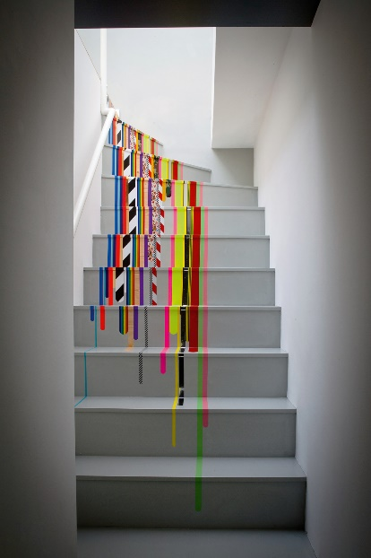
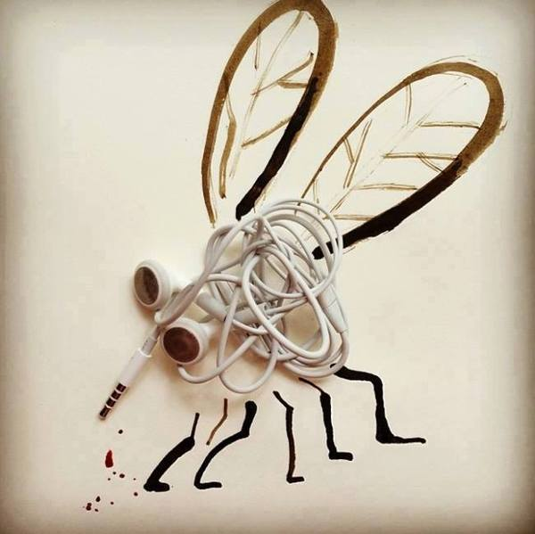
Things to consider:
Scale
Perspective
Distortion
Focus
Colour
Layers
Order and chaos
Inversions
Pattern
Rotation
Reflection
Working with materials in different ways
Transformation
Light and shadow
Crop
The unexpected
Details
Juxtaposition
Composition
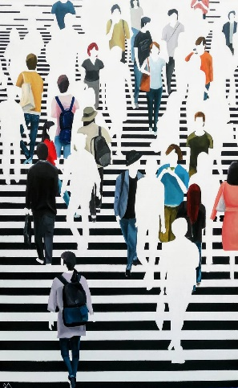


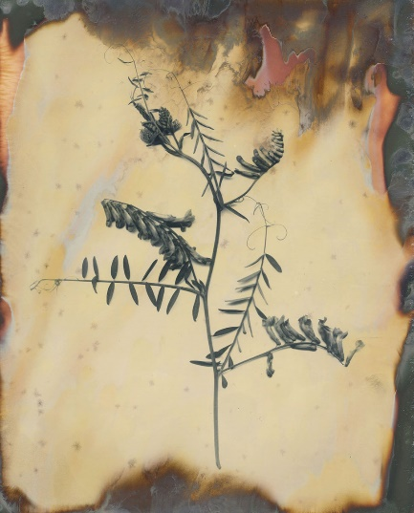
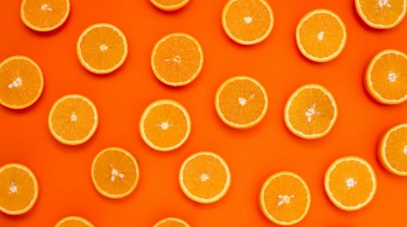
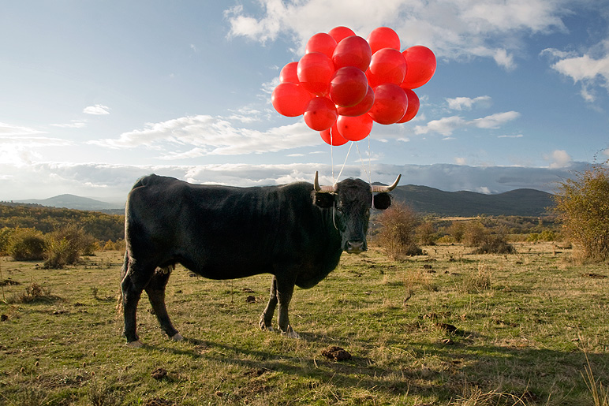
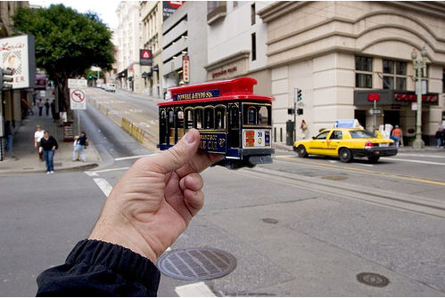
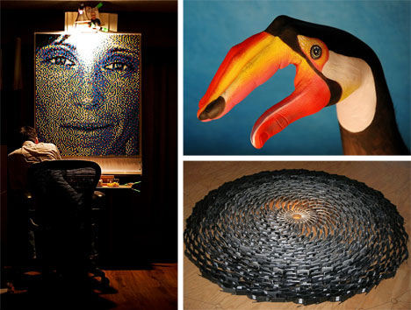
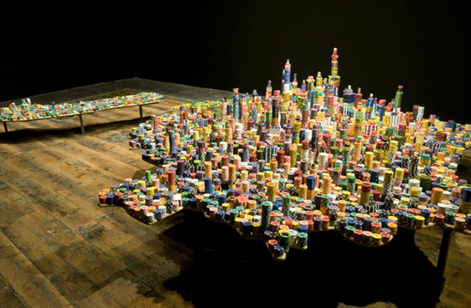

SIXTH
FORM
CROSSLEY
HEATH
THE
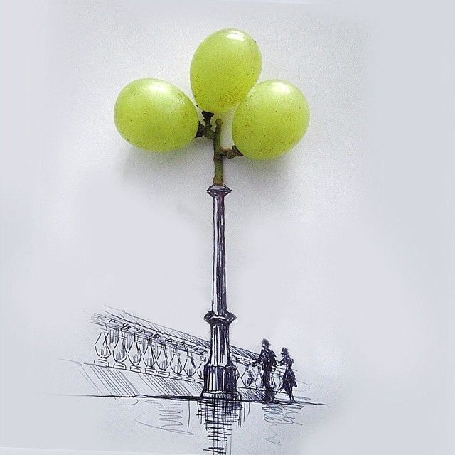
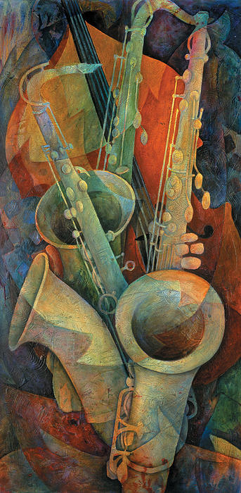
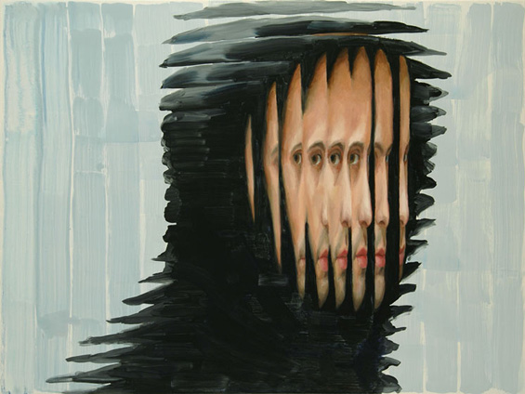
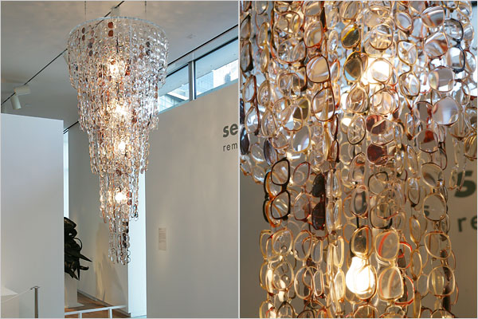
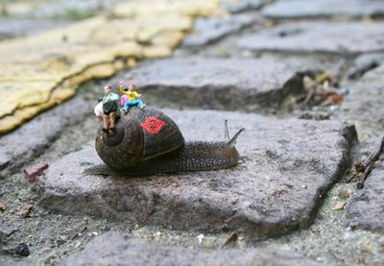
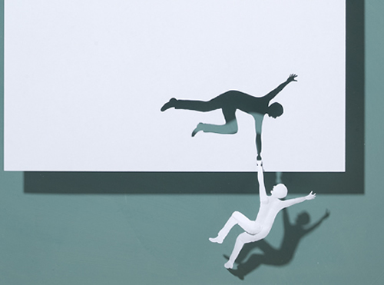
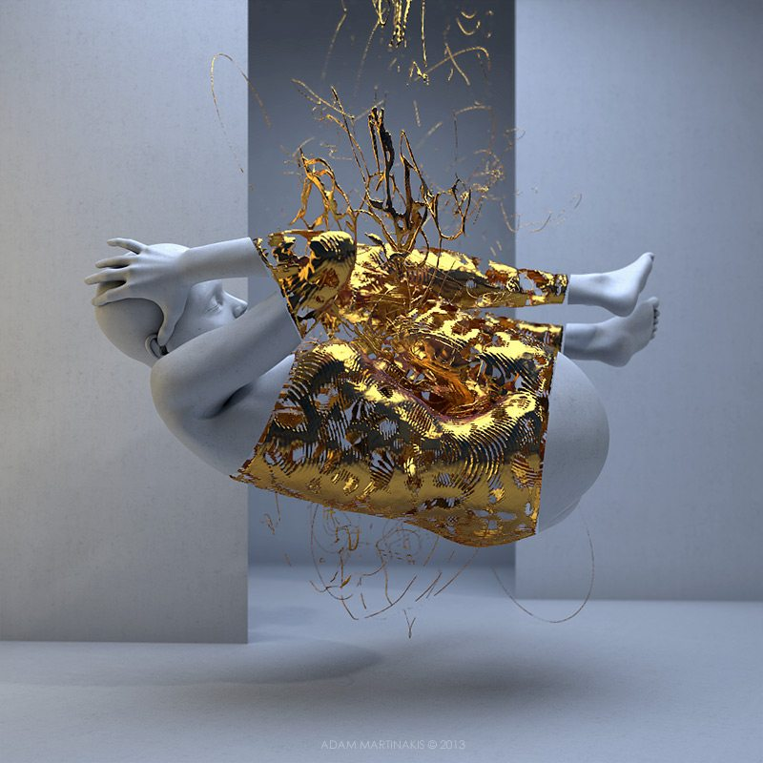
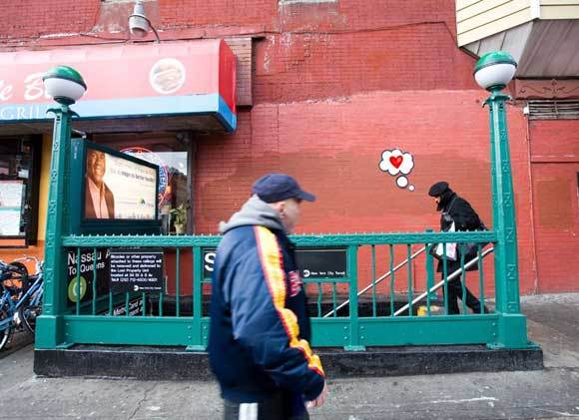
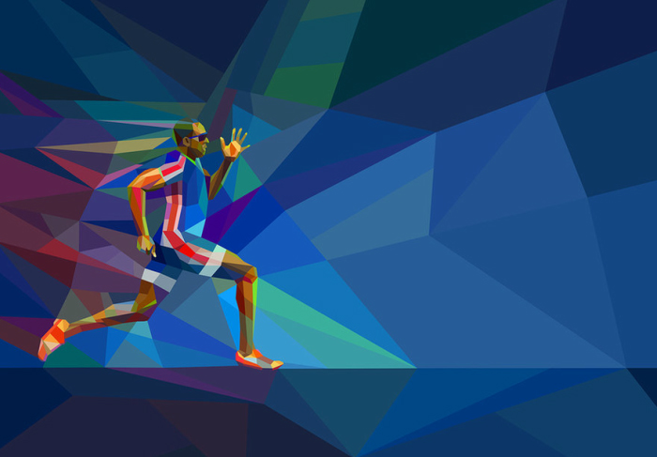
🎨 FINE ART IDEAS
Still Life with a Twist
- Paint still lifes using modern items (e.g., cereal boxes, phone chargers).
- Use chiaroscuro lighting.
- Artists: Audrey Flack, Giorgio Morandi

Monumental Mundanity
- Large-scale paintings of tiny, everyday moments (crumbs, wires).
- Artists: Chuck Close, Claes Oldenburg

Collage Project: "Supermarket Saints"
- Create Byzantine-style icons or stained-glass window compositions using wrappers, receipts, packaging, and supermarket catalogues.
- Elevate consumerism into a pseudo-religious narrative.

Painting Series: "Portraits of Forgotten Tools"
- Create classical-style acrylic portraits of overlooked everyday tools—scissors, brooms, screwdrivers—posing them as though they were dignified characters.
- Include ornate frames and formal naming plaques (e.g., “Sir Whisker of the Kitchen Realm”).

SIXTH
FORM
CROSSLEY
HEATH
THE
🧵 TEXTILES IDEAS
Embroidered Everyday
- Embroider daily scenes on luxury fabric.
- Artists: Tracey Emin, Louise Bourgeois

Soft Sculpture: Plush Mundanity
- Soft, oversized replicas of objects (e.g., plug sockets, crisp packets).
- Artist: Lucy Sparrow

Upcycled Couture
- Create fashion from old or mundane fabrics.
- Artists: Maison Margiela, Sonia Delaunay

Domestic Tapestry
- Weave a large-scale tapestry using recycled materials (plastic bags, string, old cloth) to depict a simple daily activity like making toast or tying shoes.
- Could tie into artists like Grayson Perry or El Anatsui.

Printed Pattern Collection: "Kitchen Kingdom"
- Create a repeat print collection inspired by ordinary kitchen objects—mugs, forks, teabags—but drawn in an elaborate, decorative style.
- Techniques: Screen printing or block printing with bold colours or metallic inks to give a regal or pop-art effect.
📋 GRAPHIC DESIGN IDEAS

Brand the Boring
- Create a full branding suite (logo, packaging, ad campaign) for something completely mundane—tap water, a pencil, or plain toast.
- Artist: Barbara Kruger (text/image), Jasper Morrison (design)

Epic Poster Series
- Design a set of bold posters that give heroic status to simple tasks (e.g., “The Epic of Sock Matching” or “The Battle of the Bin Bags”).
- Influence: Propaganda posters, comic art

Infographic Art
- Create beautiful, data-driven visuals from daily life: how many times you boil the kettle, walk through a doorway, or check your phone in a day.
- Artists: Stefanie Posavec, David McCandless

Diary Zine/Comic
- Make a small zine documenting a normal week—but in a wildly imaginative, graphic-novel format.
- Artists: Chris Ware, Daniel Clowes

SIXTH
FORM
CROSSLEY
HEATH
THE
📸 PHOTOGRAPHY IDEAS
Surreal Domestic Scenes
- Stage surreal versions of ordinary settings (e.g., floating tea cups).
- Artists: Sandy Skoglund, Gregory Crewdson

The Rituals of Routine
- Poetic photo series of daily habits (e.g., brushing teeth, making tea).
- Artists: Nan Goldin, Wolfgang Tillmans

Object Portraits
- Studio-style photos of objects (e.g., shoes, mugs).
- Artists: Irving Penn, Bernd and Hilla Becher

Magnify the Mundane
- Take close-up, macro shots of everyday objects (e.g., a sponge, pencil tip, salt crystals) and present them in large
- Format to emphasize hidden beauty and texture.
- Use dramatic lighting, vivid colour grading, or surreal framing to make them look abstract or cosmic.

Animation or Short Film: "Epic Chores"
- Reimagine simple tasks (making tea, folding laundry) as epic cinematic sequences with grand music and over-the-top effects.
- Use exaggerated sound design and slow motion to add drama and reverence.

