

SIXTH
FORM
CROSSLEY
HEATH
THE
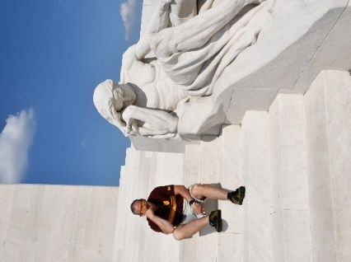
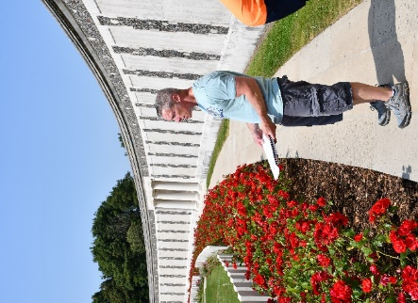

Exam Board and Specification: AQA A-Level History (7042)
1L – The Quest for Political stability – Germany 1870-1991
2M – Wars and Welfare – Britain 1906-1951

Mr Davies hardly working…
Mr Donlan working hard…
Welcome!
Mr Donlan teaches the German History course from 1870-1991
Mr Davies teaches the British side of the course from 1906-1957
Both share responsibility for the coursework (NEA) on Tudor England

Mr J Davies
(Department Leader for History/Head of Yr12/Teacher of Politics)

Mr S Donlan
(Teacher of History)

Miss H Fern
(Teacher of History)
A-Level History
Link to Specification: https://cdn.sanity.io/files/p28bar15/green/e8af941793cb16ef8915d3678684853d6c8a5ca9.pdf

SIXTH
FORM
CROSSLEY
HEATH
THE
Bridging
work

- Warnings were evident
Economic
- industrial and commercial superiority being challenged.
- GB dependent on older industries and suffering from overseas tariffs
- 10% of population owned 90% wealth

Military
- War against Boers in SA 1899-1902 had highlighted military weaknesses and some serious military failings.
- Poor physical condition of working men for army raised questions of National Efficiency
- Loss of 20,000 lives, incompetence on part of army command, introduction of concentration camps led to criticism.

Social
- living conditions appalling in poorest areas
- 4 million people living below subsistence levels
- social degeneracy reported in urban areas
- many working men and no women were entitled to vote

- Richest and most powerful country on earth
- Greatest trading nation in world, empire covers ¼ globe
- London – heart of banking, finance, investment
- Built 60% of world’s merchant ships. Navy bigger than any 2 other nations.
- UK population – 43 million, mostly employed in industry, living in cities.
- New industries developing – chemical, electrical, cars
- Queen Victoria on throne, parliament led by aristocratic Lord Salisbury, class system entrenched.
- Edward VII 1901 – can be seen as a continuation of Victorian era OR as a prelude to the Twentieth century age of change and modernity.

Our course begins in 1906 so you won’t be examined specifically on anything from before this date - but you must have some general understanding and knowledge of what Britain was like at the turn of the century.

Britain in 1900
Task 1: Research

Extend your understanding of what Great Britain was like in 1900, on the next slide, make notes from the following website: http://www.nationalarchives.gov.uk/pathways/census/main.htm
(have a good snoop about under the various tabs – some really good background information in here)

SIXTH
FORM
CROSSLEY
HEATH
THE

workspace

Task 2: Research

Make notes on the video – Andrew Marr – first 37 minutes
https://www.youtube.com/watch?v=X_eICyolb8Q
The German Empire was founded on January 18, 1871, in the aftermath of three successful wars by the North German state of Prussia. From 1864 to 1871 Prussia had emerged as the dominant state, making up 60% of the population and land of the new empire.

As such you will need to make a judgement on how important Prussia was in winning the wars and in establishing the modern state of Germany. You will also need to consider the role of the Prussian aristocracy/elites who sought to preserve their power in this new regime and how they used the military traditions of Prussia to increase their grip on power

The quest for political stability: Germany 1871-1991

SIXTH
FORM
CROSSLEY
HEATH
THE

List the strengths of Bismarck’s character.
How does Steinberg view Bismarck
What was his role in unifying Germany?
What was the consequence of unification?

https://massolit.io/courses/the-unification-of-germany-1815-71/what-role-did-individuals-and-the-military-play-in-the-formation-of-a-german-nation-state

How important was Bismarck in 1871?
What evidence is discussed showing his status?
Who were the 2 major European states?
What role did religion play in unifying Germany?
What was the national identity based on?
How did the universities help unification?

https://massolit.io/courses/the-unification-of-germany-1815-71/what-was-germany-like-in-1871

Task 3: Use the weblinks below to answer the following questions:
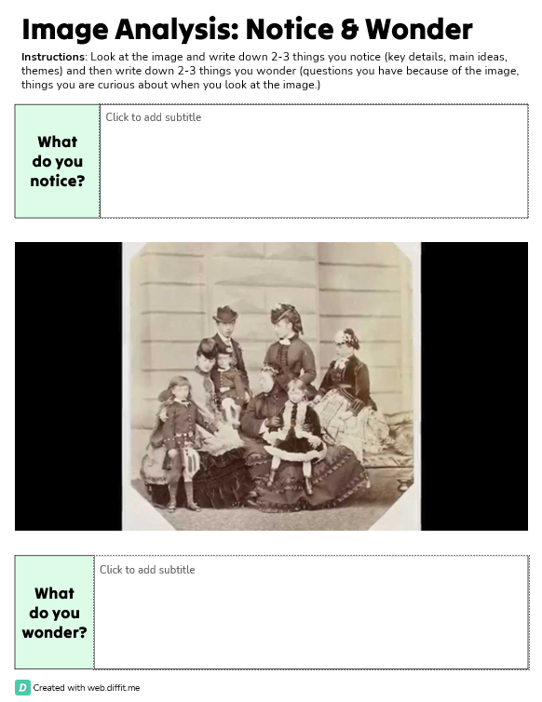
Task 4: Work through the following sheets:

SIXTH
FORM
CROSSLEY
HEATH
THE
[delete and type here]

[delete and type here]

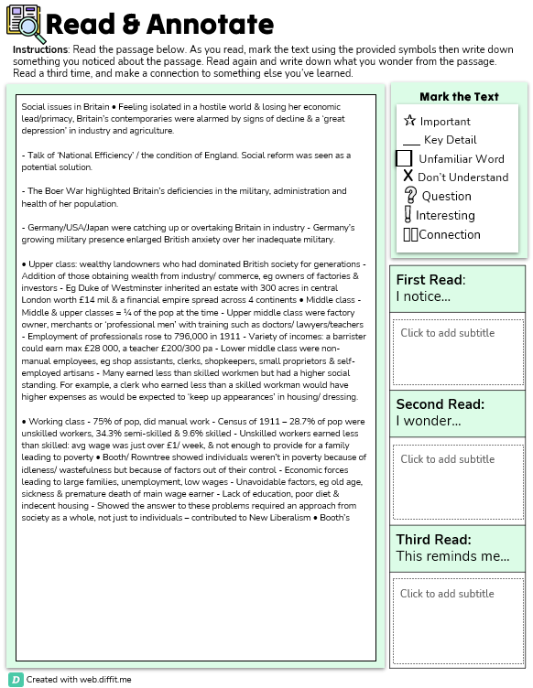

SIXTH
FORM
CROSSLEY
HEATH
THE
[delete and type here]

[delete and type here]

[delete and type here]
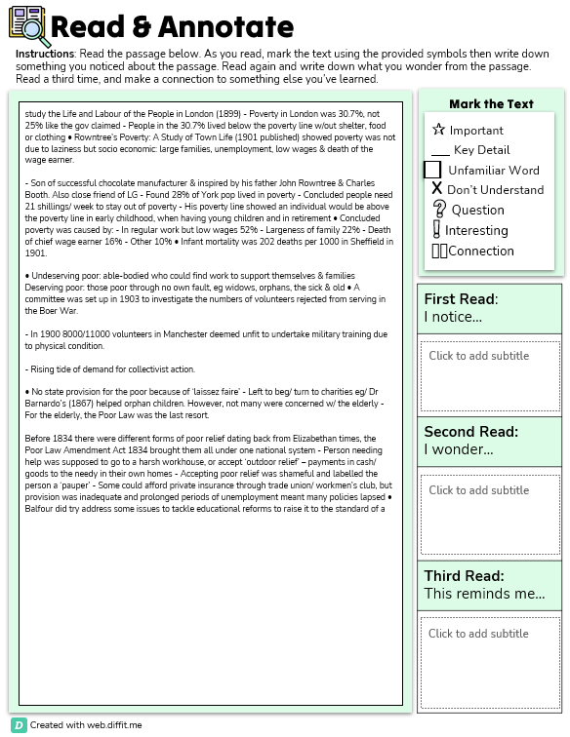

SIXTH
FORM
CROSSLEY
HEATH
THE
[delete and type here]

[delete and type here]

[delete and type here]
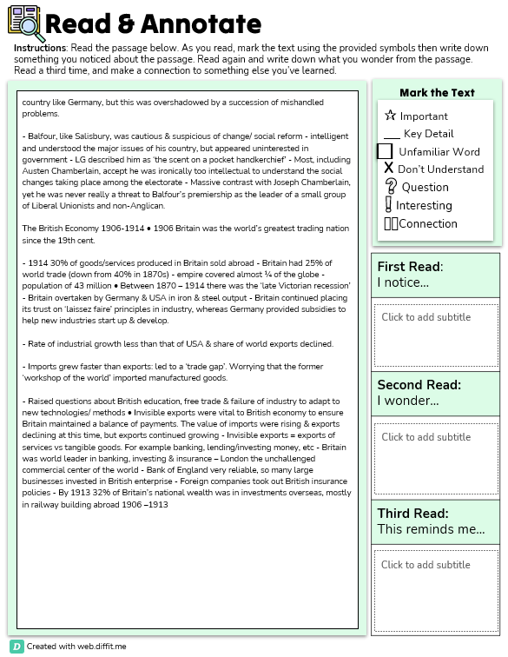

SIXTH
FORM
CROSSLEY
HEATH
THE
[delete and type here]

[delete and type here]

[delete and type here]
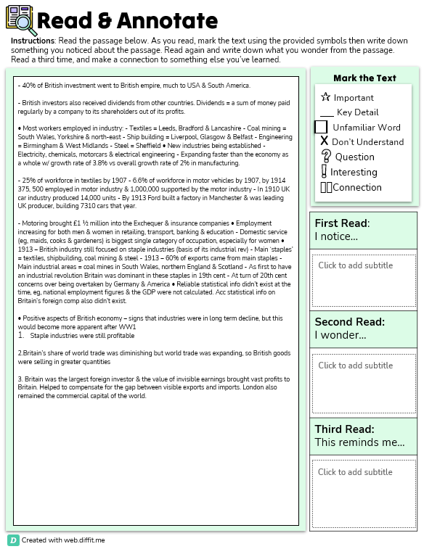

SIXTH
FORM
CROSSLEY
HEATH
THE
[delete and type here]

[delete and type here]

[delete and type here]
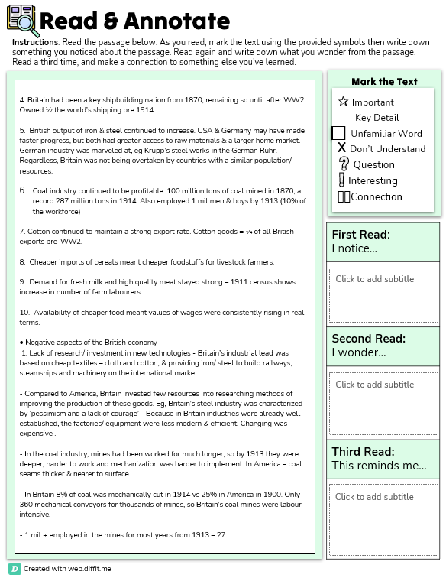

SIXTH
FORM
CROSSLEY
HEATH
THE
[delete and type here]

[delete and type here]
[delete and type here]

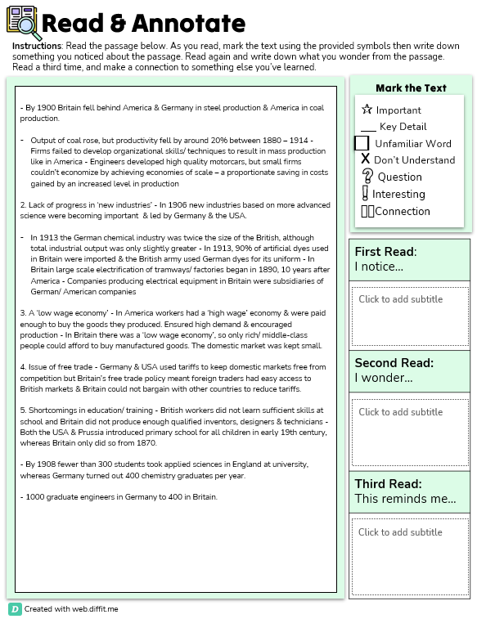

SIXTH
FORM
CROSSLEY
HEATH
THE
[delete and type here]

[delete and type here]
[delete and type here]

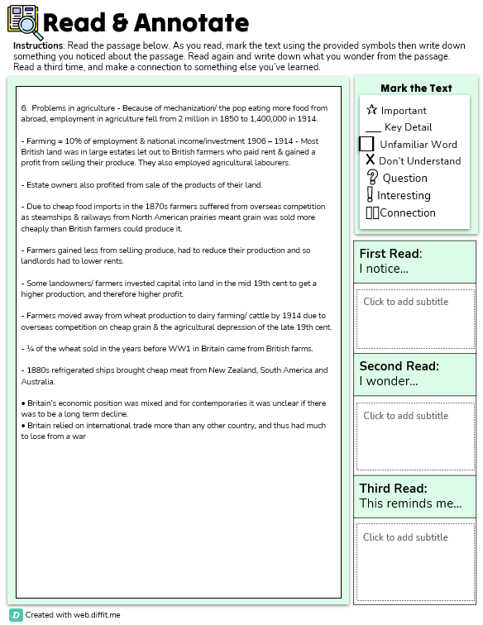

SIXTH
FORM
CROSSLEY
HEATH
THE
[delete and type here]
[delete and type here]

[delete and type here]

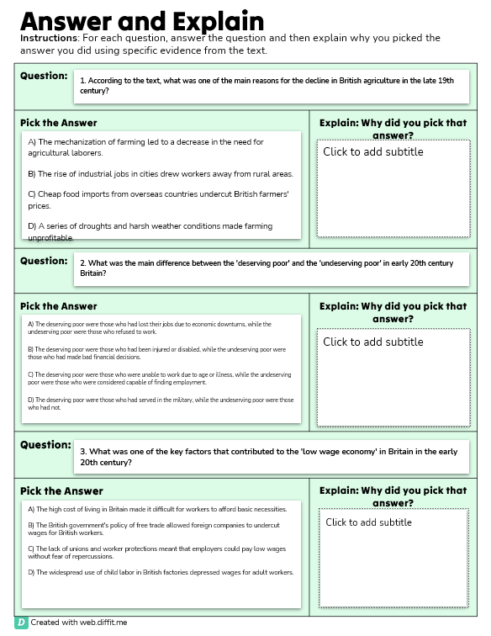

SIXTH
FORM
CROSSLEY
HEATH
THE
[delete and type here]

[delete and type here]

[delete and type here]

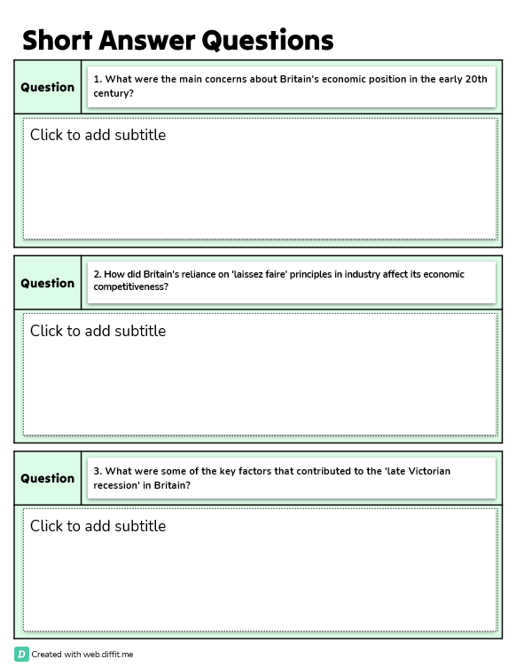
1

SIXTH
FORM
CROSSLEY
HEATH
THE

[delete and type here]

[delete and type here]

[delete and type here]

