

SIXTH
FORM
CROSSLEY
HEATH
THE

A-Level English
Language
Welcome!

We are really looking forward to introducing you to a completely new way of looking at the language we use on a day-to-day basis. During the course we will be discussing how age, gender, occupation, sexuality, ethnicity and where you live have an impact on the language you use. We will also be introducing you to how the language has changed over time, right up to the present day. Another part of the course is learning the way children learn to speak, read and write.

Our lessons take a range of forms including discussions, seminars and group work. We expect everyone to take part and will encourage you to develop your own interests in the subject.

Mr A Coote
(Assistant Department Leader for English/UCAS Coordinator)

Mrs J Doig
(Teacher of English)

Link to Specification: https://cdn.sanity.io/files/p28bar15/green/886f7485ca79ba97293cf690d46c6c296aabf3f2.pdf
Exam Board and Specification: AQA A-Level English Language (7702)

SIXTH
FORM
CROSSLEY
HEATH
THE
Bridging
work

Activity 1:
Why does our language change? Can you think of some of the reasons why it might change?
(Example included)

Travel – moving between countries, towns or cities causes people to share words/languages amongst themselves which changes our language.
Pick 4 activities and spend no more than 4 hours in total. Be prepared to discuss them in the first few lessons in September.
The choice is yours...
Activity 2:
Consider the sentences below. For each one, consider the word classes in bold particularly. What do you think the writer’s intended effect was when using them?

(To help you do this, it might be useful to think about all the other word choices the writer could have used but chose to use the ones below – why?)

SIXTH
FORM
CROSSLEY
HEATH
THE

Police are hunting for the suspect.
Protestors swarmed the streets, chanting robotically.
The soldiers were killed in friendly fire.
The slim, young woman sauntered in to the room.
Gangs of youths sneer at the older generation. These mobs have no regard for society.
I beg of you, please donate to the RSPCA.
We need to stand together to grow the next generation so they might flourish as adults.

Activity 3:
Conduct some research on two of the following topics.
What information and notes can you make to help you understand these very important topics on the A-Level Language course?

SIXTH
FORM
CROSSLEY
HEATH
THE

- The difference between prescriptivism and descriptivism. What do these words mean and what have they got to do with the study of language?
- The history of the English Language. Who were the first speakers/settlers in Britain? What invasions and other significant events have occurred in the UK that has meant we have the language we have today? (key words that might help you in your research: Celts, Romans, Vikings, Norman Conquest 1066, British Empire, The Great Vowel Shift, the introduction of the printing press by William Caxton).

[delete and type here]
[delete and type here]
[delete and type here]
3. Theories around how children acquire their language. What are some of the contradictory views on how we begin to speak?

SIXTH
FORM
CROSSLEY
HEATH
THE
4. Attitudes to different accents around the UK. How do people view certain accents? (Scousers, Geordies, the Yorkshire accent, Brummies, Cockneys). Which accents carry more prestige than others? Why is this? Can you find any research/linguistic studies that have been done in to particular accents? What is Received Pronunciation (RP)? Why is this accent deemed the most prestigious?

[delete and type here]

SIXTH
FORM
CROSSLEY
HEATH
THE

Did you use any proto words (made up words) e.g., blankie for blanket?
Were there any words/phrases used in your family that could not be understood by others outside of your family?
Were there examples of words you got ‘wrong’ e.g., wrong context/ meaning?

What was your first word?
Were you a chatterbox, shy, quiet?
Were there any words you used more frequently and why?

Activity 4:
As part of the course, you will study Child Language Acquisition - CLA (how children ‘learn’ to speak).
Do some research of your own learning?

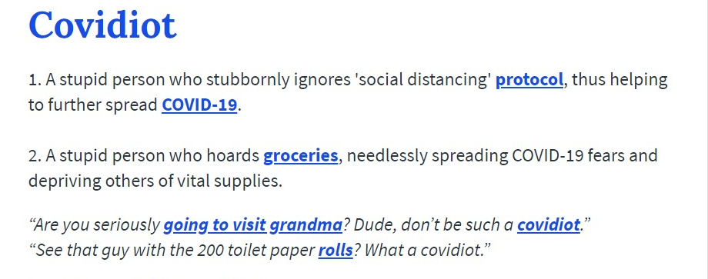
What other new words have you come across because of the Corona virus pandemic?

Activity 5:
Language is changing & evolving all the time. New words & meanings are constantly being added to English to support new ways of doing things.
For example:

My early speech...
Activity 6:
Read each slide below. Each slide contains information to read and learn on different sentence structures or functions.

Complete the activity at the end. Google can be your best friend.

SIXTH
FORM
CROSSLEY
HEATH
THE
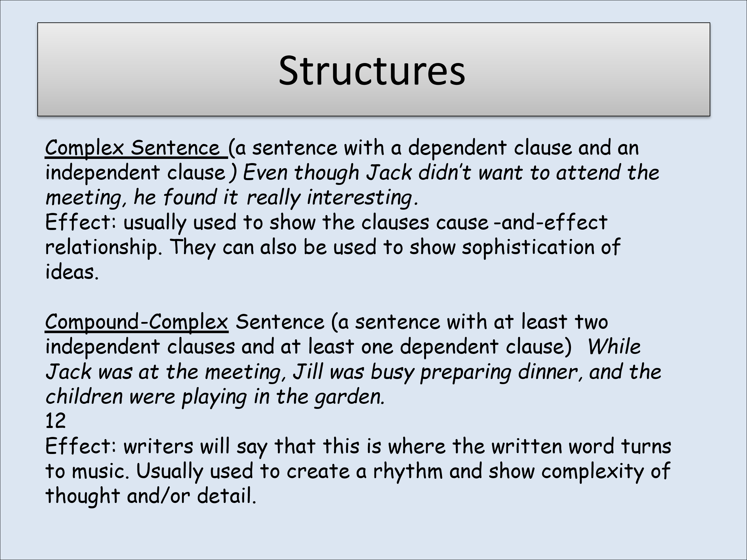
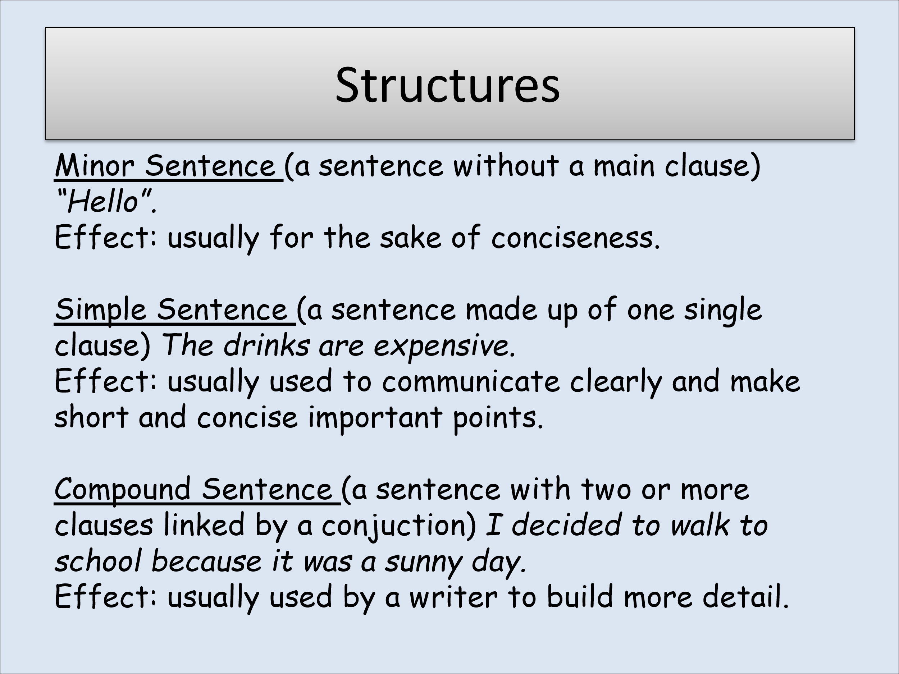
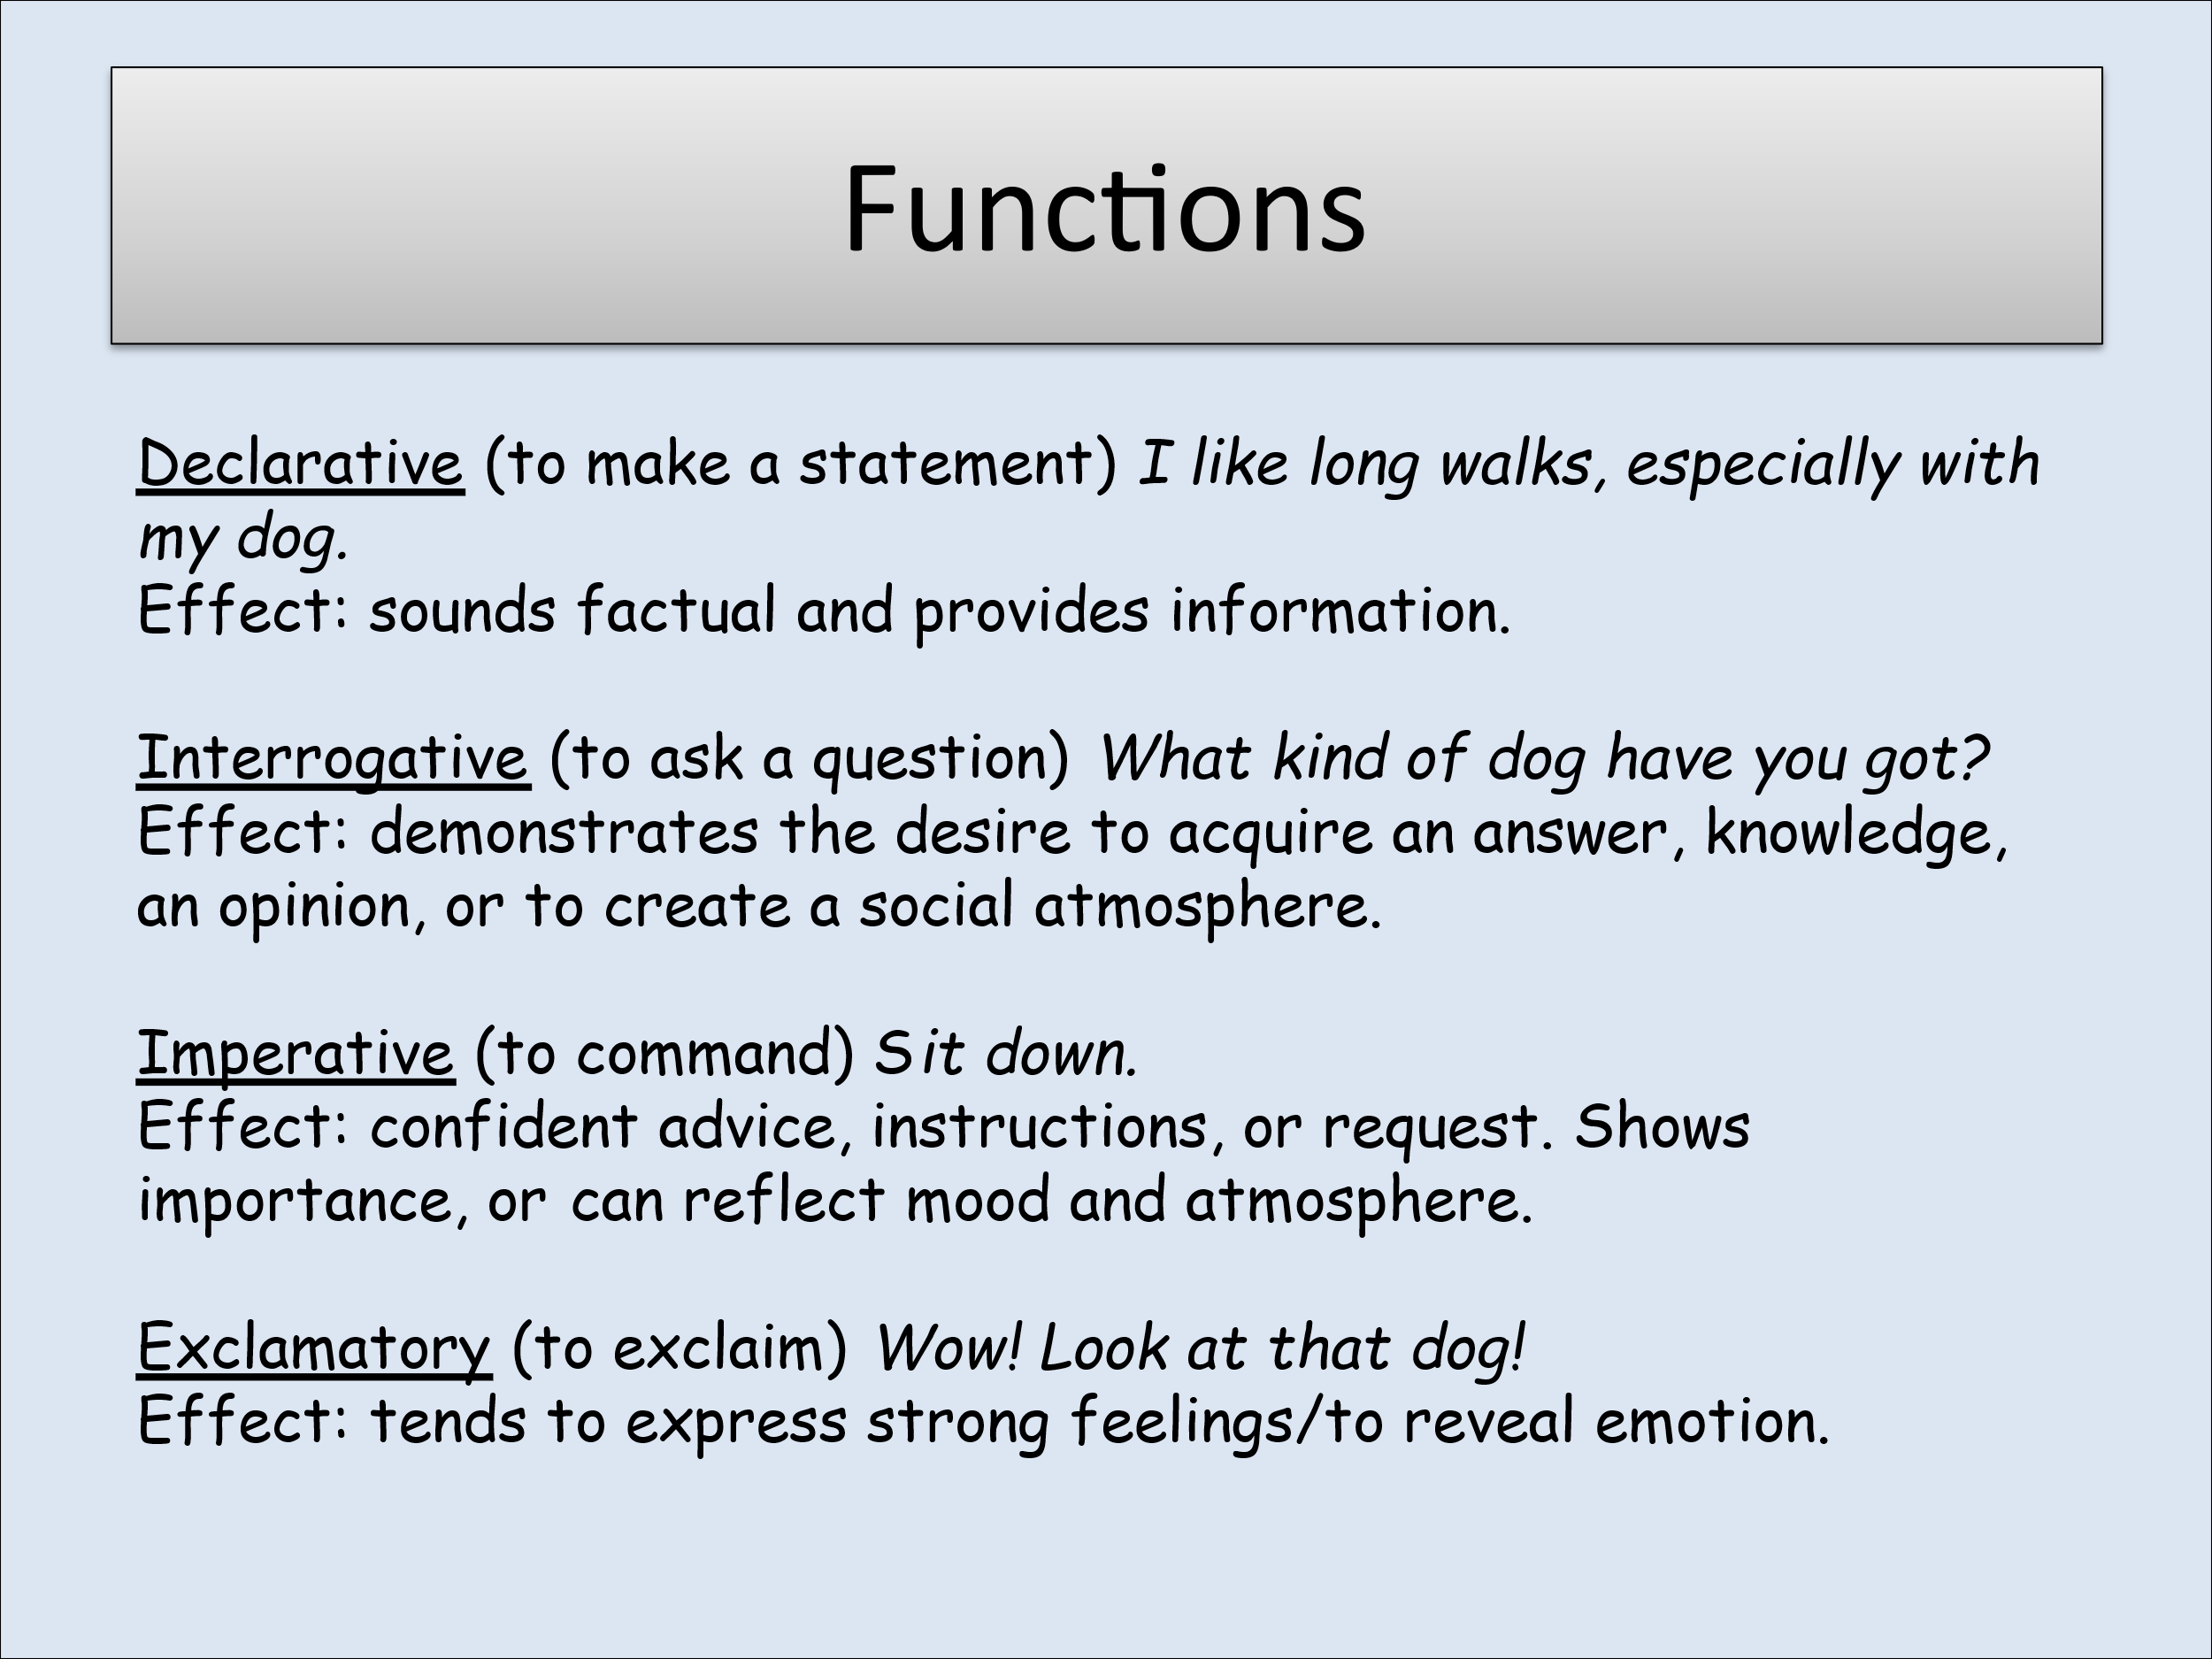
- My dog is called Dave.
- My dog is called Dave and he likes chewing bones.
- The cat came around the corner, swishing its tail.
- Although I am tall, I could not reach the top shelf.
- Phil is my best friend.
- Phil is my best friend but she lives a long way from me.
- I want to learn to swim and I would like to play football.
- Sue had to go to bed, even though she wasn’t tired.
- The rugby match, which took place on Sunday, was excellent.
- James fell off his bike.

Bridging
work

SIXTH
FORM
CROSSLEY
HEATH
THE

Task 1:
You are going to transcribe about a minute’s worth of this conversation (see the advice on the following page on transcribing speech). Ensure that you pick a section of the conversation when people are speaking normally, not ‘performing’ for the recording.

One of the things we look at in English Language is speech patterns.

Make a recording of a casual conversation lasting about two minutes. This could be about anything. Remember to tell the people that you are recording that you are going to do this (it’s only fair).

Speech Patterns
Speech Patterns
Write a few paragraphs commenting on what you notice about the transcription. This might include:
- Who dominates the conversation?
- Whether there are any interruptions
- If there are any features of a person’s language which stand out e.g. fillers, mispronunciations, tag questions etc.

Task 2:

SIXTH
FORM
CROSSLEY
HEATH
THE

Transcript
conventions

SIXTH
FORM
CROSSLEY
HEATH
THE
Use the following symbols when transcribing your data
[ ] means simultaneous utterance i.e. when two or more people start speaking at the same time. Put the symbol in front of both speakers’ utterances.
// means overlapping speech. Put the symbol in line with the person who is interrupted.
e.g. A: Did you see John again // last night
B: // No (2) I haven’t seen him in ages

(.) indicates a micropause i.e., a very short pause of a second or less
(3) indicates a pause in seconds – three in this case.

Capital letters or underlining are used to show emphasis.
One or more colons can indicate an elongated vowel
e.g. A: Yea::h I see::

N.B. Normal sentence punctuation is not used in speech transcription, so do not use commas, full stops, question marks or exclamation marks. If you want to indicate a high rising tone (to show a question, for example) use an upward-pointing arrow at the end of the utterance. Replace names with an initial letter and a line, so James would become J_ in your writing. Call participants by their initial letter when saying who is speaking – put this in the margin.

Your transcripts should be between approximately 30 seconds’ worth of speech and one minute’s worth per transcript.

= means that there is no pause between speeches
e.g. A: Did you go=
B: = What do you mean did I go

