
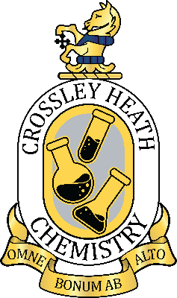

SIXTH
FORM
CROSSLEY
HEATH
THE
Student Name:

SIXTH
FORM
CROSSLEY
HEATH
THE
This bridging work is designed to help you consolidate the GCSE knowledge needed in A level Chemistry. During the first lesson of the course, you will bring this completed booklet and have a discussion with your teacher about how you found it. You will then mark your booklet and use it to identify any further work needed at the start of your A level chemistry journey. You may need paper as some of the answers may not fit in the booklet

A-Level Chemistry
Welcome!
Hello, and welcome to Crossley Heath chemistry. We are very much looking forward to seeing you in September as you embark on your next steps as part of The Crossley Heath School's sixth form. We are eager to be part of your learning journey that will see you enhance both your chemistry knowledge and transferable skills as we help prepare you for the future. If you need any help or advice along the way, our supportive team will be available to guide you every step of the way.

See you in September!

Mrs E Ryan
(Department Leader for Chemistry)

Dr J Norcliffe
(Teacher of Chemistry)

Dr H Stevens
(Teacher of Chemistry)
Link to Specification: https://www.ocr.org.uk/images/171720-specification-accredited-a-level-gce-chemistry-a-h432.pdf

Exam Board and Specification: OCR A-Level Chemistry A (H432)

SIXTH
FORM
CROSSLEY
HEATH
THE
Bridging
work

A level chemistry relies on a lot of the fundamental GCSE ideas. If any of the things on the list are something you struggled with or don’t remember, you need to prioritise raising your understanding of it. This booklet focuses on the key skills and knowledge needed early at A level

What you can do to boost your understanding if necessary
Fuse School videos on YouTube have lots of excellent GCSE videos
Borrow a GCSE textbooks from the department
Come to the Chemistry drop in session to ask for help
Email your teacher for help
Go on physics and maths tutor and look at the GCSE past paper questions on that particular topic
Watch MaChem Guy YouTube videos called ‘Prep for A level Chemistry’
Content | Current confidence (1-5) very confident to not at all
Covalent bonding
Ionic bonding
Metallic bonding
Ionic formulae
Balancing Equations
Moles
Reacting masses
Gas volumes
% yield + Atom economy
Titrations
Types of formulae
Alkanes
Alkenes
Alcohols

Maths skills
Rearranging equations to make something else the subject
Drawing graphs, lines of best fit and tangents
Converting units
Standard form
Decimal places, significant figures and rounding

What you need to have a really good understanding of from GCSE
Covalent bonding
Ionic bonding
Metallic bonding
Writing formulae
Balancing equations
Moles
Reacting masses calculations
Gas volume calculations
% yield and atom economy
Titrations
Molecular, structural and displayed formula
Drawing alkanes and combustion (up to 4 C’s)
Drawing alkenes and their GCSE reactions (up to 4 C’s)
Drawing alcohols (up to 4 C’s)

The Fundamentals!
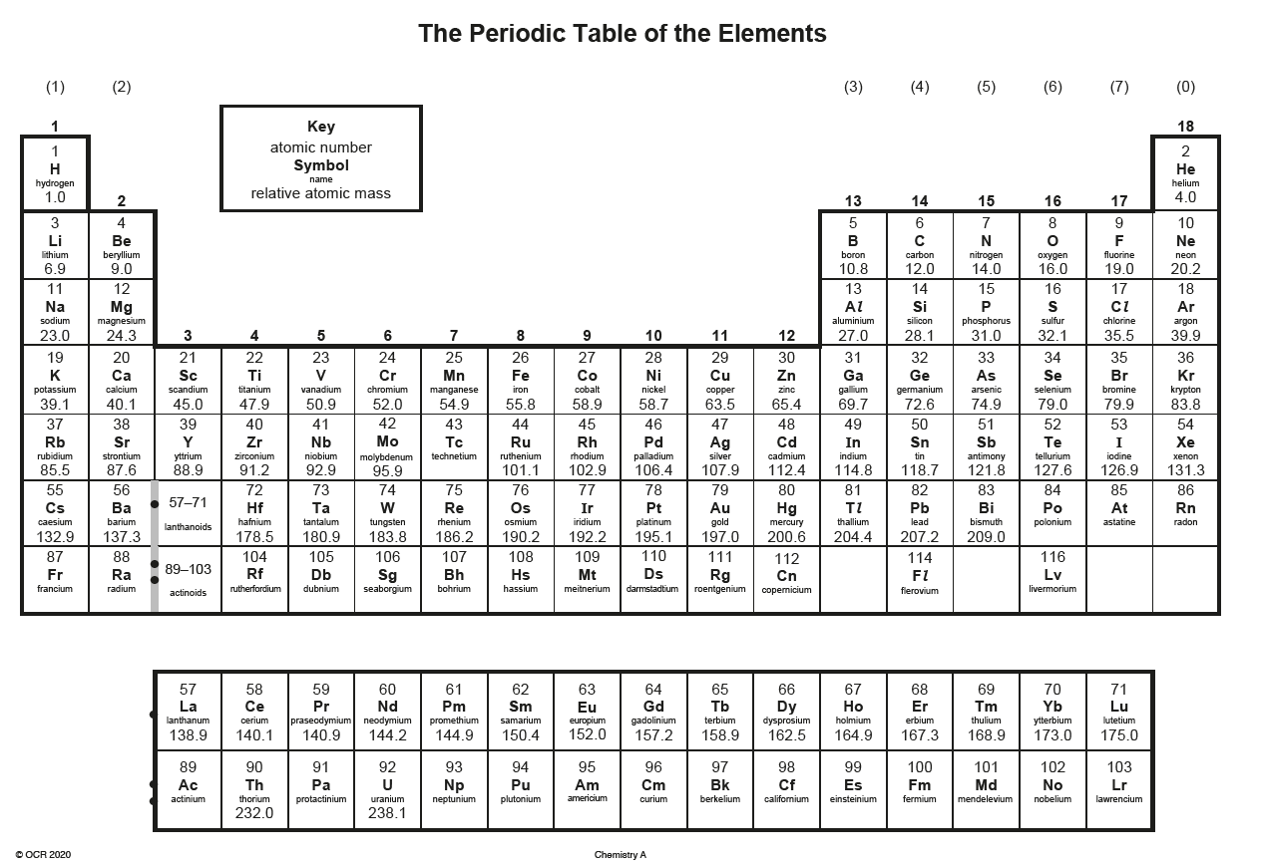

(2 hours 30 minutes)
Section 1: Charges on Ions and writing forumlae

SIXTH
FORM
CROSSLEY
HEATH
THE
Task 1:

Watch the following video on writing ionic formulae. Whilst watching, write a short summary of the video below: https://www.youtube.com/watch?v=tV8Cv2x0SD0

Task 2:

Read the guidance we wrote for this section on the next pages and use your notes and ours to complete the questions

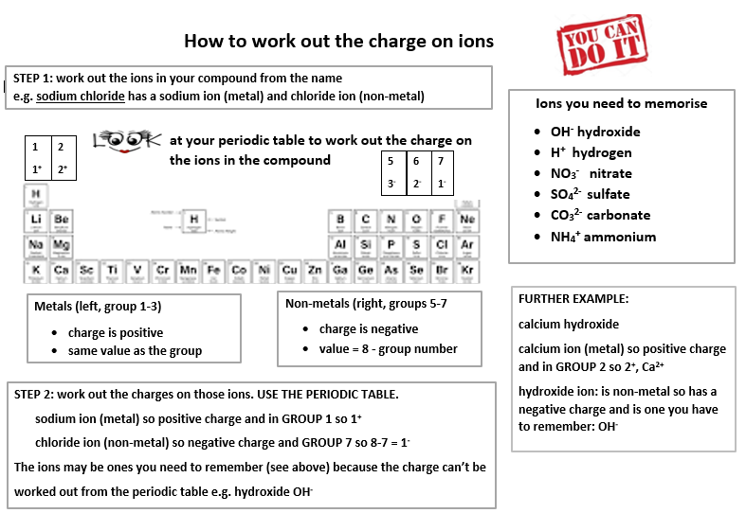

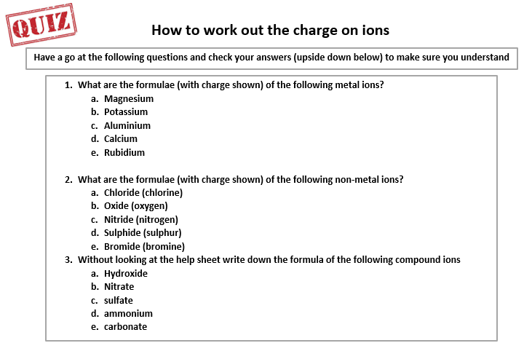

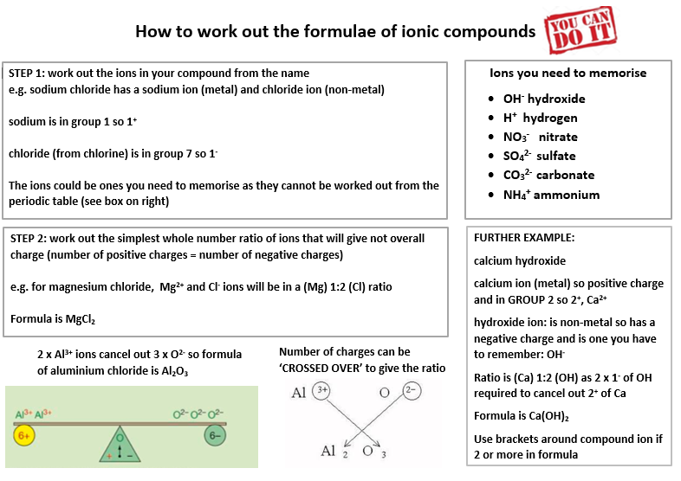

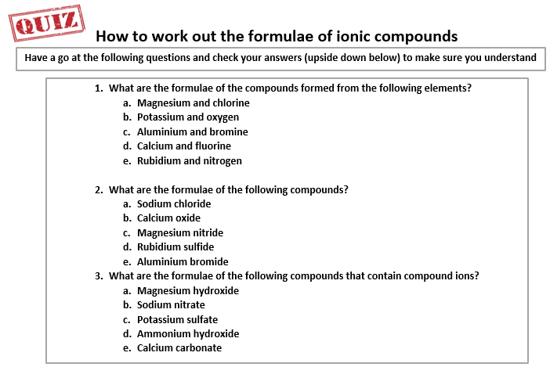

(2 hours 30 minutes)
Section 2: Bonding

SIXTH
FORM
CROSSLEY
HEATH
THE

Watch the following video of the different types of bonding. Whilst watching, write the answers to the video questions below and mark them yourself: https://www.youtube.com/watch?v=vUbUoyR6Log

Task 1:

Task 2:

Read the guidance we wrote for this section on the next pages and use your notes and ours to complete the questions

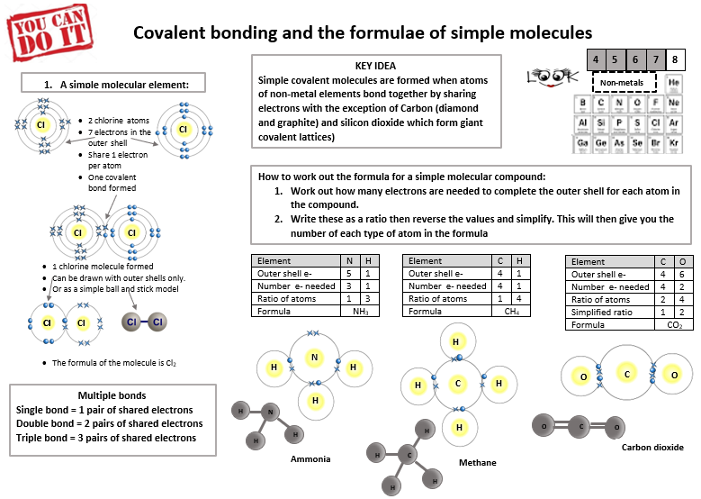

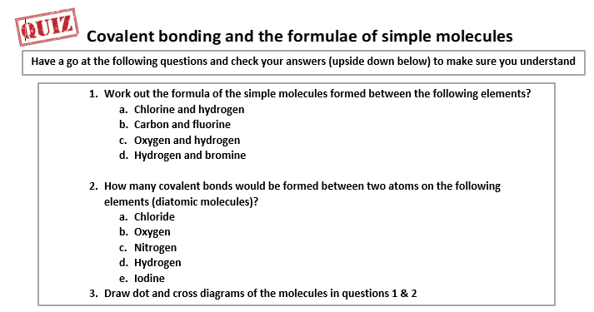

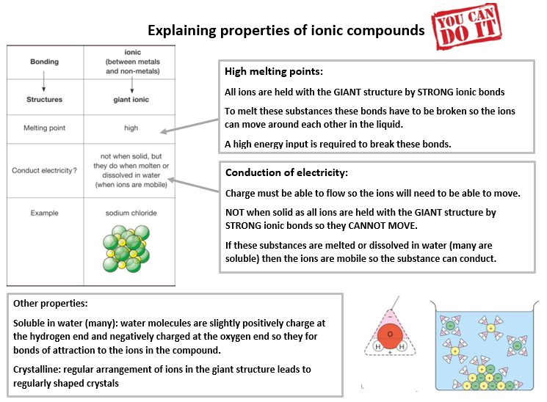

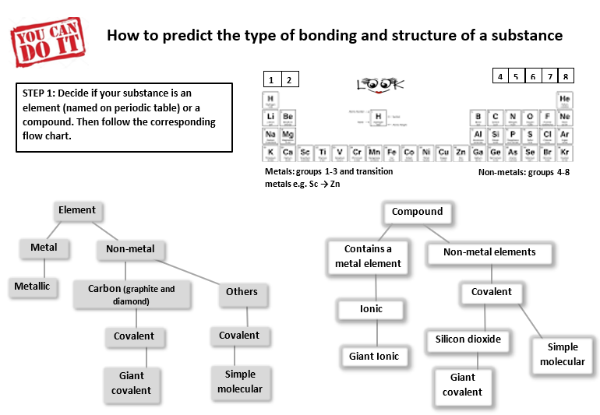

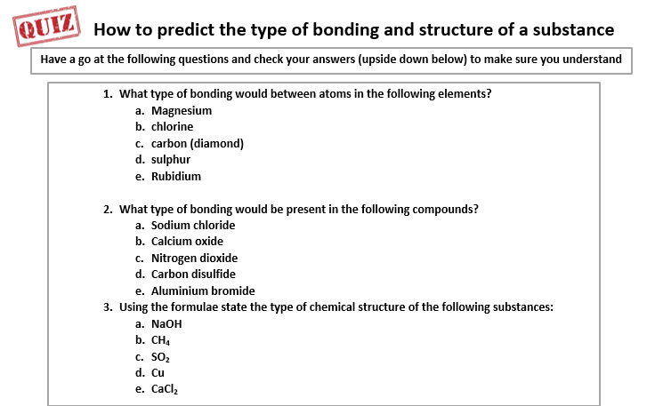

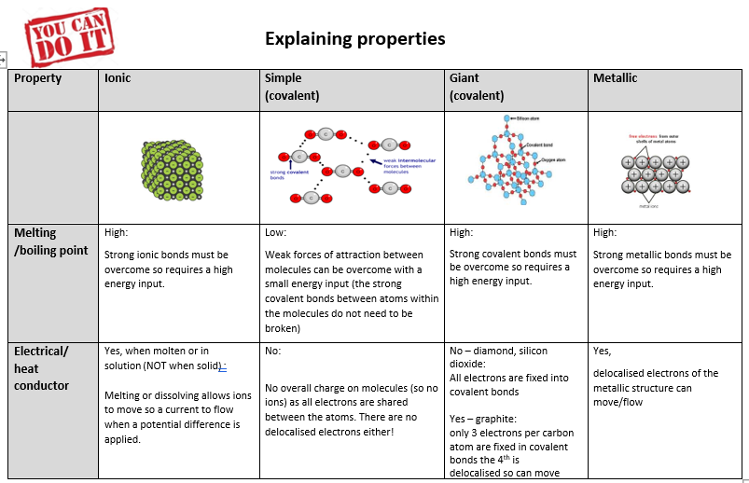

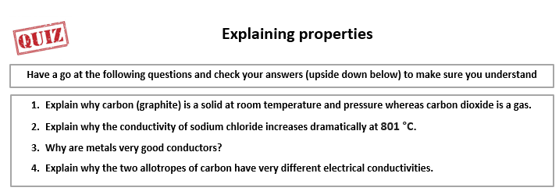

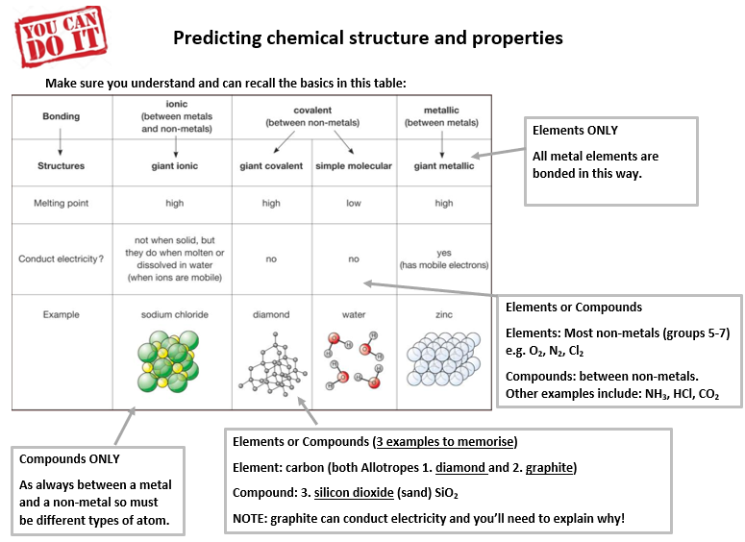

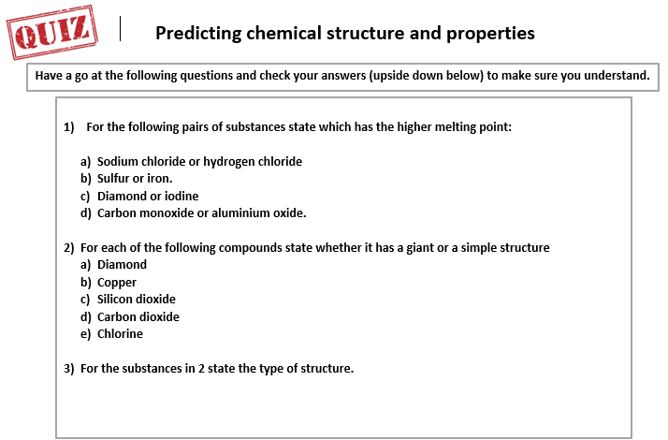

Section 3: Chemical Calculations
(3 hours)
Task 1:

Watch the following videos on reacting masses and limiting reactants. Whilst watching, write the answers to the video questions below and on the next page. Use the video to mark your answers
Reacting masses video and space for answers
https://www.youtube.com/watch?v=I3WVO3TEqAY

SIXTH
FORM
CROSSLEY
HEATH
THE

Task 2:

Limiting reactant video and space for answers: https://www.youtube.com/watch?v=CVN6M7Pe0M0

Read the guidance we wrote for this section on the next pages and use your notes and ours to complete the questions

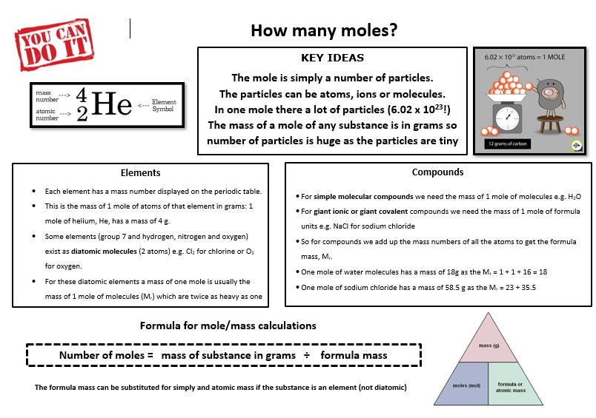

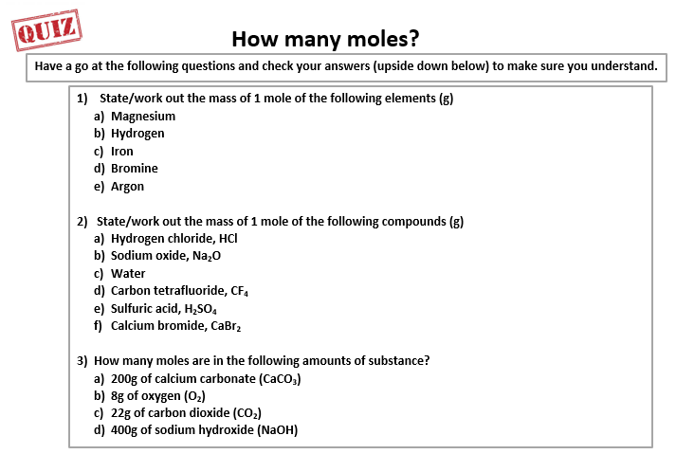

SIXTH
FORM
CROSSLEY
HEATH
THE

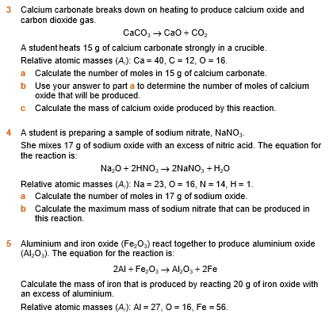
Reacting Masses Practice

SIXTH
FORM
CROSSLEY
HEATH
THE
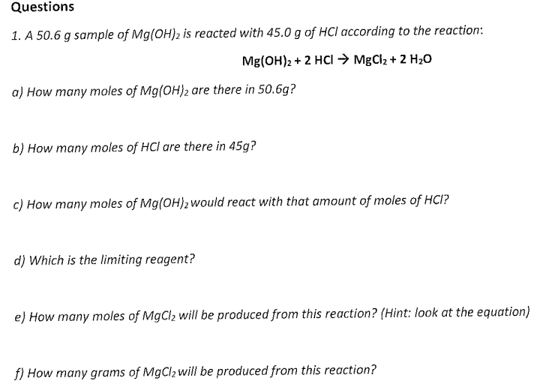
Limiting Reactant Calculation

SIXTH
FORM
CROSSLEY
HEATH
THE
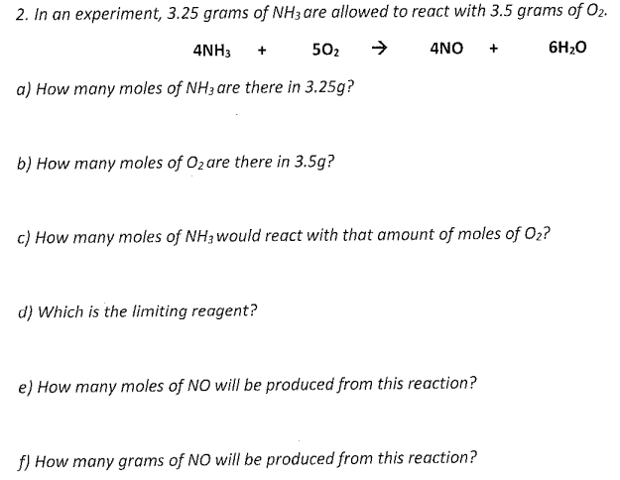
(1 hour)
Section 4: Balancing Equations

SIXTH
FORM
CROSSLEY
HEATH
THE
Task 1:

Watch the following video on balancing equations. Whilst watching, write the answers to the video questions below. Use the video to mark your answers
https://www.youtube.com/watch?v=kwD7raDxm_A

Balance the following equations for types of reactions you studied at GCSE

SIXTH
FORM
CROSSLEY
HEATH
THE
- H₂ + Br₂→ HBr

- H₂ + O₂→H₂O

- Mg + HCI→ MgCl₂ + H₂

- Na + H₂SO₄→ Na₂SO₄ + H₂

- Zn + O₂→ ZnO

- MgCO₃ + HCI → MgCl₂ + H₂O + CO₂

- C + O₂→ CO

- MgO+HNO₃→ Mg(NO₃)₂ + H₂O

- FeCl₃ + NaOH → Fe(OH)₃ + NaCl

- CuS0₄ + NaOH → Cu(OH)₂ + Na₂SO₄

